**Active Directory and Amazon Web Services**

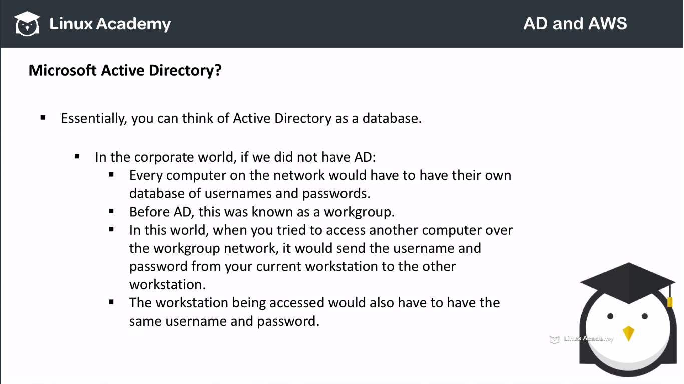

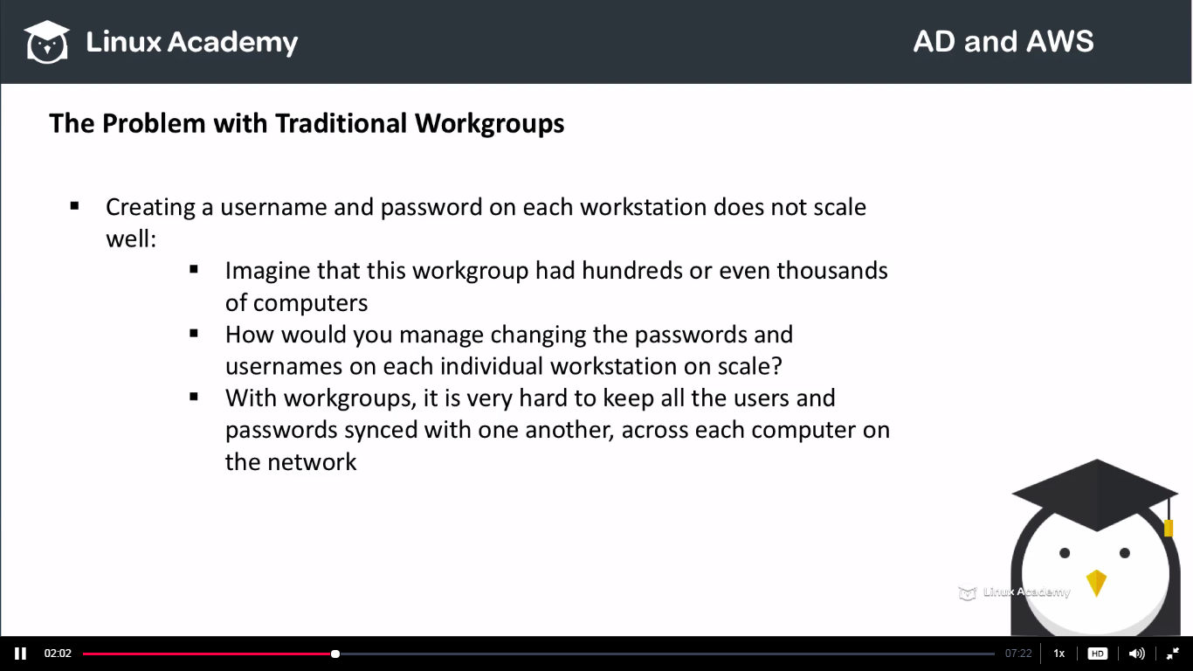

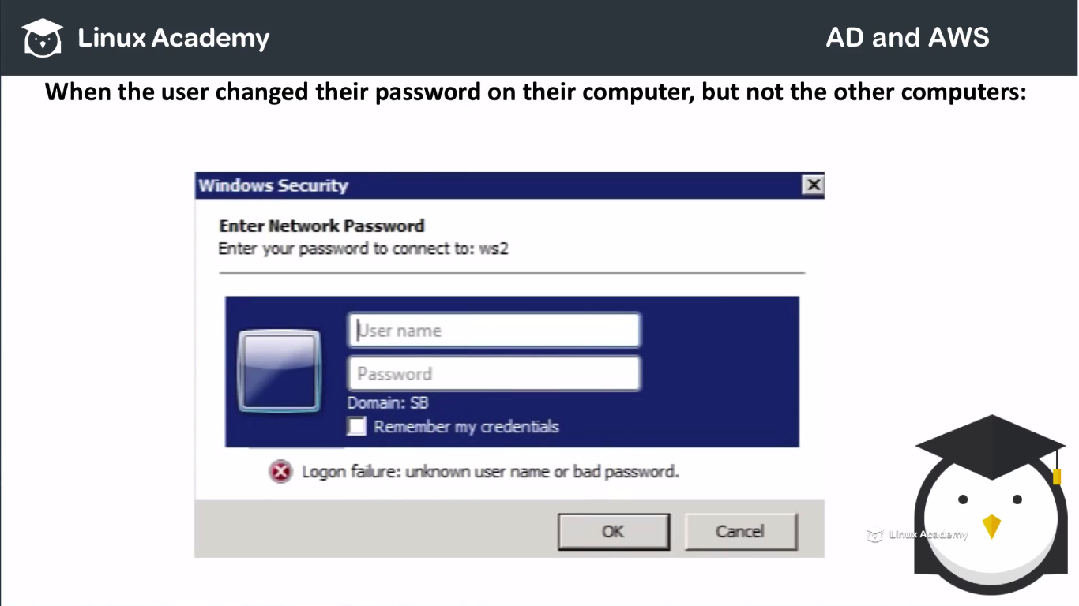

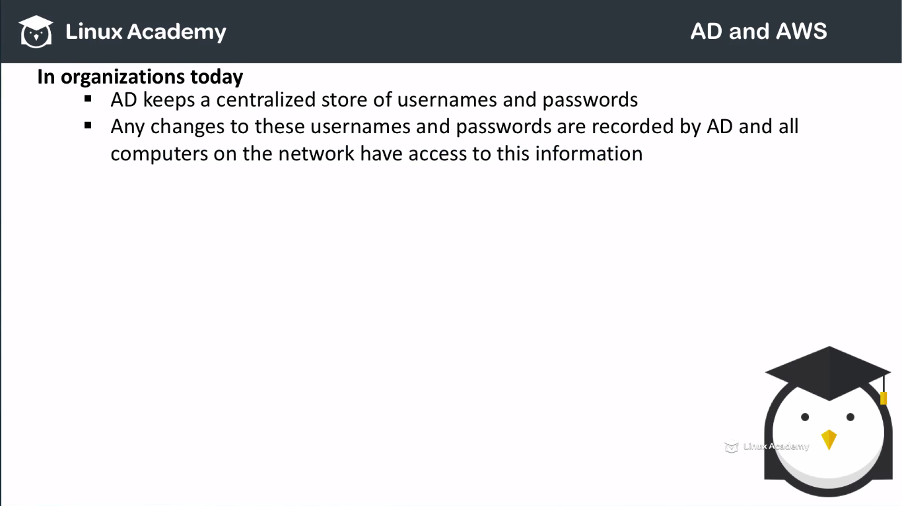

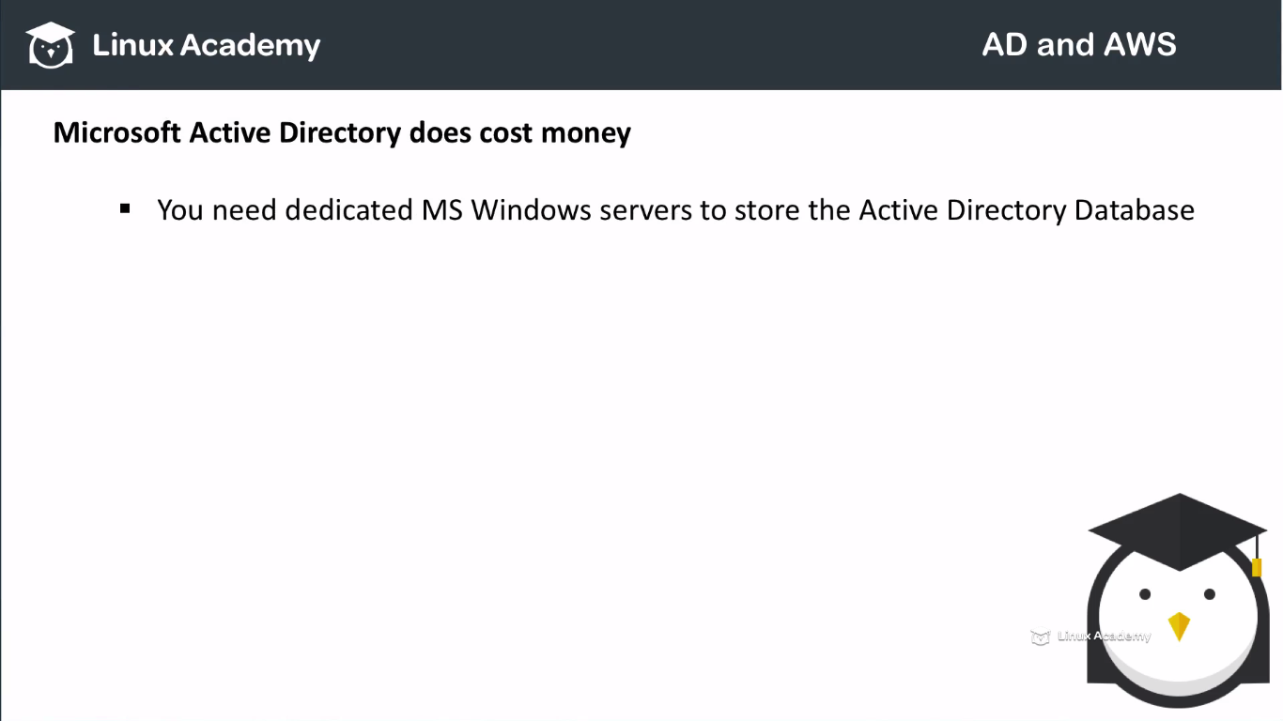

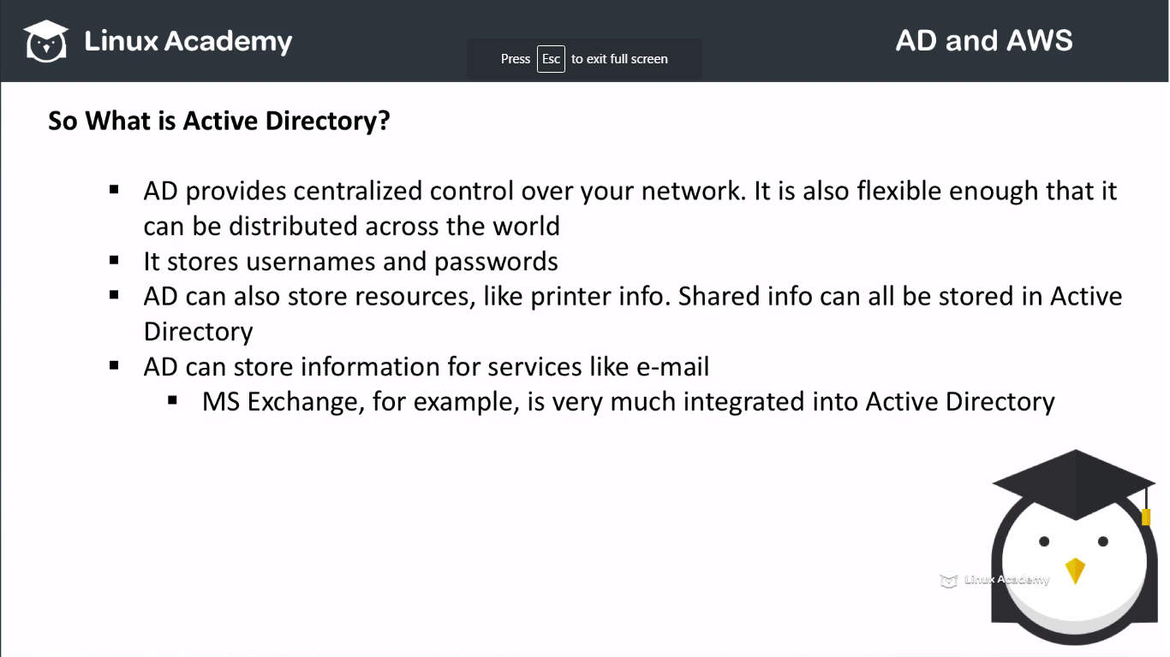

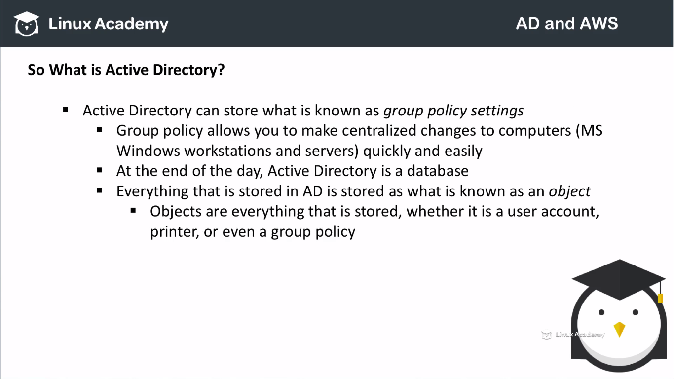

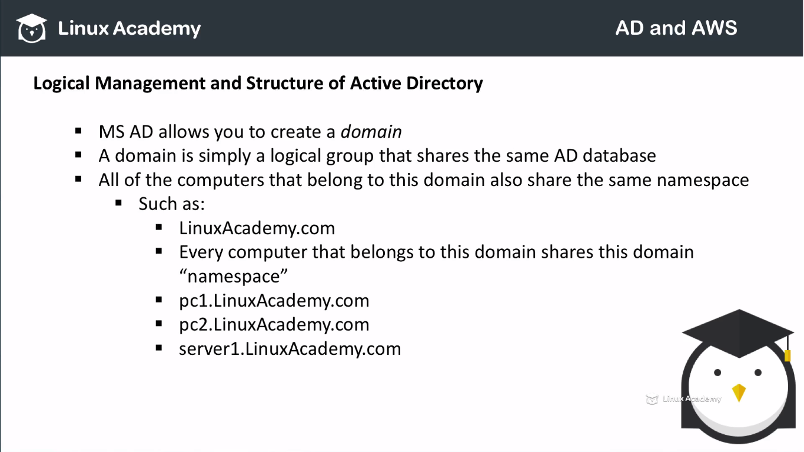

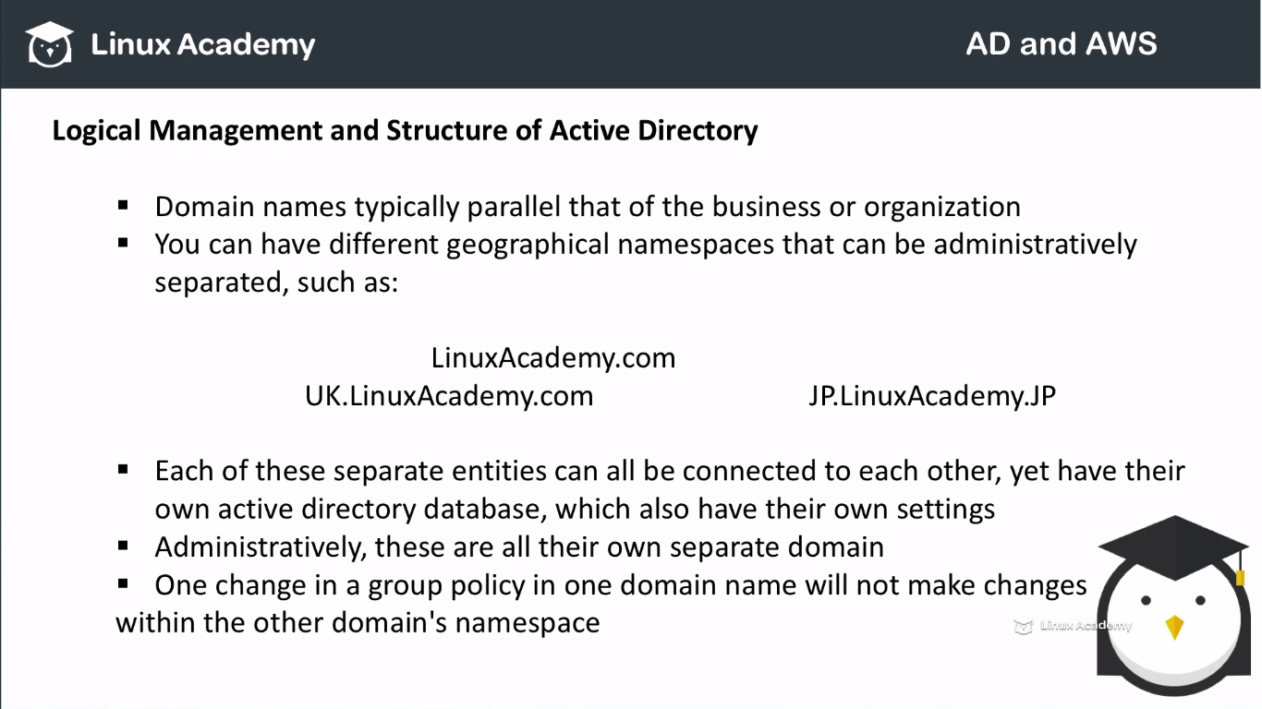

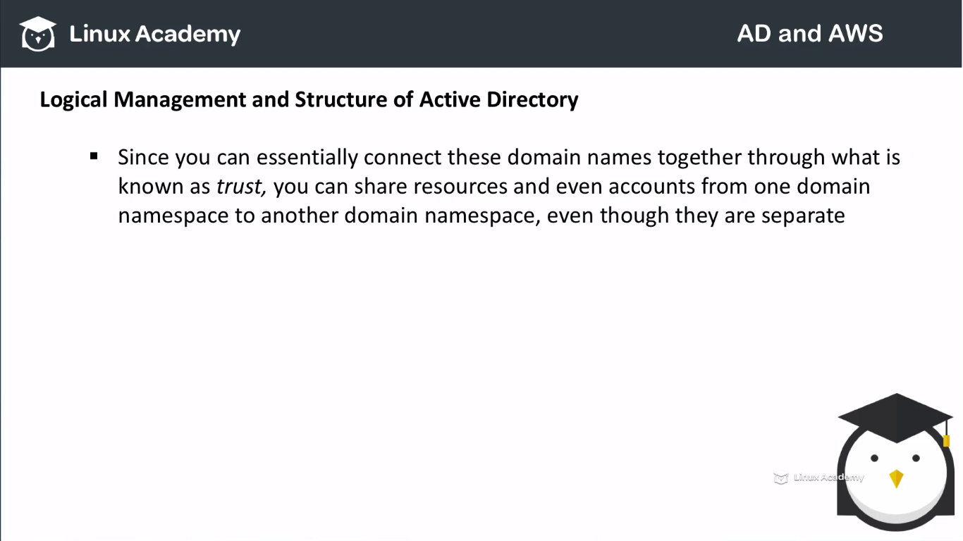

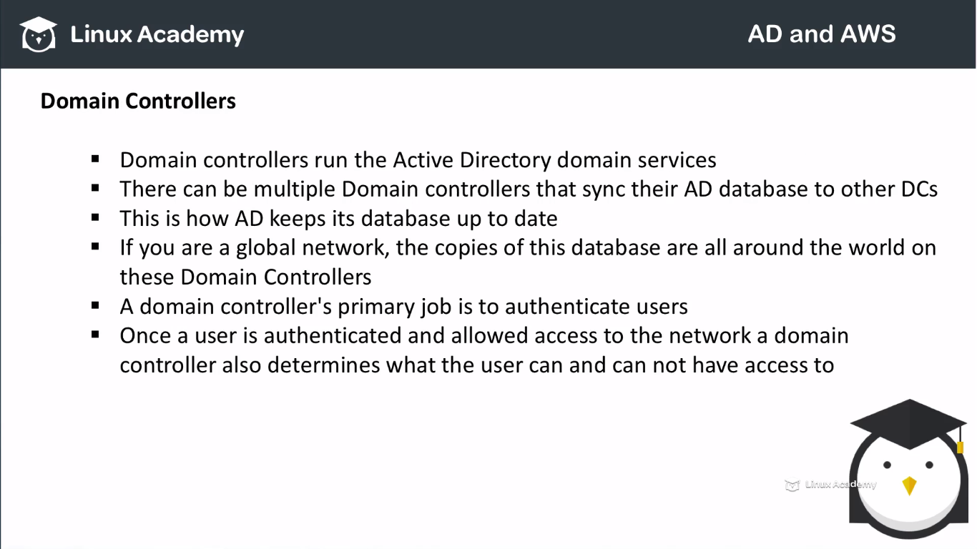

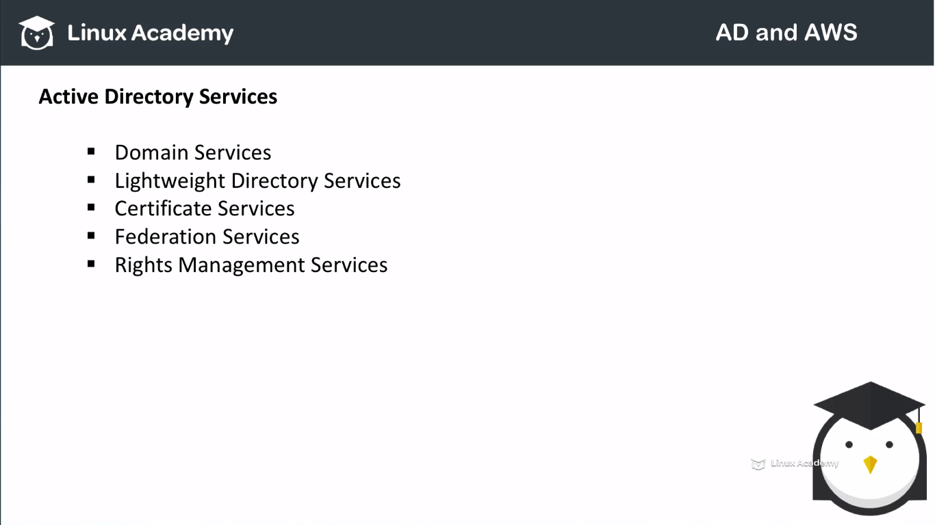

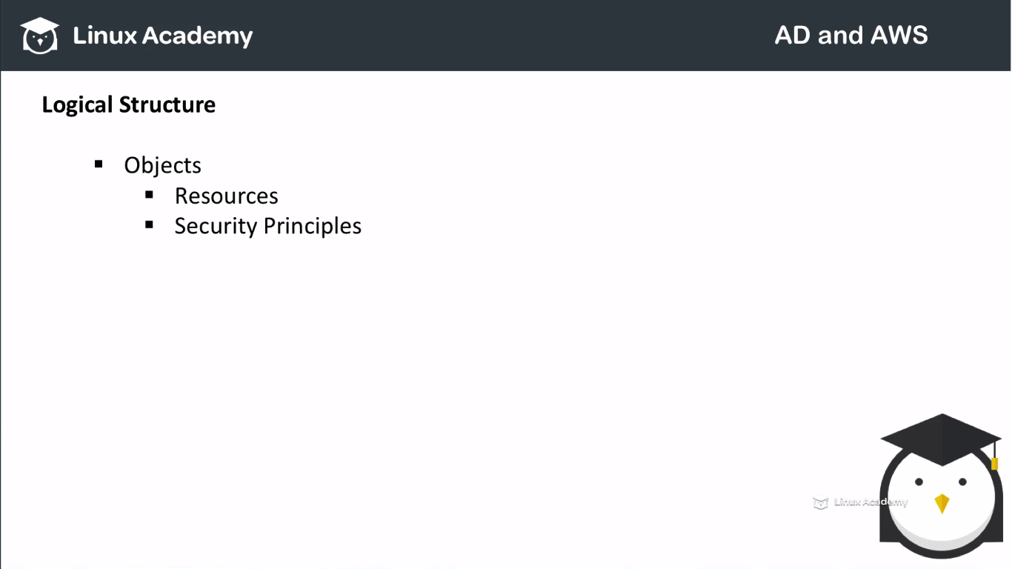

Resources such as printers. Security principals are user accounts and groups. These principles are assigned unique identifiers or sid’s. Each object represents a single identity whether it’s a user or a computer,printer or group and its attributes stick along with it. Certain objects can contain other objects. Objects is identified by its name and has a set of attributes. The characteristic and the information the objects represents defined by the schema which also determines the kind of the objects that can be stored within the active directory. The schema objects lets the administrators extend or even modify the schema when necessary. Schema changes automatically propogates throughout the system. Once created an object can only be deactivated not deleted. Changing of the schema needs planning ahead of time.

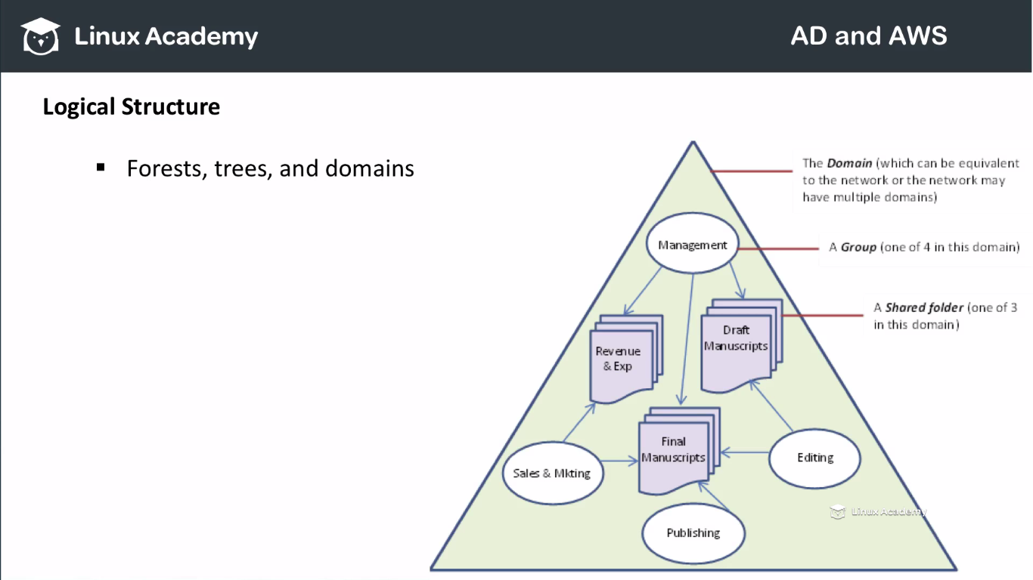

Domains are identified by their dns name structures simply named as the namespace. A domain is defined as the logically group of network objects, computers, users, devices that share the same active directory databse. A tree is a collection of one or more domain and domain trees and a contiguous namespace. This is linked in a transitive trust hierarchy. At the top of the hierarchy is the forest. A forest is a collection of trees that shares common global datalog, directory schema, logical structures and directory configurations.

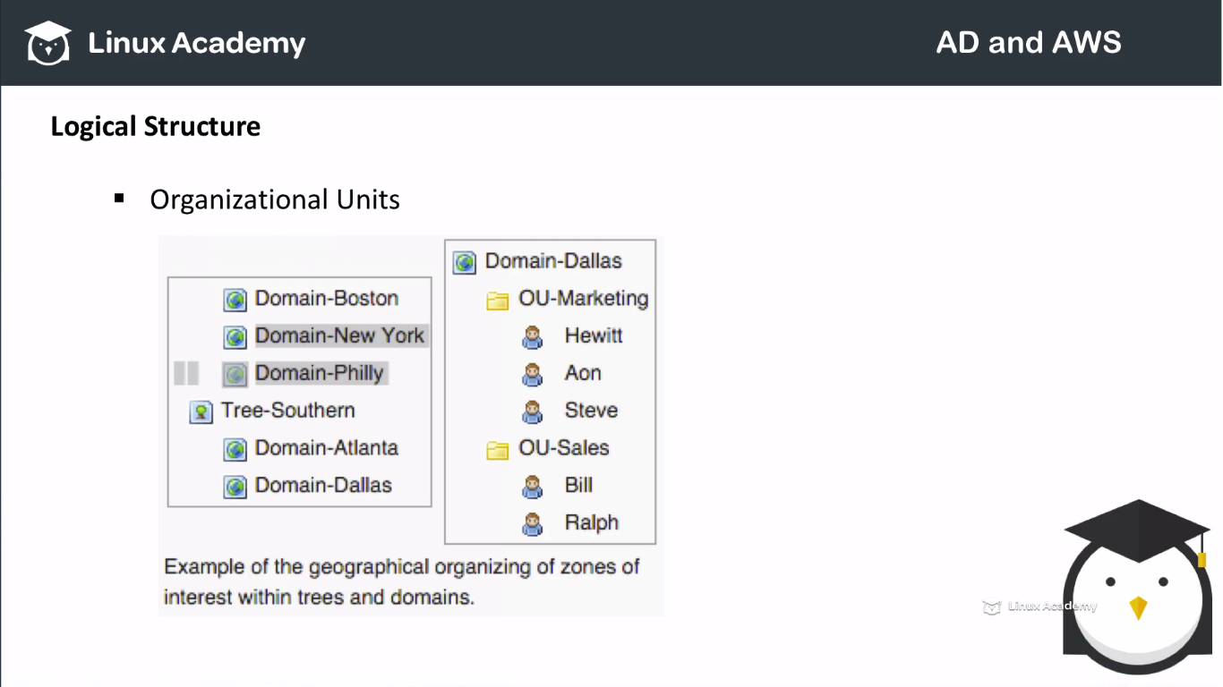

The objects held within a domain can be grouped into a organizational units. They are known as OU’s and provide hierarchy to the domains, ease administration and can reasable the orgainizational structure and managerial and even geographical structure. OU’s can contain other OU’s(domains and containers). OU’s don’t have each individual namespace. For example user accounts identified with the same username such as the same account name and separate OU’s with a domain are not allowed such as [fred.staff@linuxacademy.com](mailto:fred.staff@linuxacademy.com) and [fred.student@linuxacademy.com](mailto:fred.student@linuxacademy.com) where staff.ou and student.ou are the OU’s themselves. This is because the same account names or simple a user attribute object must be unique within the domain. However two users in two different OU’s can have the same common name.

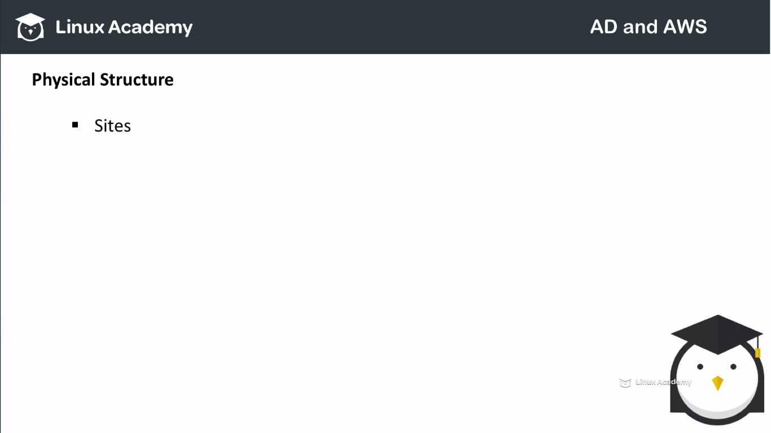

Sites are physical groups then logical groups defined by one or more ip subnets. Sites definations are independent of the domain and OU structure and common across the forests. These are used to control the network traffic generated by replication and also forward the clients to the nearest domain controllers or dc’s. Microsoft exchange uses the sites topology for mail routing. Policies can also be defined at the site level. Physical the active directory information is held in more than one or more domain controllers replacing what to be called as the NT or primary domain controller or VDC model. Each domain controller has the copy of the active directory. Now other servers that could be join to the active directory they are not domain controllers are called member servers. A subset of the object in the main partition replicate a domain controller and is configured what is called a global catalogue. Global catalogue servers provide a global listing of all objects within the forests. These servers replicate to themselves all the objects from all the domains and hence provide a global listing of objects within a forest. Again multiple domains all join by trust towards what know as a forest. However to minimize replication traffic and to keep the global catalogue database small only selected attributes of each object is replicated. This is called the partial attribute set or PIAS. This PIAS can be modified by modifying the schema and marking attributes for replication to the global catalogue. Earlier versions of windows used net bios to do this communication. Active directory is fully integrated with dns and requires TCP/IP. The DNS server must support the SRV records and resource records also known as service records.

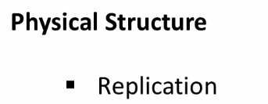

Active directory synchronizes changes to muti-master replication. Replication bydefault is a pull rather than a push meaning replication pull changes from the server when the change was actually affected. The known consistency check or KCC create a replication topology site links using the defined sites to manage the traffic. Inter site replication is frequent and automatic as a result of changed notification which triggers peers to begin pull replication cycle. Inter site replication intervals are typicall less frequent and do not change notification bydefault. Although this is configurable and This can be made identical to inter-site replication. Each link can have a cost. KCC alters the site-link topology accordingly. Replication may occur transitively through several site links on the same protocol site link bridges. IF the cost is low although the KCC automatically cost a direct site to site link lower than the transitive connection. Site-to-site link replication can be configured to occur between a bridge hard server and between each site which then replicate changes to other domain controllers within the same site. Replication to active directory zones automatically configured when DNS is activated in the domain based by site. Replication of active directory uses remote procedure call or RPC over IP. Now between site SMTP can be used for replication but only for the change in schema configuration and partial attributes set within our global catalogue. SMTP can’t be used for replicating the default domain partition.

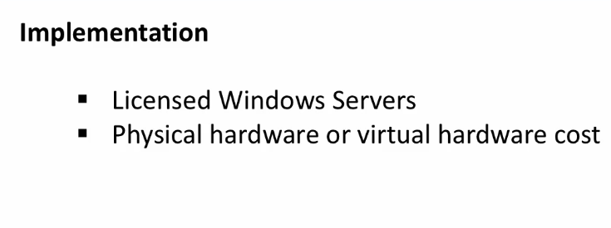

In general a network utilizing active directory has more than one license window server computer.

Backup and restore of active directory is possible for the network with a single domain controller but Microsoft recommends that one domain controller to provide automatic failover protection of your active directory domain controllers.

## Lecture: Active Directory Environments

**Lecture: Active Directory Environments**

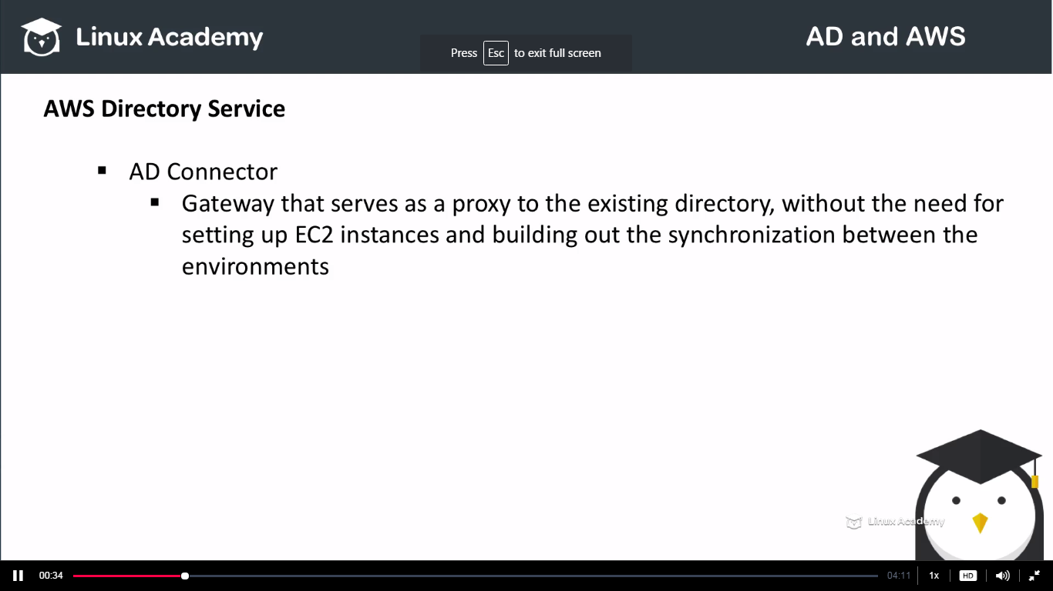

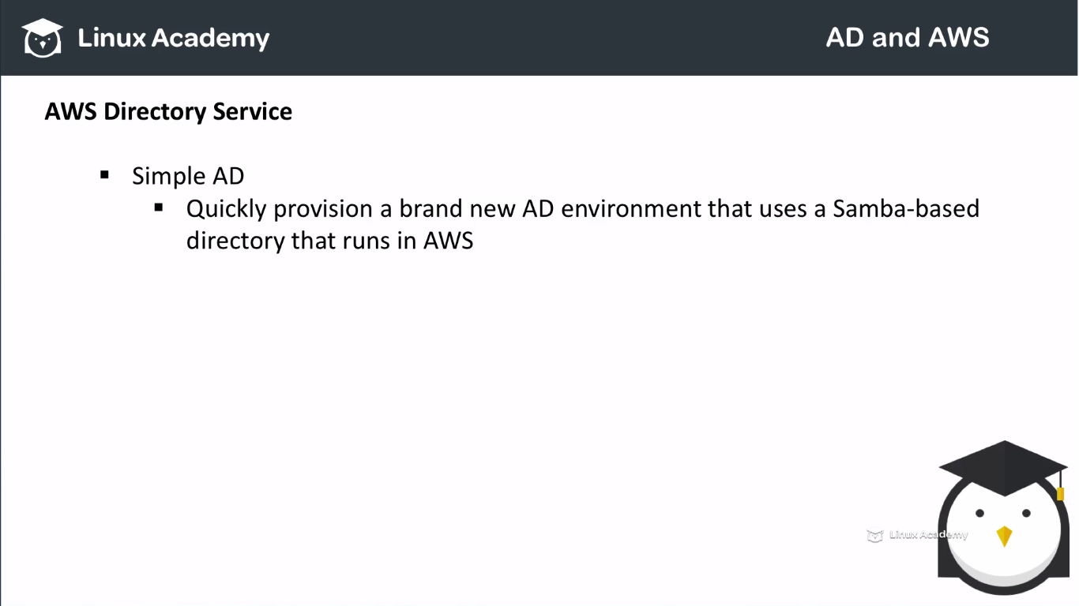

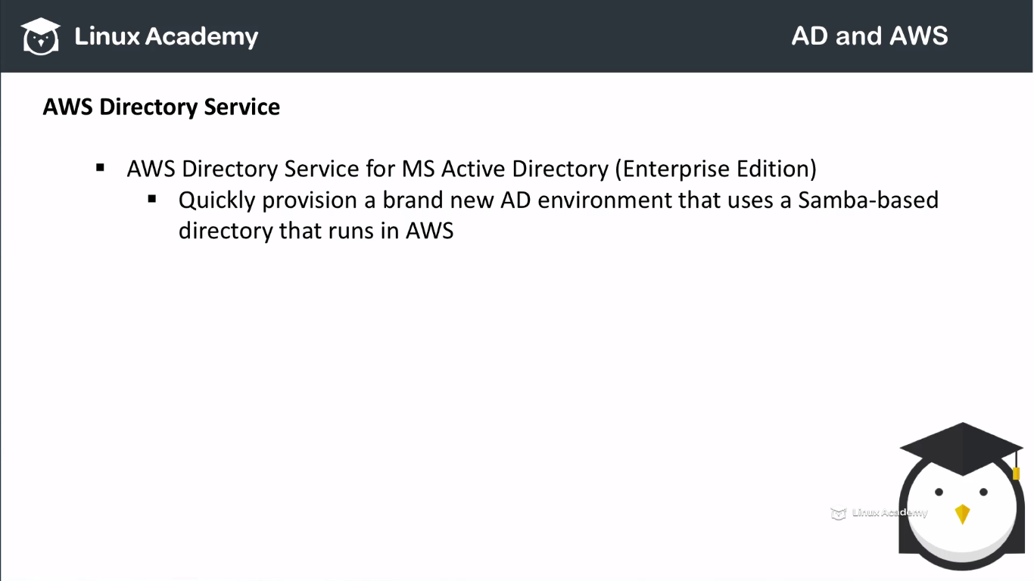

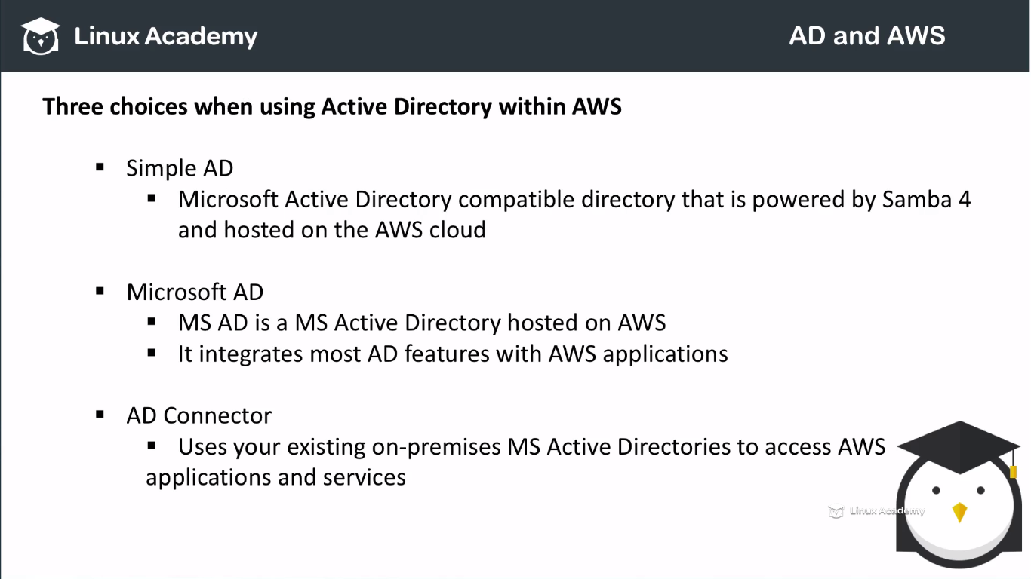

**Active Directory and Amazon Web Services**

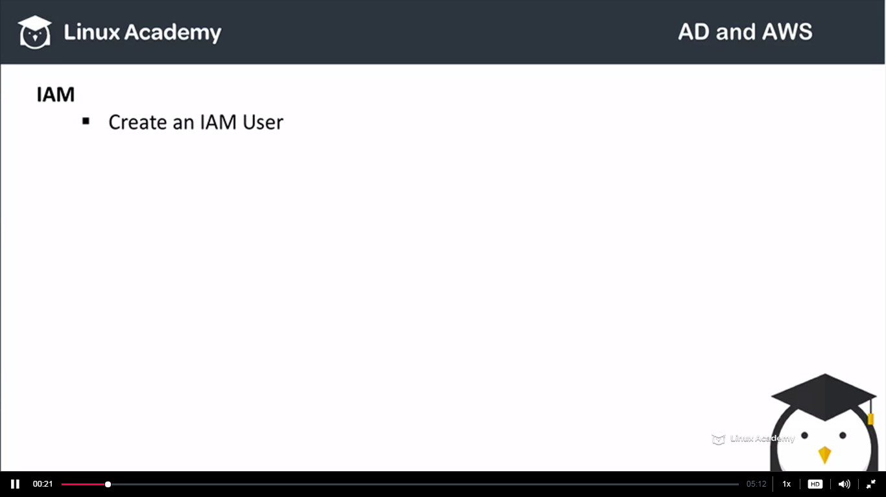

Go to IAM and groups

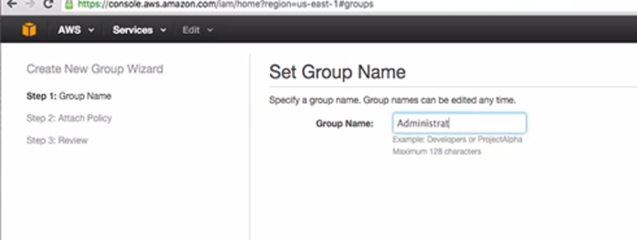

Do next as we are not attaching any policies to it.

Create new user and attach this user to the group administrators.

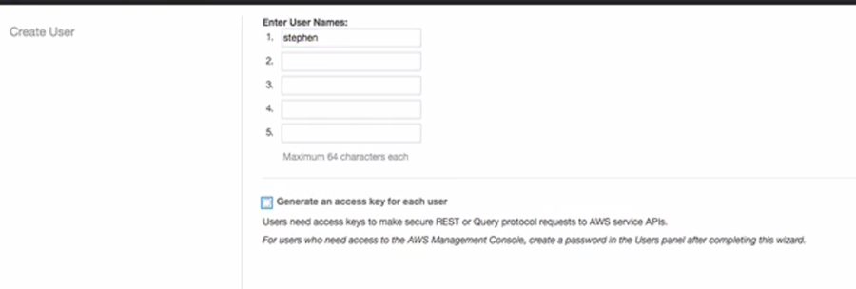

Go to user Stephen and then go to password

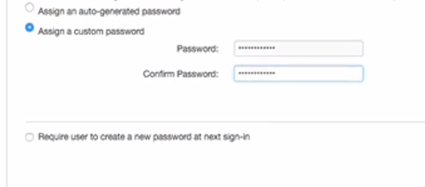

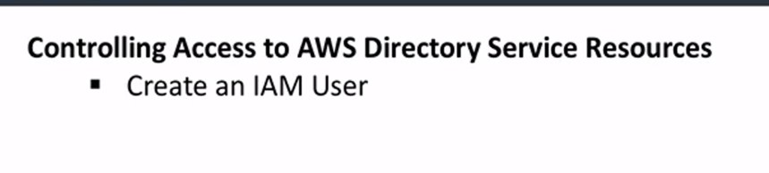

We need to create a policy that allows access to the AD for the admin group we created.

Copy the document of the policy.

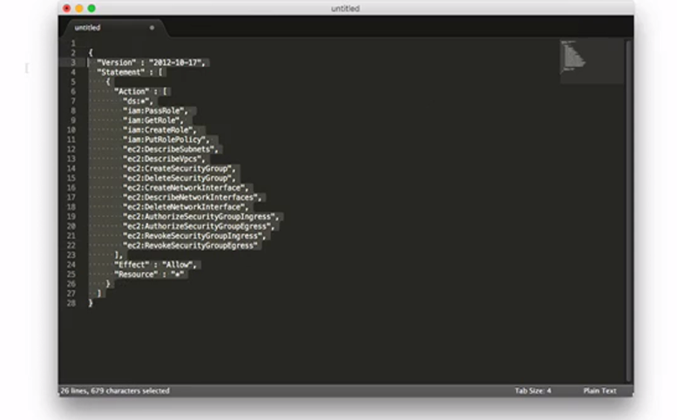

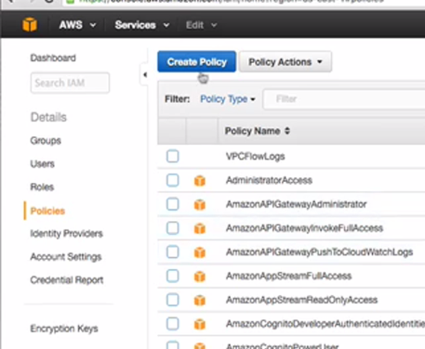

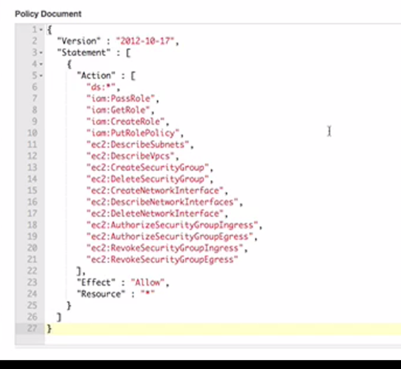

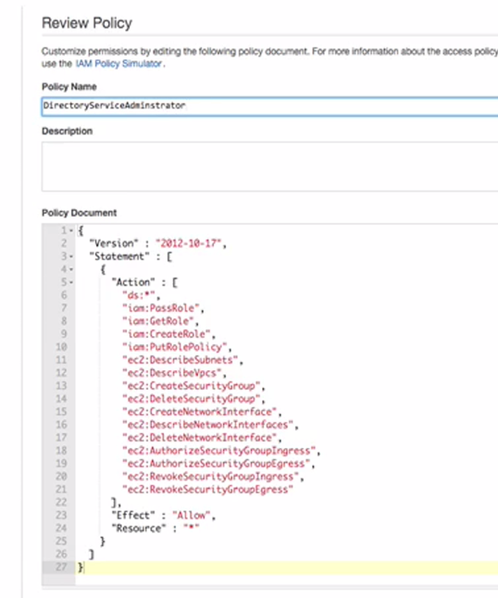

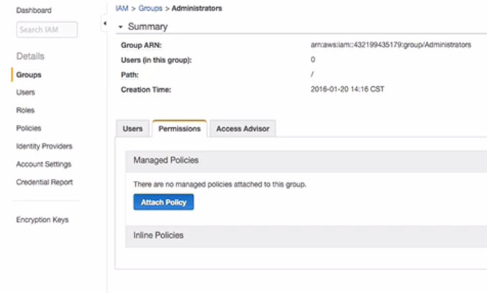

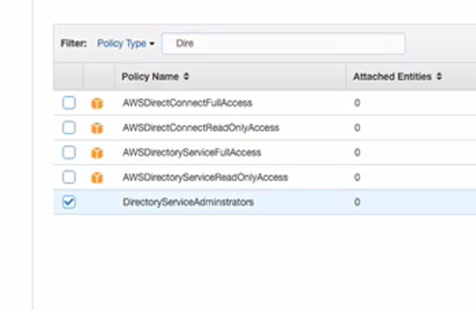

## Lecture: Setting up Simple AD

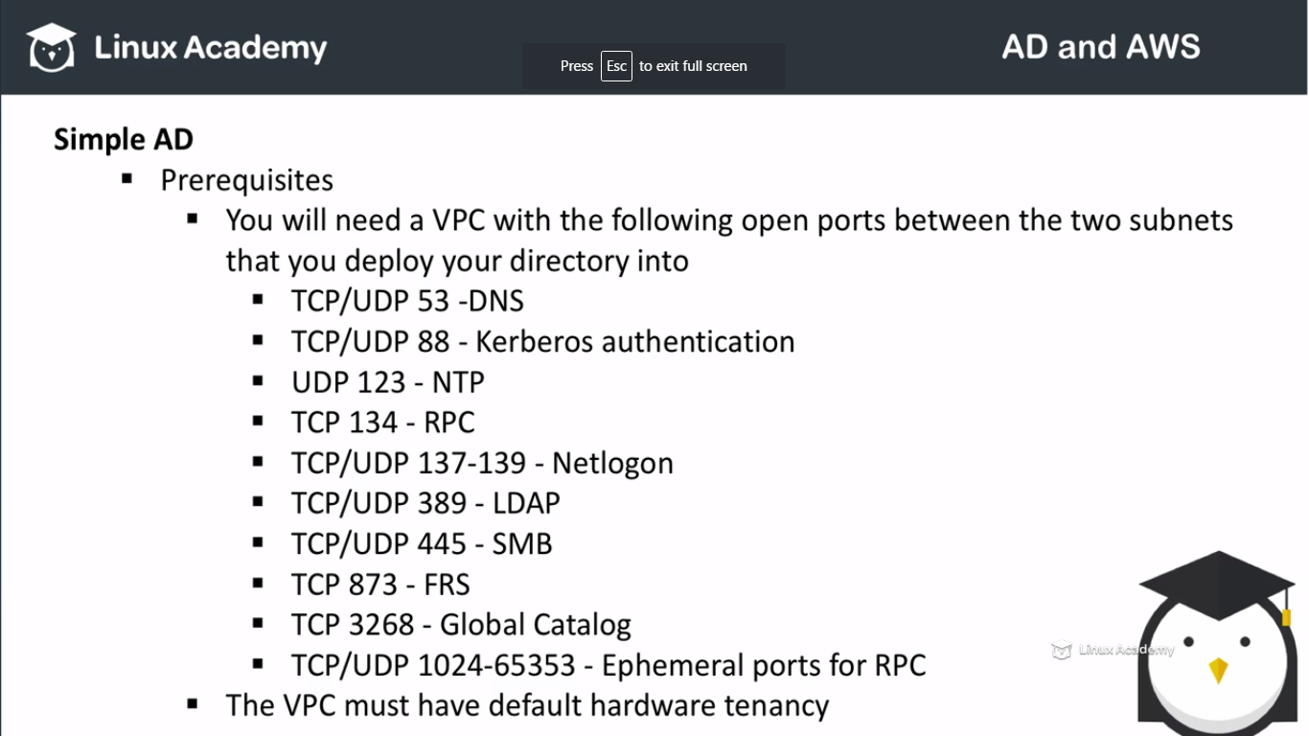

The AWS AD service creates 2 directory server and one DNS servers on our behalf. The directory servers are created in 2 different subnets in a VPC.

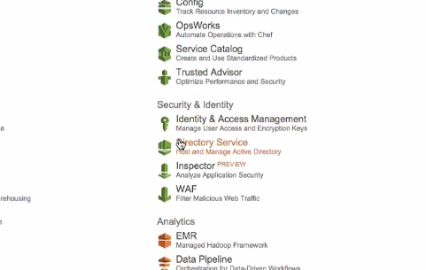

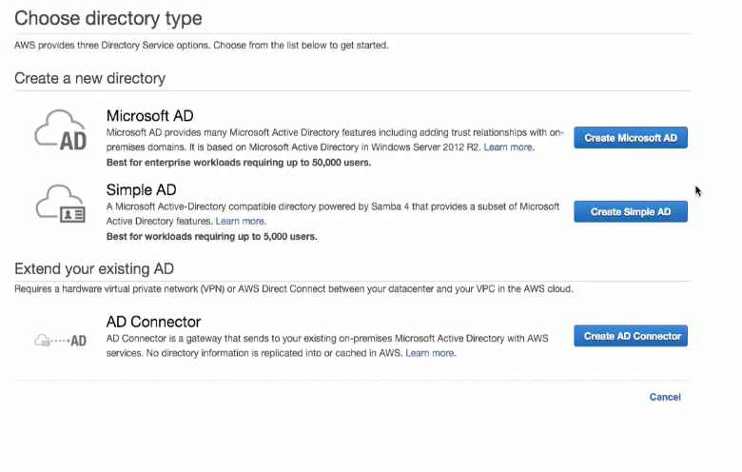

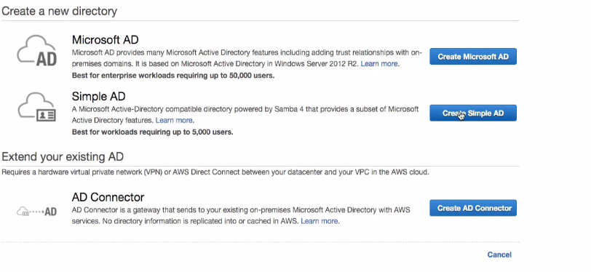

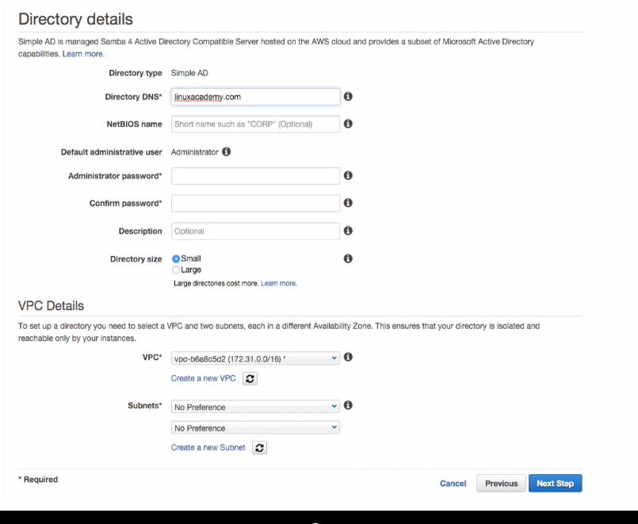

The DNS name is not the public url. This is the internal DNS name for our actual DNS for our AD using simple AD. The netBios name is the short name for our AD.

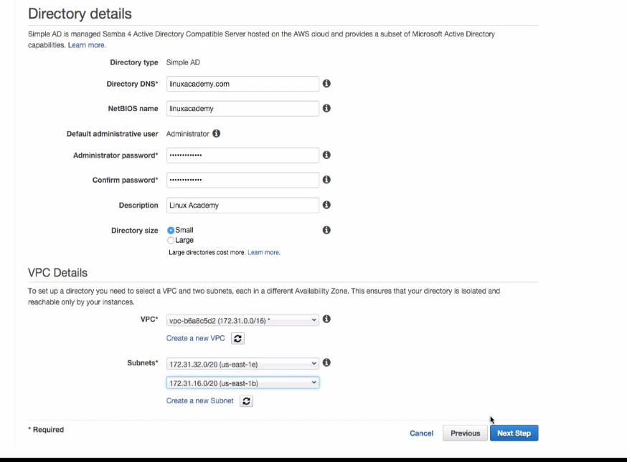

WE just used the default VPC and subnets.

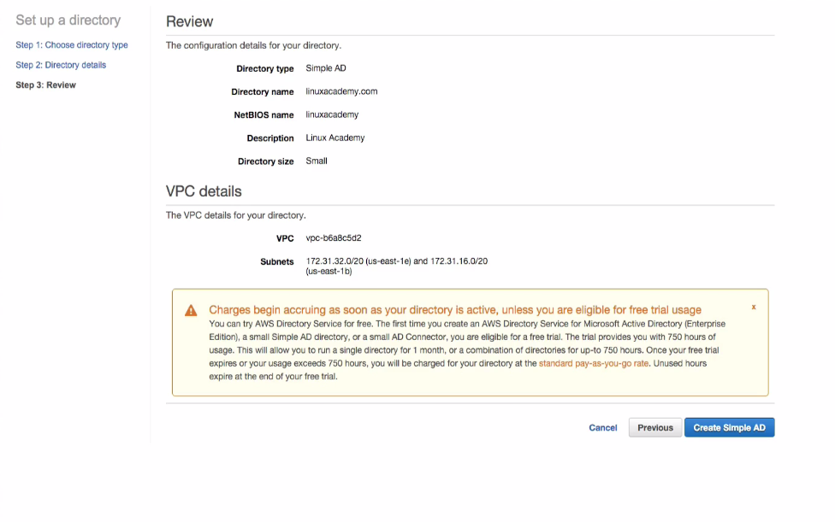

Make sure to save the password as AWS AD don’t give a password to be retrieved and even didn’t give a change to reset.

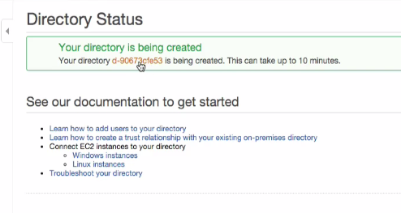

## Lecture: Setting up AWS Directory Service for MS AD

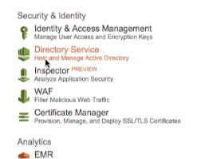

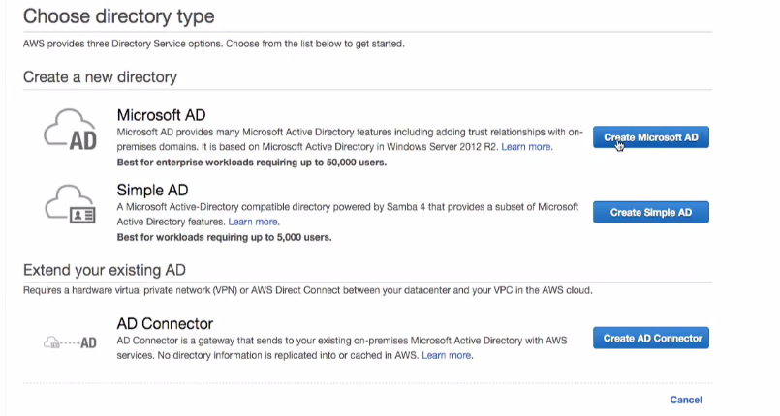

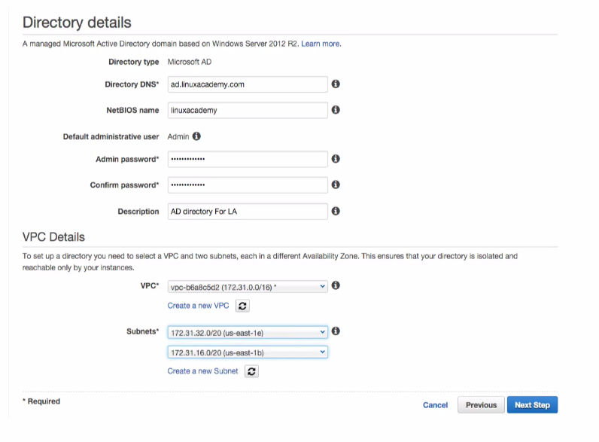

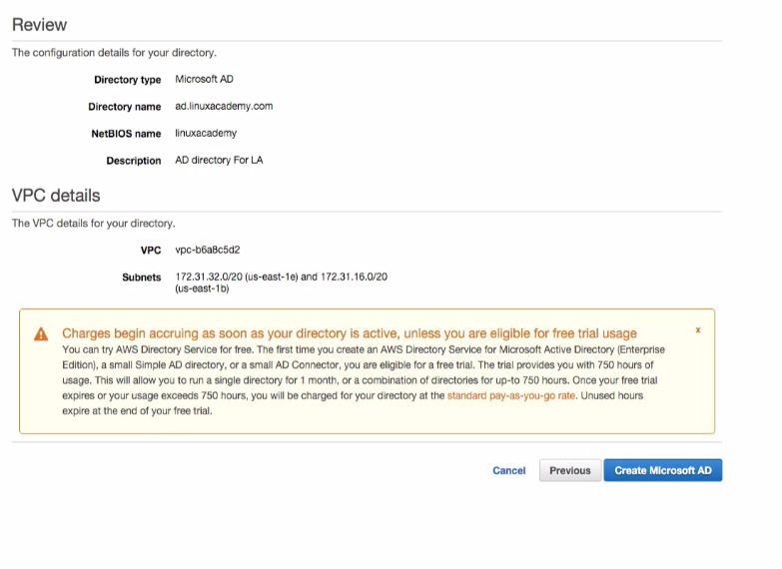

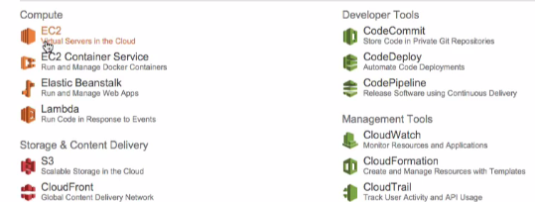

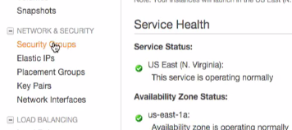

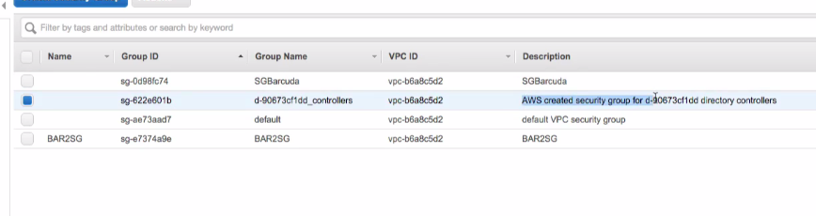

We see after some time the AD is in created state as

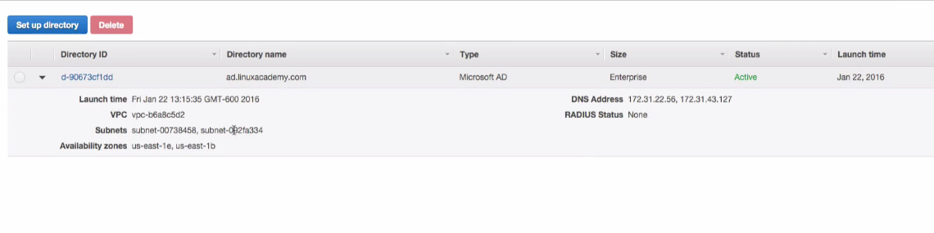

## Lecture: AD Connector

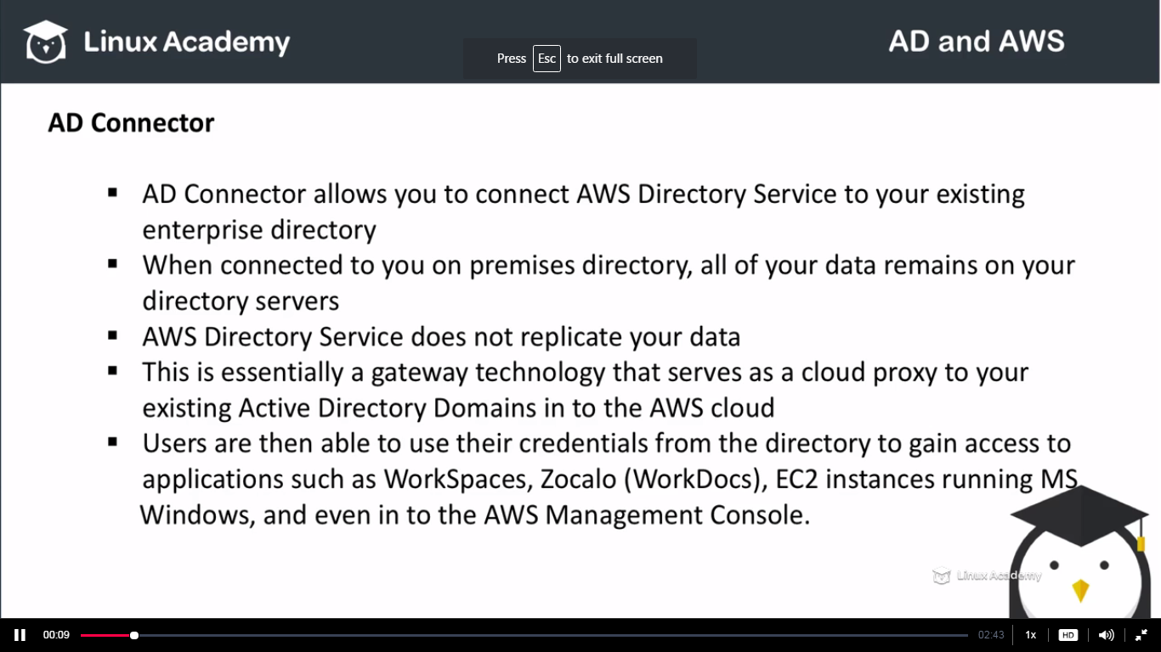

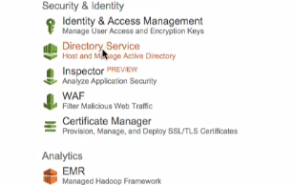

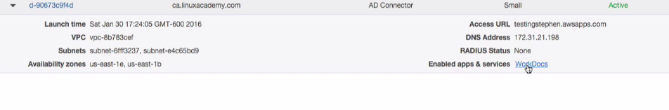

Lets give me an example of a AD connector and its functioning. See we have already have my own AD configured in our own premise Data Center in California. So I have enabled a vpn connection between my AD connector from AWS to the Data Center I have in California. This AD connector is just a proxy between the Aws and my on premise AD. I have enabled for an Aws service called Word Docs and I want to access it with the same credential which I have configured with the AD on my on premise DS. So inorder to do that I have used this AWS AD connector.

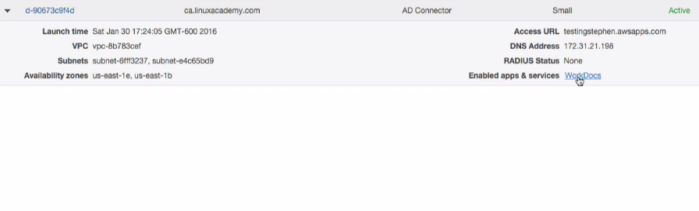

IF I click to the WordDocs as

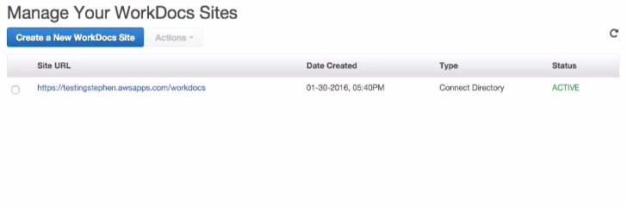

WE notice we have site URL setup. Clicking on it. Lets say I have a user administrator sitting on my AD in the on premise DS. So I signin here in the amazon Docs with my credentials which are sitting on the on premise data controllers in California AD.

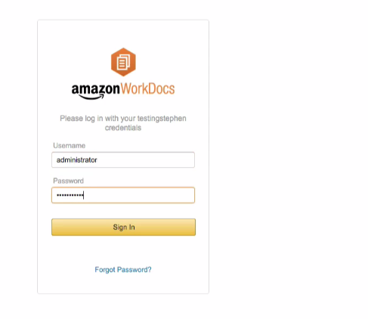

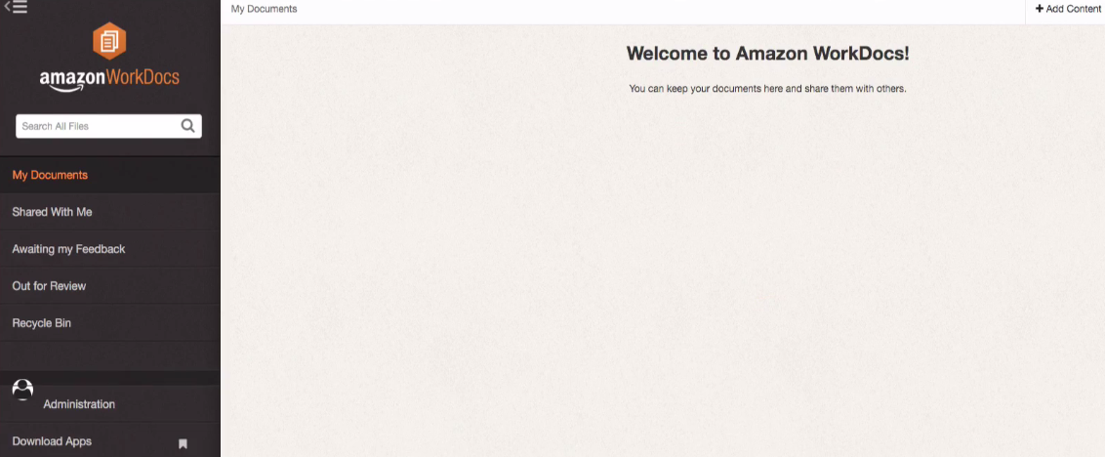

## Lecture: Limitations

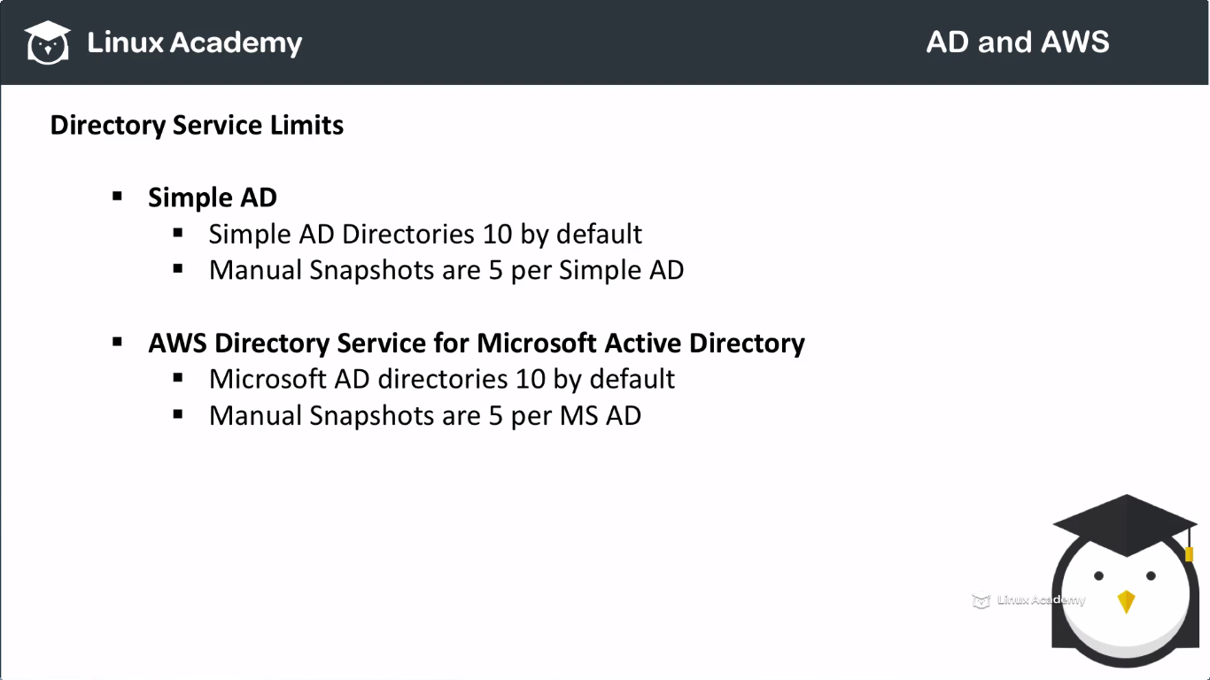

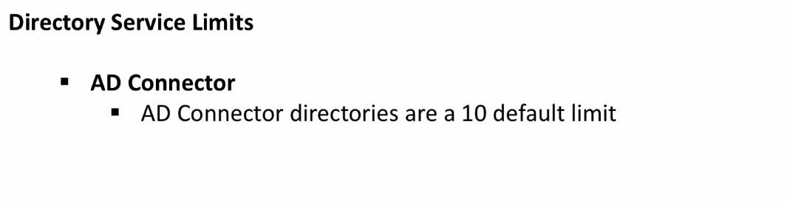

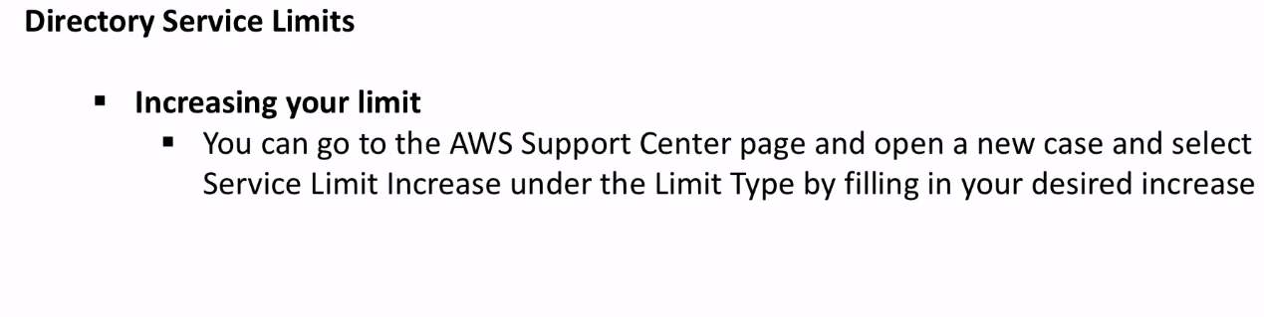

## Lecture: Prerequisites for Setting Up AWS Managed Domains IAM ROLES

This IAM role which we are creating or we have created here is what is going to allow Ec2 config service to communicate at the background with the AD service to allow our instances to add automatically seamlessly to the AD.

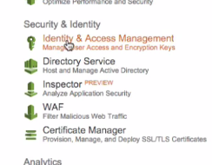

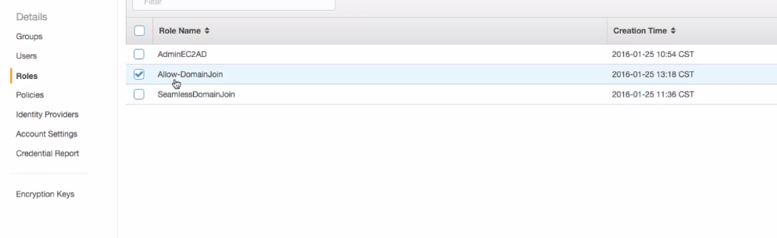

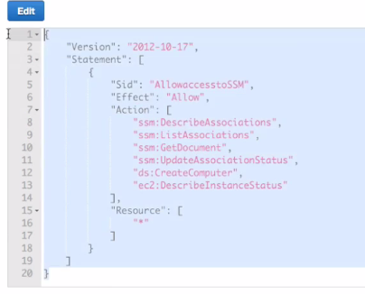

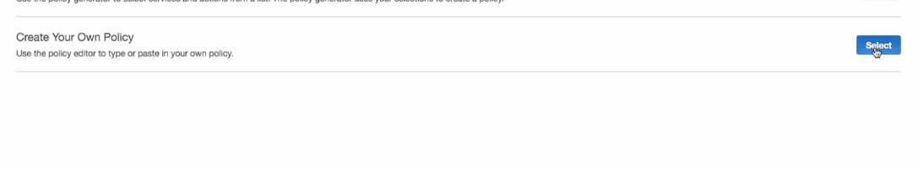

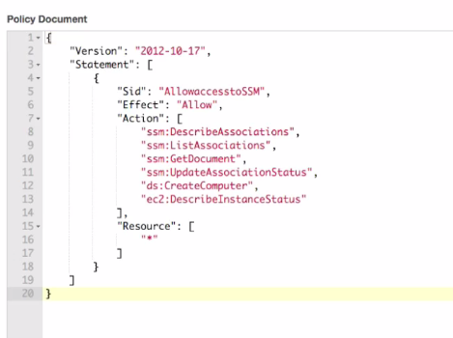

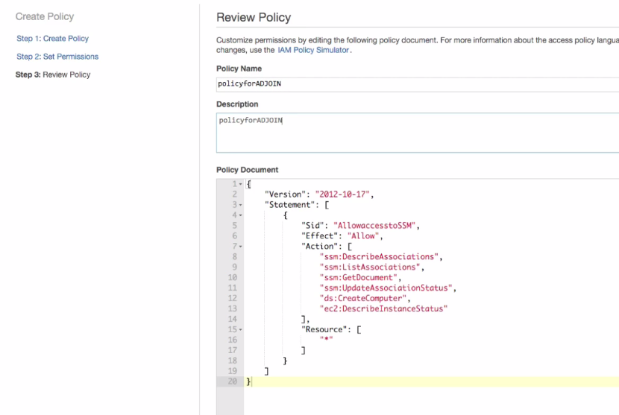

Create a new role.

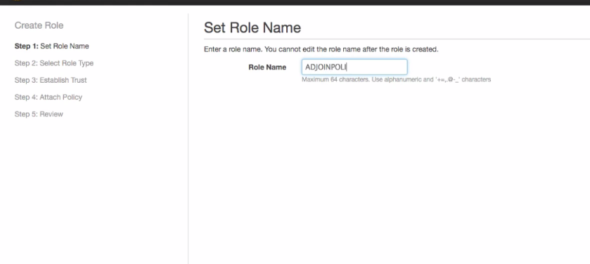

Select the amazon EC2

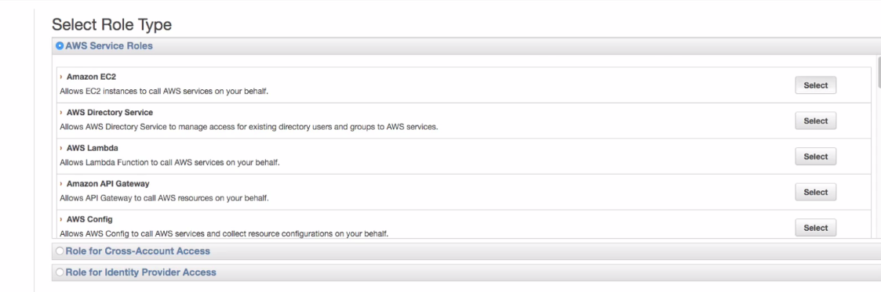

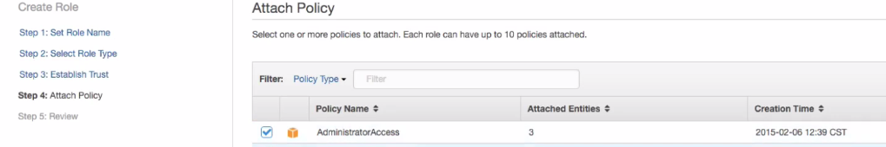

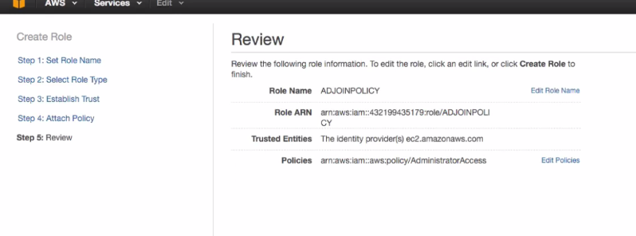

Now we need to attach the role the policy we created.

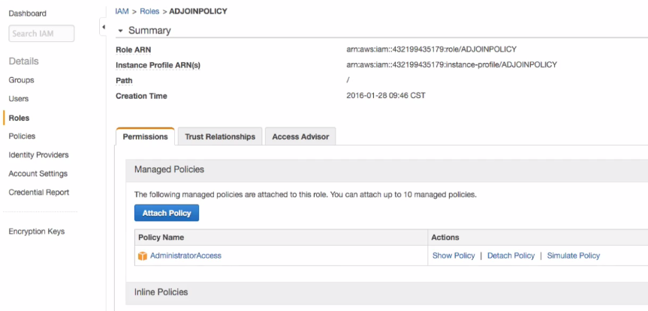

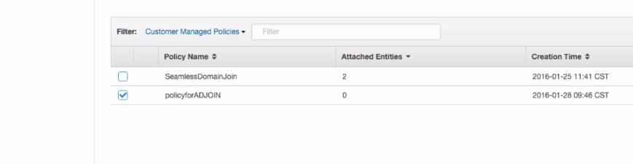

Attach it as above.

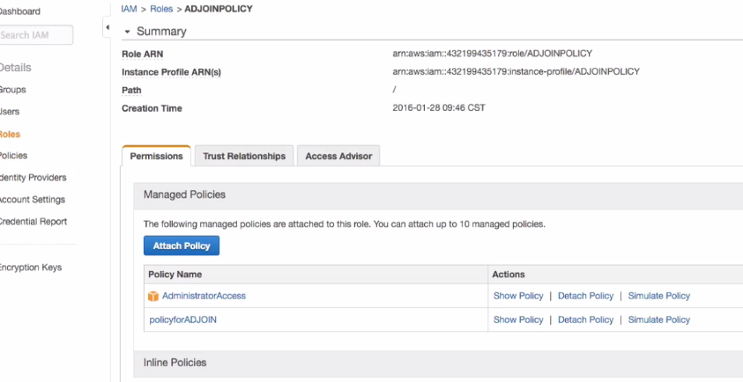

## Lecture: Prerequisites for Setting Up AWS Managed Domains DHCP Option Set

This is basically for when we spin up linux ec2 instances the DNS information will point to the domain controllers so that they can do actual references to the AD ie ad.linuxacademy.com domain in the example here.

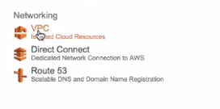

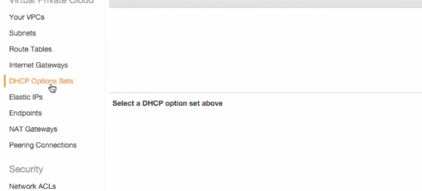

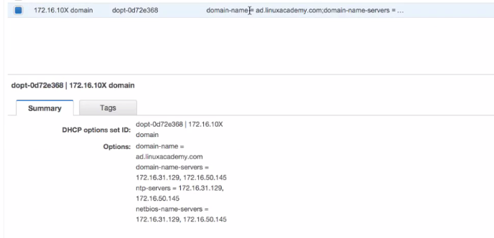

This is already created a DHCP set lets look what the options here are available. So domain name is the ad.linuxacademy.com and domain name servers are as

IF we go back to the directory service as

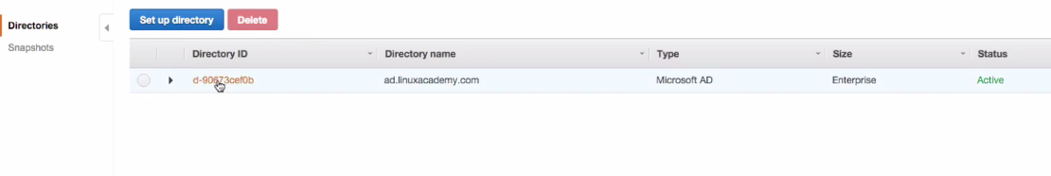

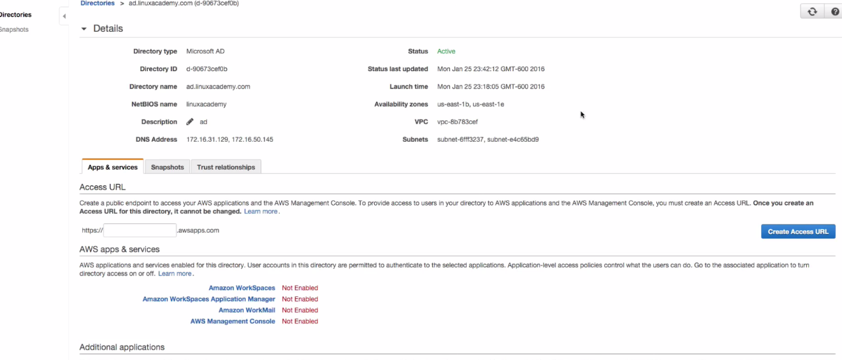

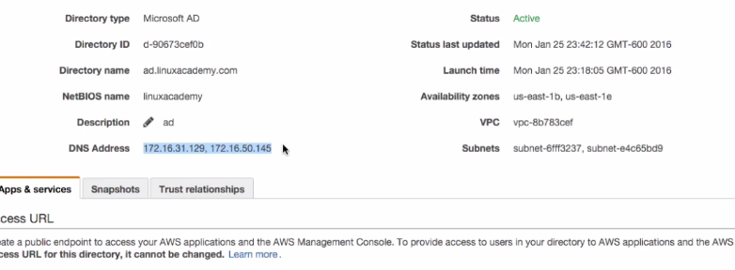

It will show the dns addresses which are basically the dns controllers in our active directory domain.

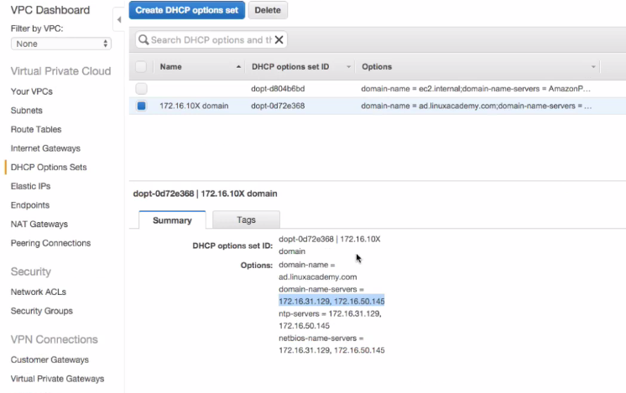

So lets see how we create the this dhcp set.

Go to create a new DHCP as

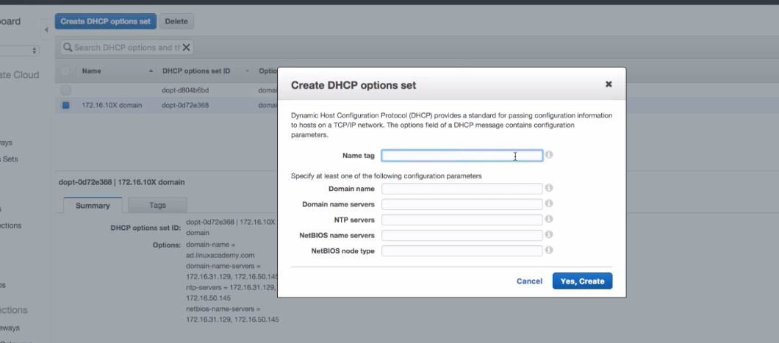

Here the name servers are the AD controllers and dns name is the same DNS name that we kept while creating the AD.

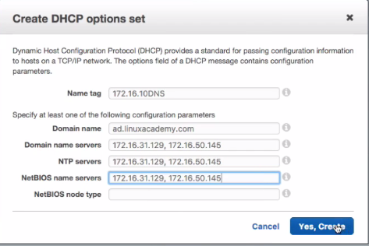

Once we have this dhcp option set created its very easy to assign it to the VPC that we want it to assign with.

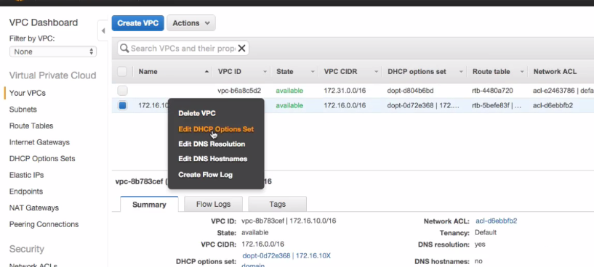

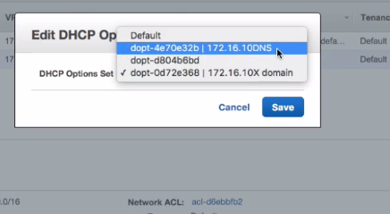

Select the third once which we created earlier.

So once you assign it you linux instances will be able to get the DNS information from those Ad servers that’s needed.

## Lecture: Simple AD and Microsoft AD Snapshots

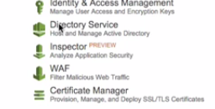

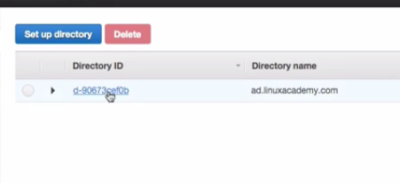

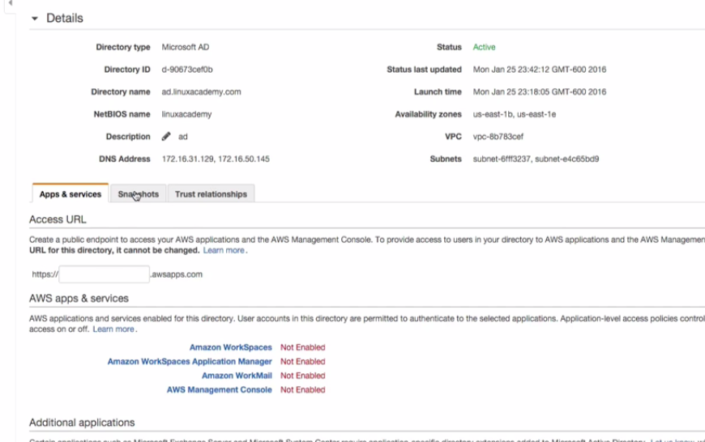

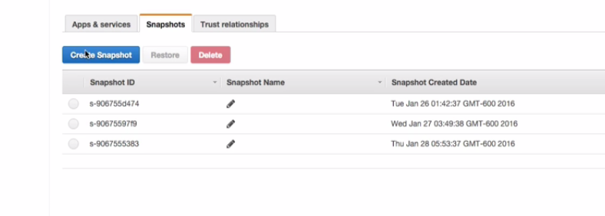

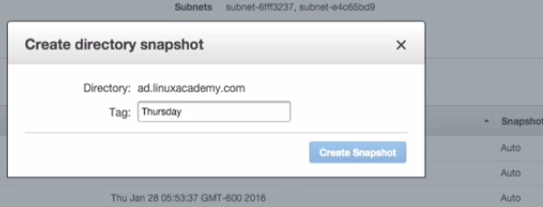

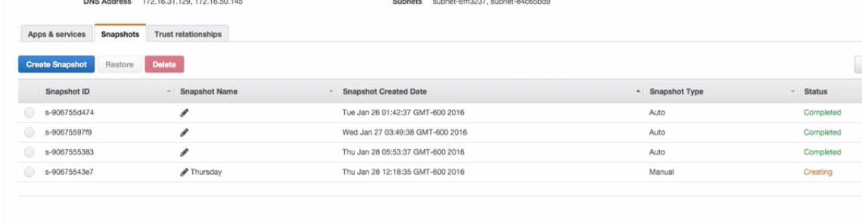

Now we can restore the AD from the snapshot. Just select the snapshot and click the restore button. We can delete the snapshot as well. Just select the snapshot and click the delete option.

## Lecture: Creating An Active Directory EC2 Instance With CloudFormation

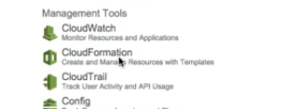

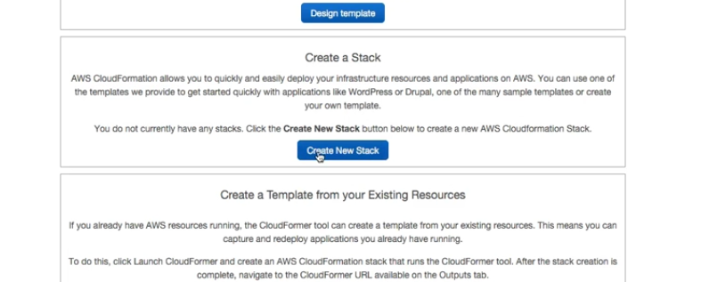

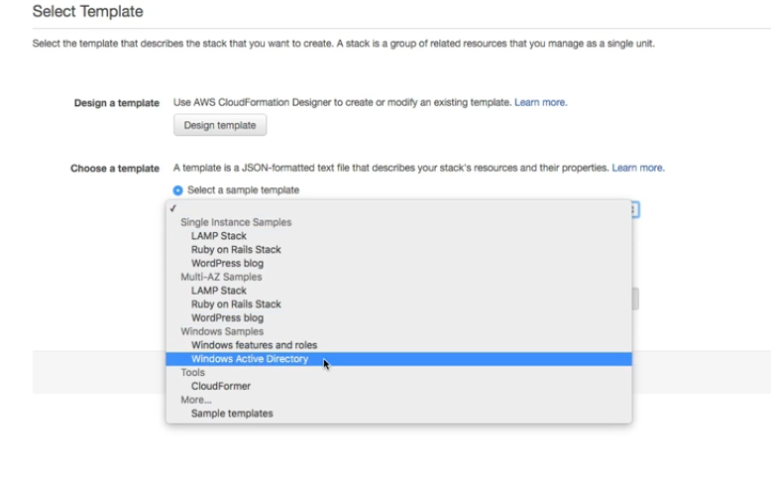

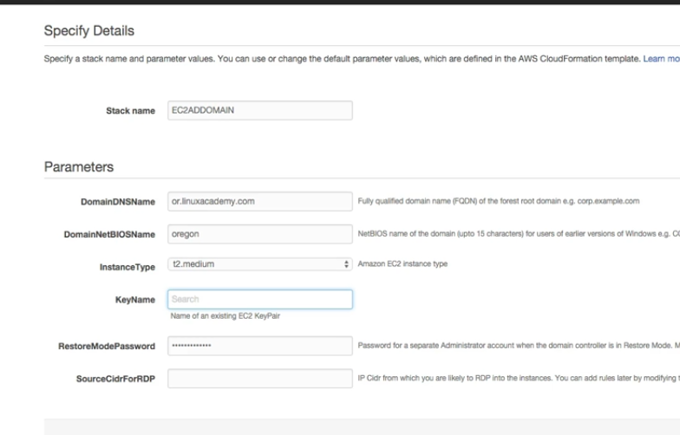

Open a new tab and create a new key pair from the ec2 service.

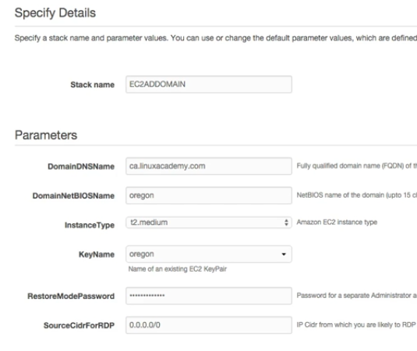

We have given 0000 as CIDR range as we want everyone to RDP into it, however you can give something else too.

Press create

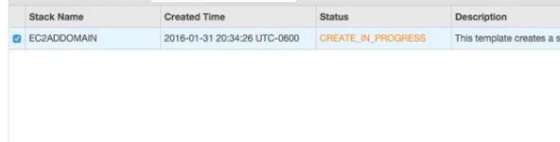

Lets connect to the ec2 instance which is our domain controller.

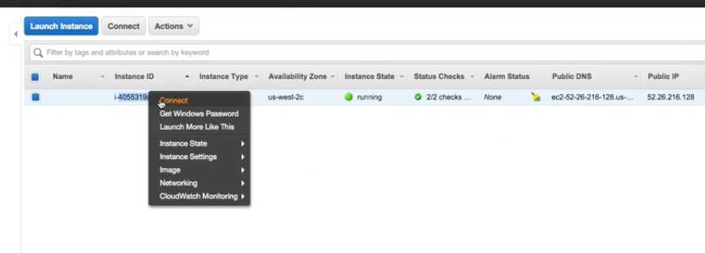

c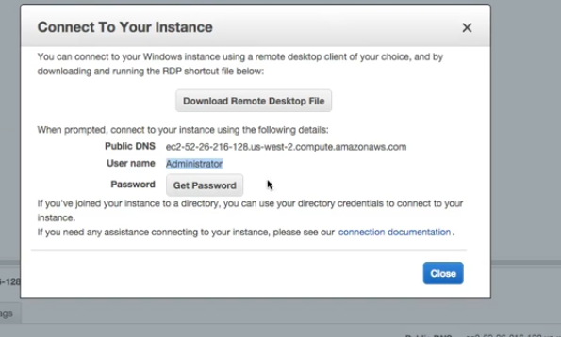

Paste the content of the pem file which we created before creating the instance from the cloud formation stack.

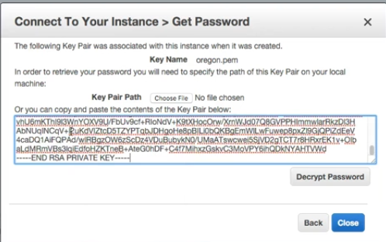

So decript the password and copy it.

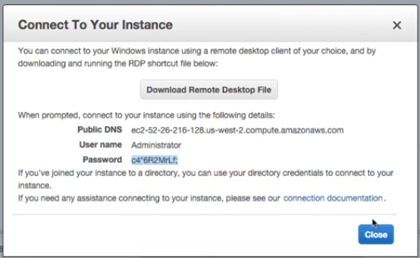

Open mstsc for rdp

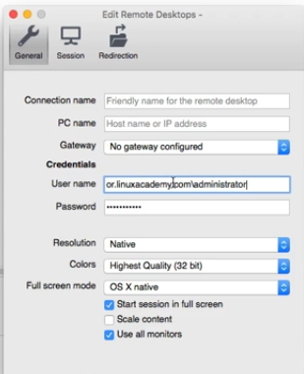

And then copy the public ip of the instance.

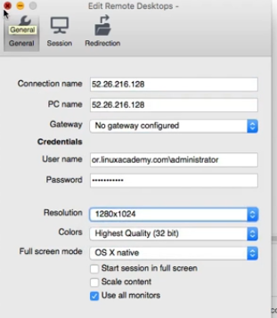

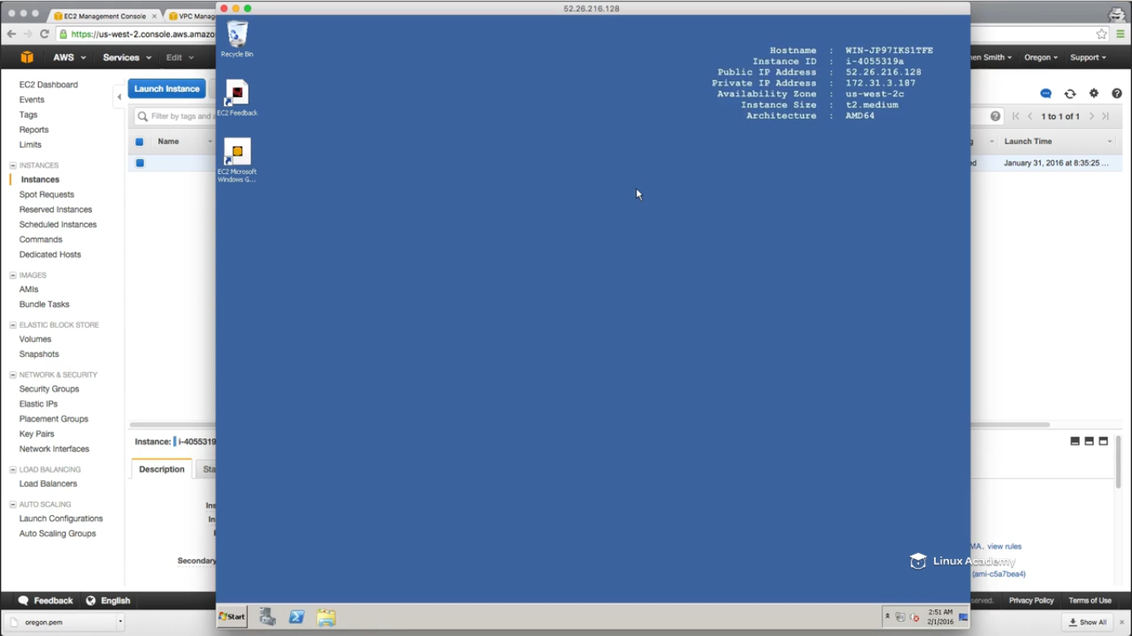

Lets open users and computers by searching from the start button of the AD.

Lets create a new user

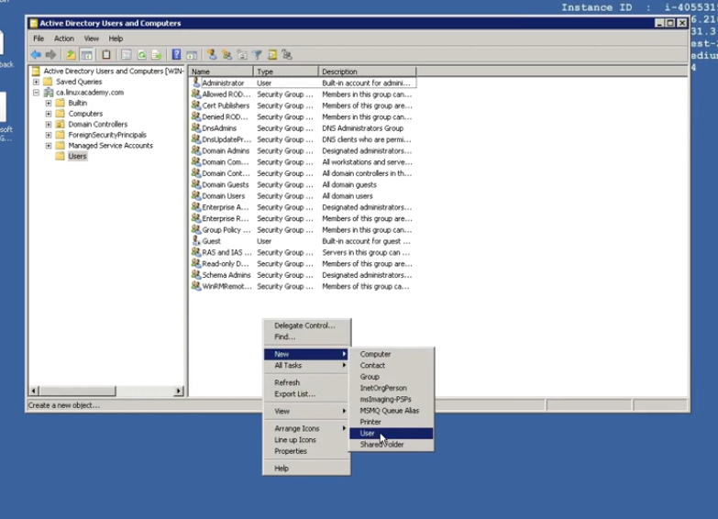

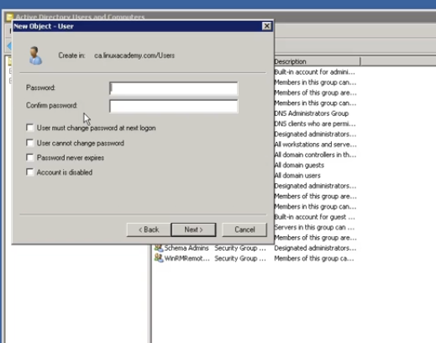

We can create the domain admin as well by clicking on the domain admins as

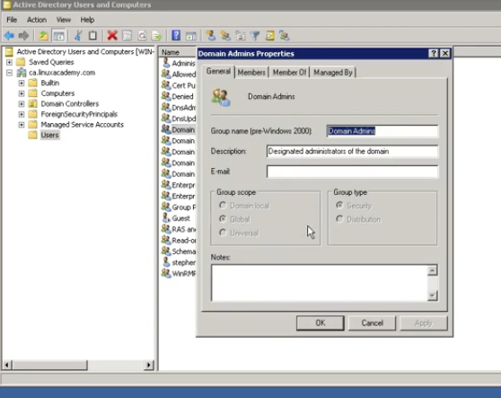

IF I want to add myself go to members.

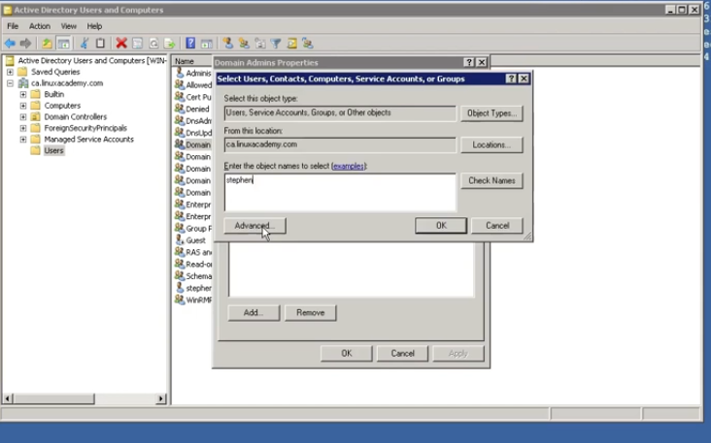

Add you name as above to the member list.

We can however go to the manage service account as

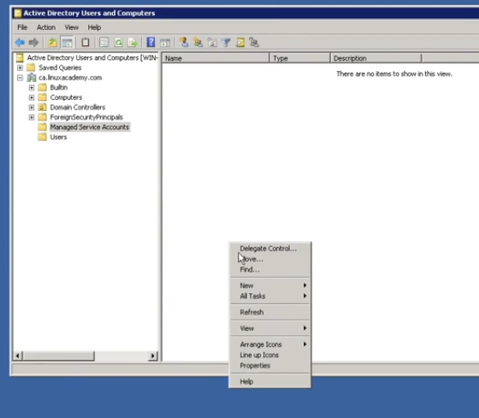

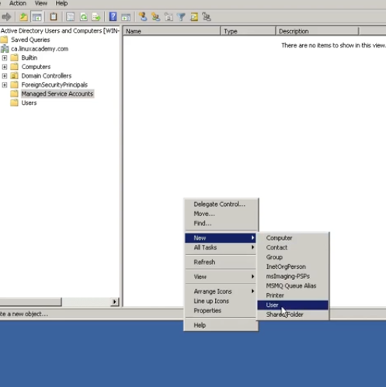

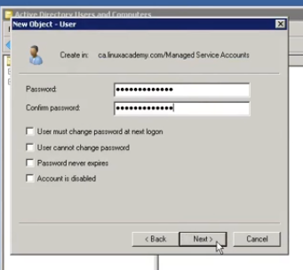

We will be using this connector in the later section to actually bind this domain from across regions. Rather then going ahead and setting up from the ground up an ec2 windows instance and then promoting that ec2 instance into an active directory domain controller, as you can see using cloudformation template we can get one spun up for us quickly.

### Using the Directory

## Lecture: Seamlessly Join EC2 Instance to the Domain (Simple AD & AWS AD) Windows

We remember we have set up ad.linuxacademy.com AD earlier in the previous lecture.

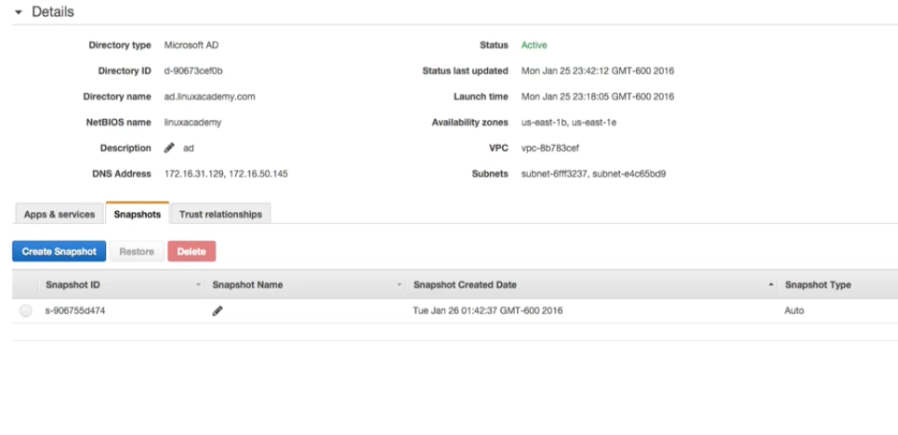

We have learned about OU’s(Organization units) earlier that are basically containers that distribute different objects of our active directory environment. So for example we have users account which has a admin account which we are actually using to manage this active directory account.

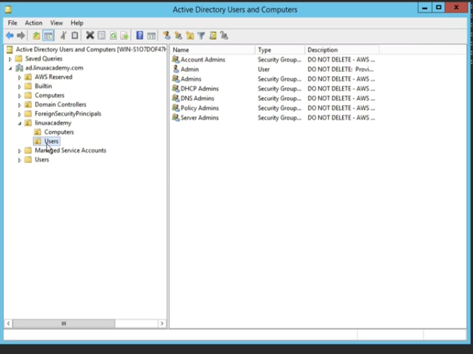

Also if I have go to the computers section on the left on this AD server, there are two servers which are already added to the domain

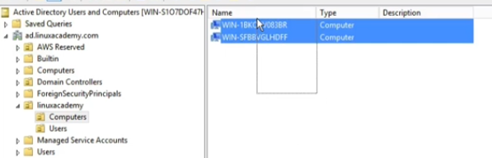

Out of these two servers on one I’am already logged in as a admin user which we have created on the users section of the AD account. So I’am able to loggin with the admin user to this server which is added to the computer section of the AD domain controller. Similarly we will add one more server to the AD and then we will understand as how we are able to access the new server which we are about launch will authenticate the access to the instance from this AD server. We will add the newly launched instance which are about to launch to the AD and the access to this would be launced server is done through the ad.lnuxacademy.com AD server.

We will launch a instance and will se how easy is it to connect this instance to the AD.

One thing importance is the SG. We know when we create the AD from AWs on the default VPC then the amazon creates one default Sg for the AD itself which has all the rules configured for the AD.

I have created a default SG with the below rules as

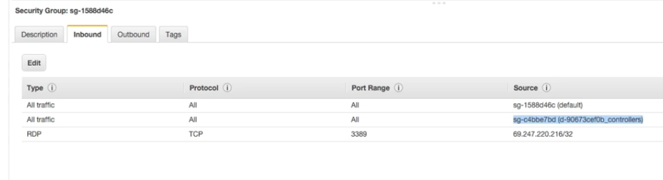

What is done here is that I have allowed all the traffic from the sg of the AD to this SG. Below is the AD SG

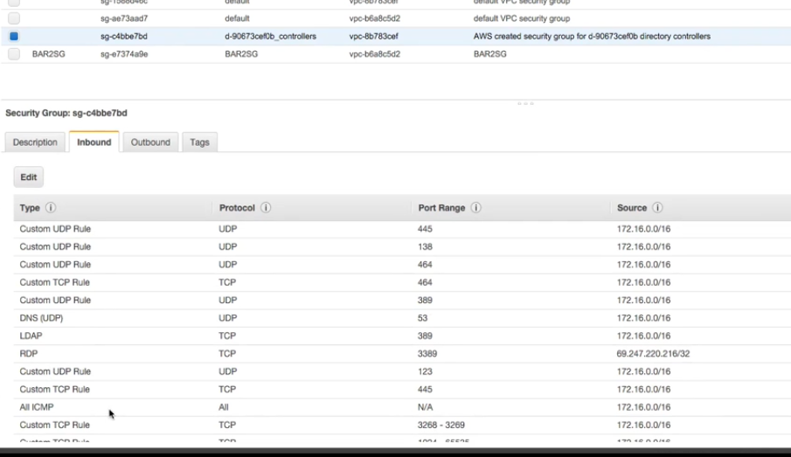

Also I have added the traffic from this default SG which I have created to the AD’ s SG as below

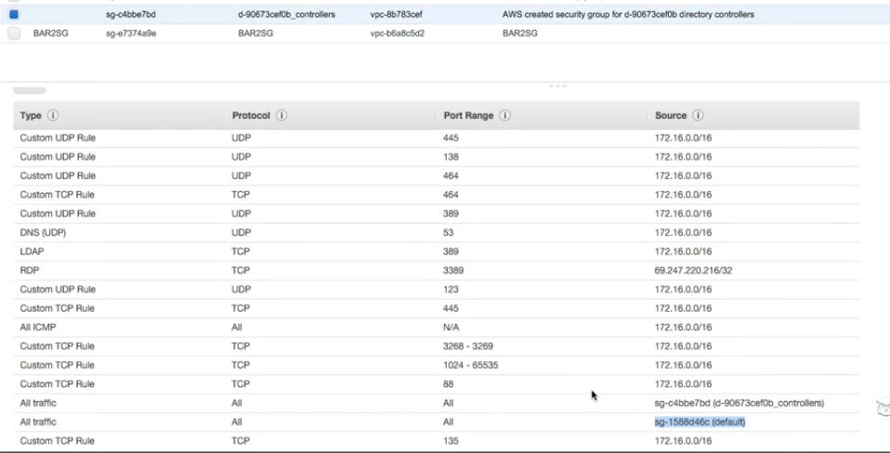

This setting is done so that the new instance we are created would be able to get connected to the AD and there can be proper communication between them.

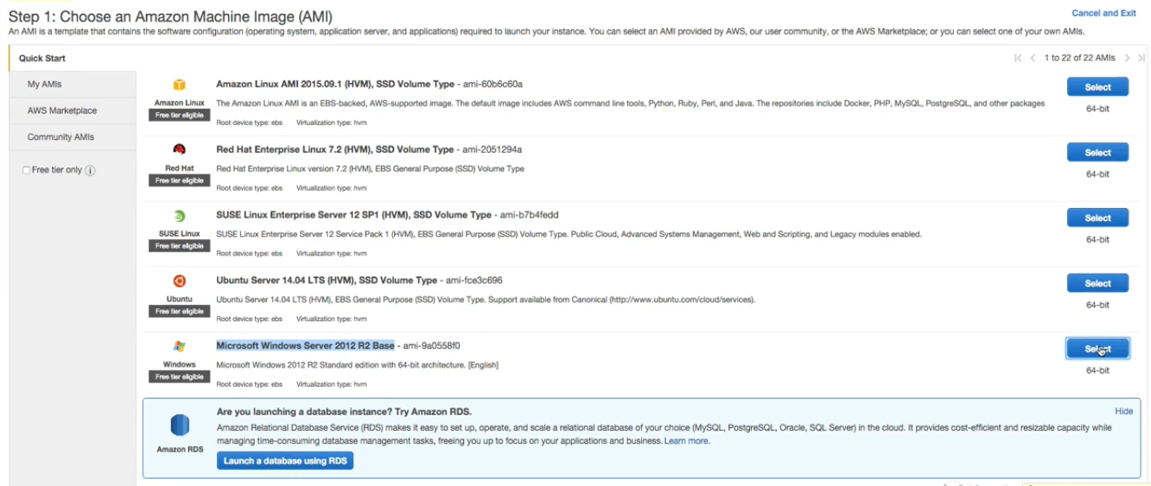

Select t2 micro. Select VPC the same on which we have our AD. Make sure you enable public Ip as this is required to do the RDP.

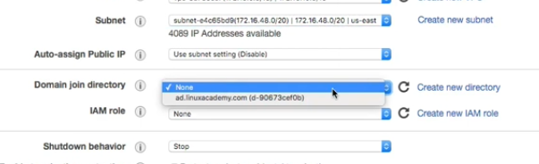

Further the IAM role which we gave to the Ec2 as well as Ec2 config, this gives the right that it needs to actually add itself ec2 windows instance to the active directory domain. We have set this in our previous lessons which we have given the name the allow domain join. WE have created this role earlier which we are using now.

Now click next and add storage which is default.

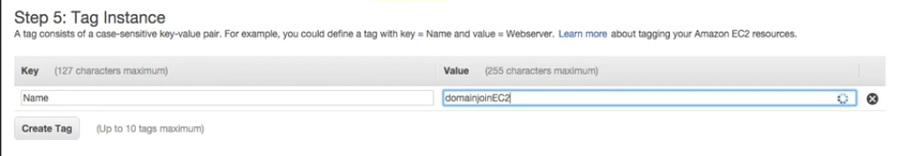

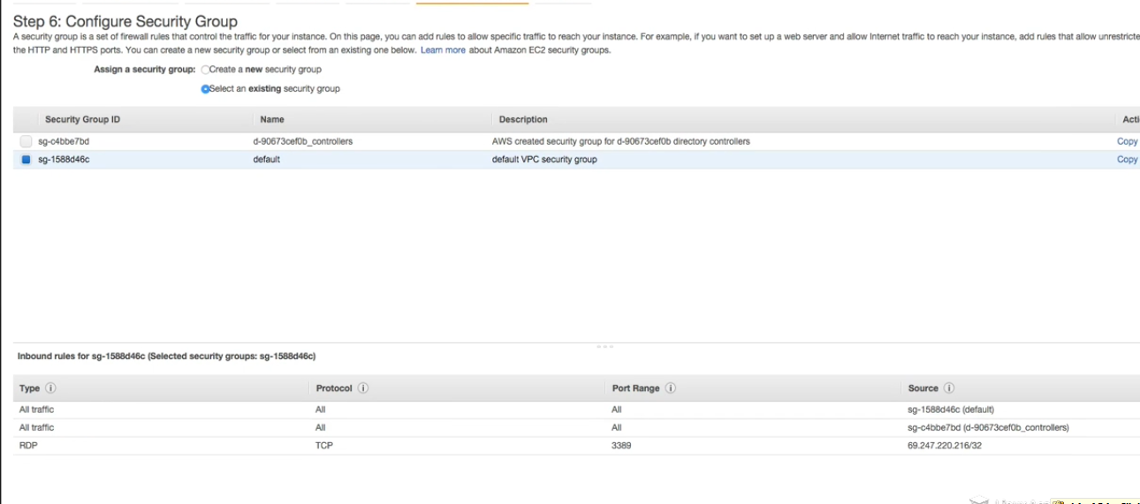

Attach the SG which we created as default and which allows traffic from the AD controller.

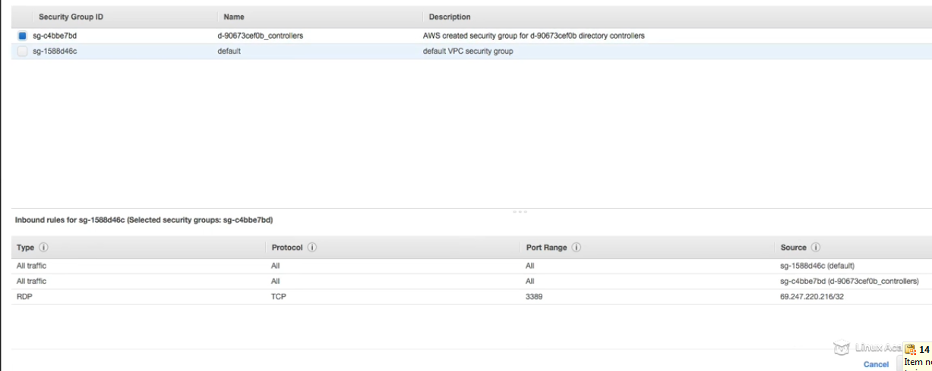



I have allowed the EDP from system’s IP so that I can rdp it from my system so now launch this instance.

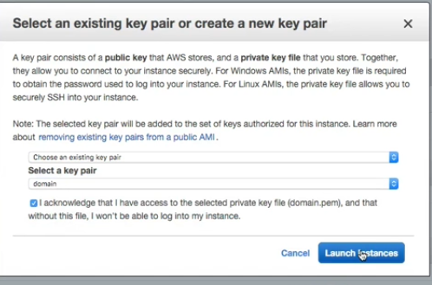

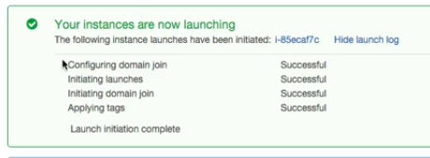

This instance is launching in the background and using the EC2 config service and its automatically adding this windows instance to the AD for us.

WE can see the system log if it shows something like its joining to the domain successfully or not.

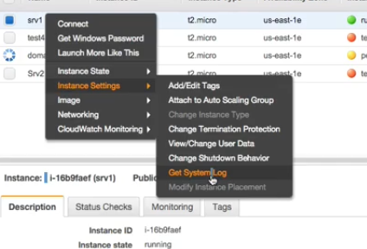

It may take some time for the logs to display.

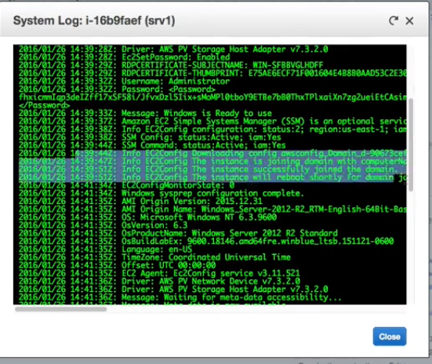

So lets now RDP to this brand new windows server.

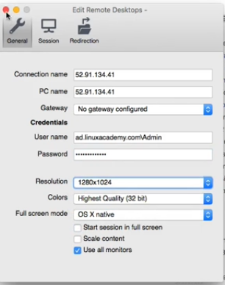

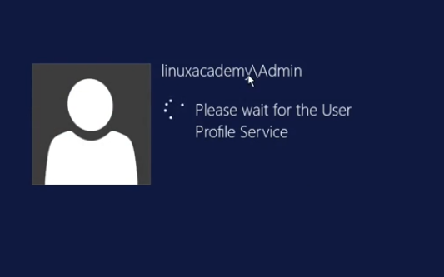

This is the default use which we set up while creating the AD. We are logging into the new server using the Simple AD as an authenticator.

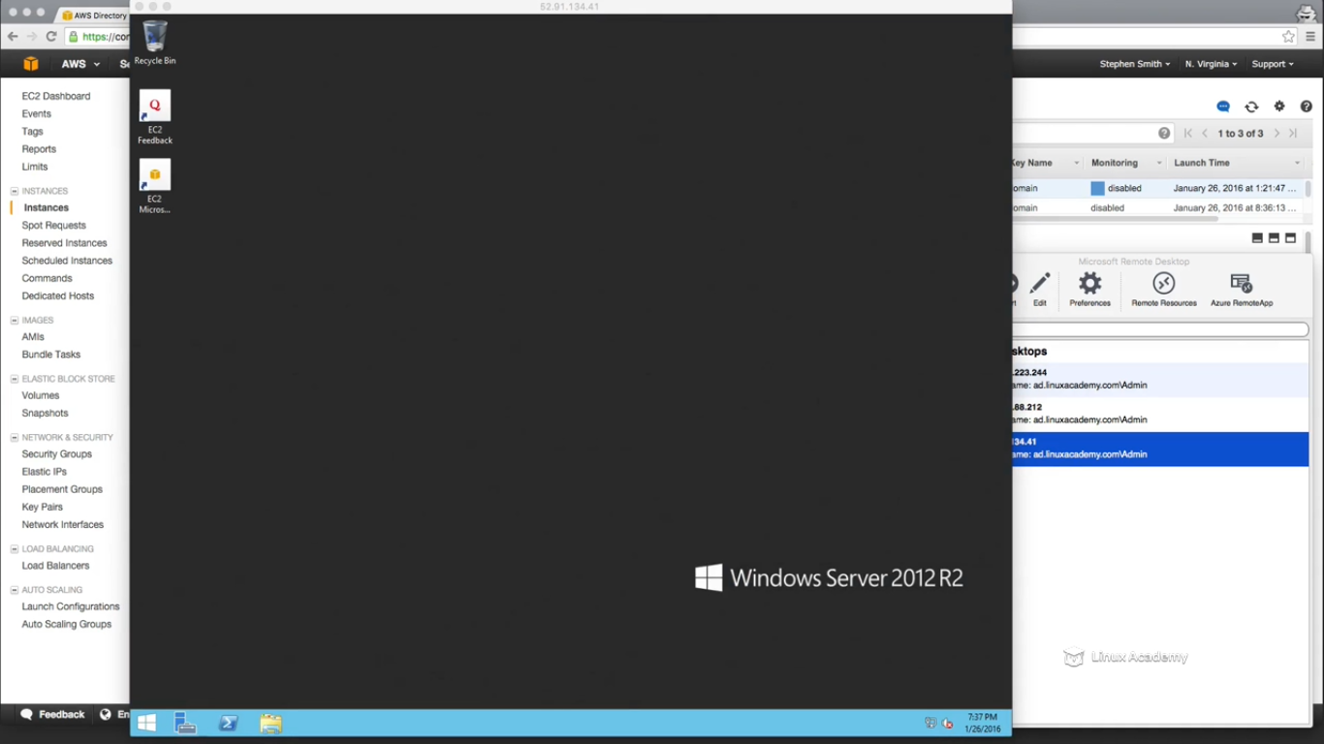

WE can verify if it’s the part of the domain.

So to the server manager on the tab down near to the start button

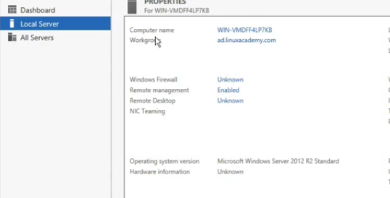

Also go to the AD server and under computer see the new windows instance in there too.

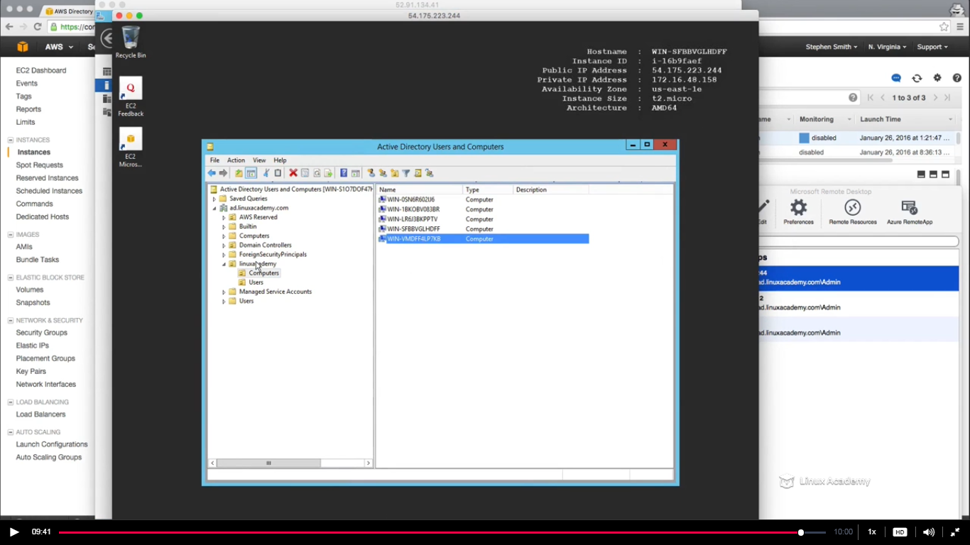

## Lecture: Manually Join EC2 Instance to the Domain (Simple AD & AWS AD) Windows

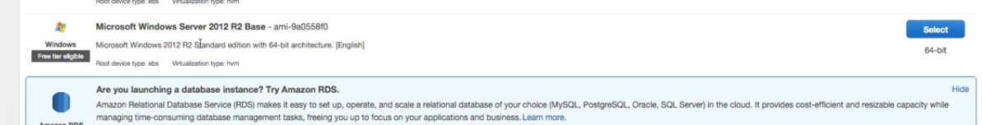

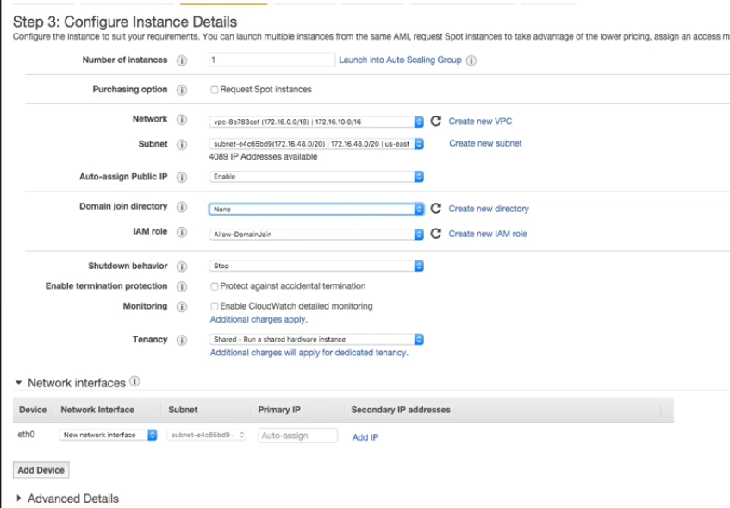

This time we left the option of automatic join to the directory, rest configuration are the same as of the previous chapter.

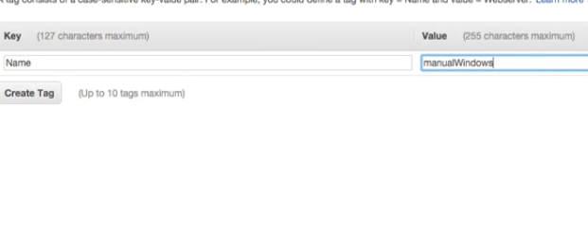

Choose the same SG as was in the previous lecture the default SG.

And launch the instance.

Click to connect the instance and give the pem key inorder to decript the password to login into the windows instacnce.

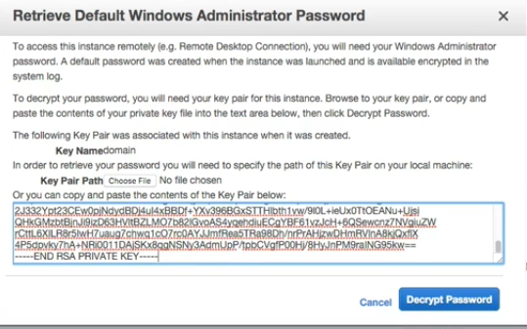

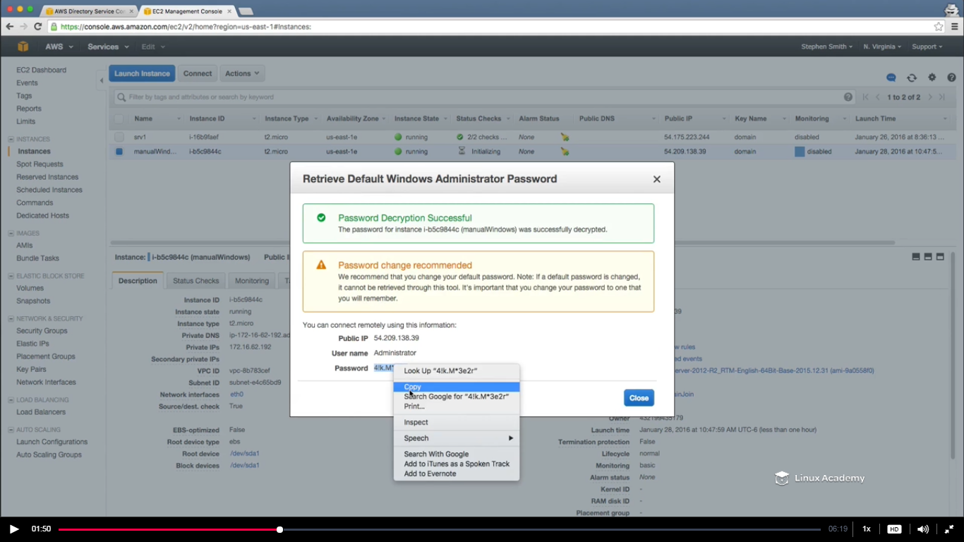

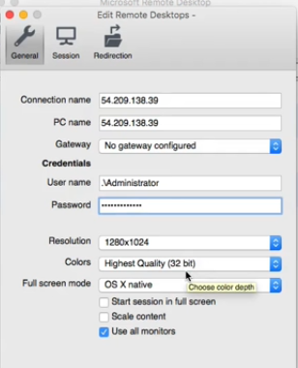

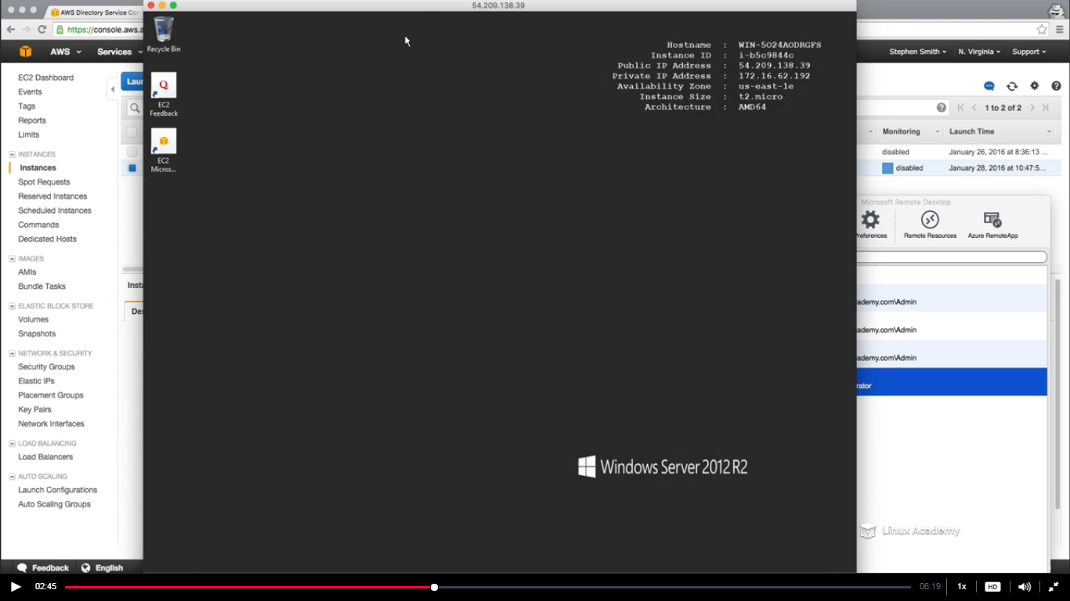

WE logged in the windows instance. Remember earlier we set up a DHCP option set so that the instances within our VPC automatically get the DNS server or in order words our domain controllers so that they can do name resolution for our domain. So since we are a DHCP option set , lets double check to make sure that are our DNS servers are in fact the domain controllers of our active directory domain.

So goto cmd here in this windows server we are logged in

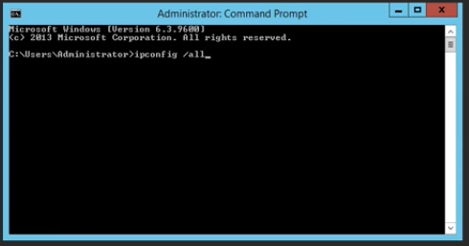

Lets see what the primary dns servers are

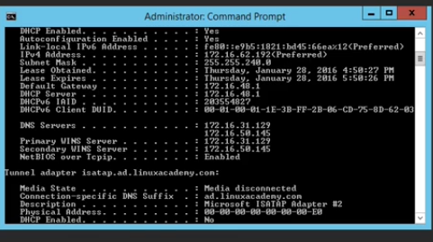

They are 31.129 and 50.145. So back to DNS service

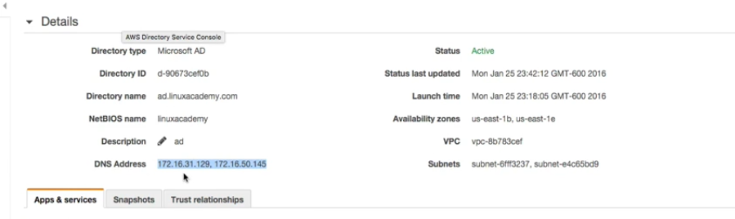

And we see the same servers our DNS servers in this windows instance. So the next task is to resolve the ad.linuxacademy.com to those ip address. So if I ping ad.linuxacademy.com I must get one of the two ip addressed mentioned above

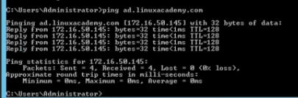

So we are getting the 50.145 ip. Now we have to bind this windows instance into the AD domain.

So click the server manager icon below near the start button.

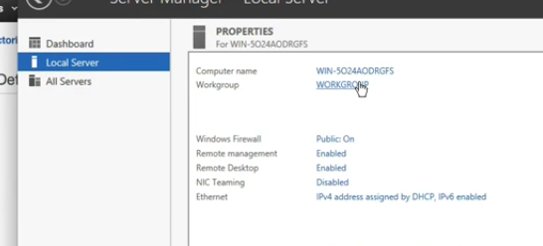

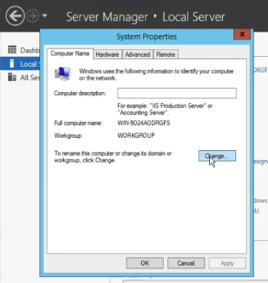

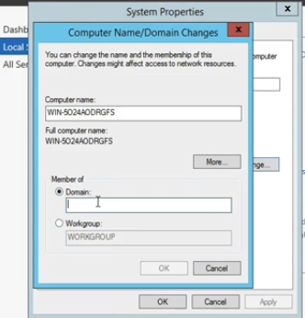

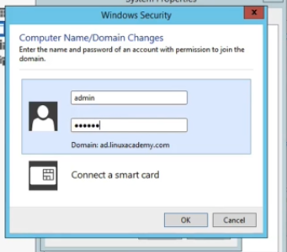

Give the name and password that we gave during the setup of AD.

Once that is done it will show the below

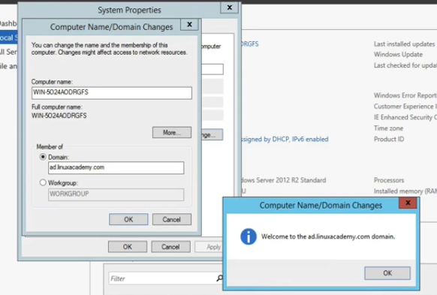

Click ok

It will ask for a restart

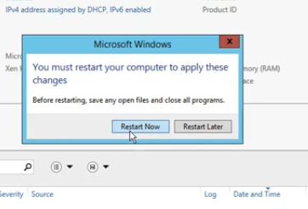

Our Ec2 windows instance will restart and will append on restarting and will join the AD domain.

Now once its restarted I can login with the user and password of the admin that we gave while the AD setup.

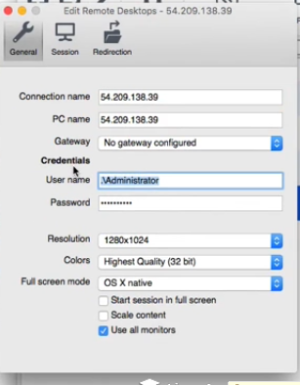

Replace the username and password of this instance which we gave before the binding to the new one of the AD domain username and password as

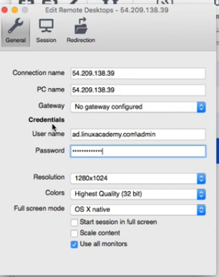

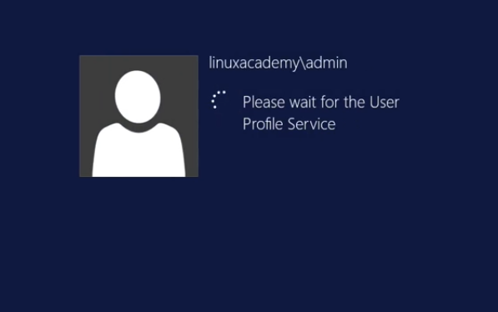

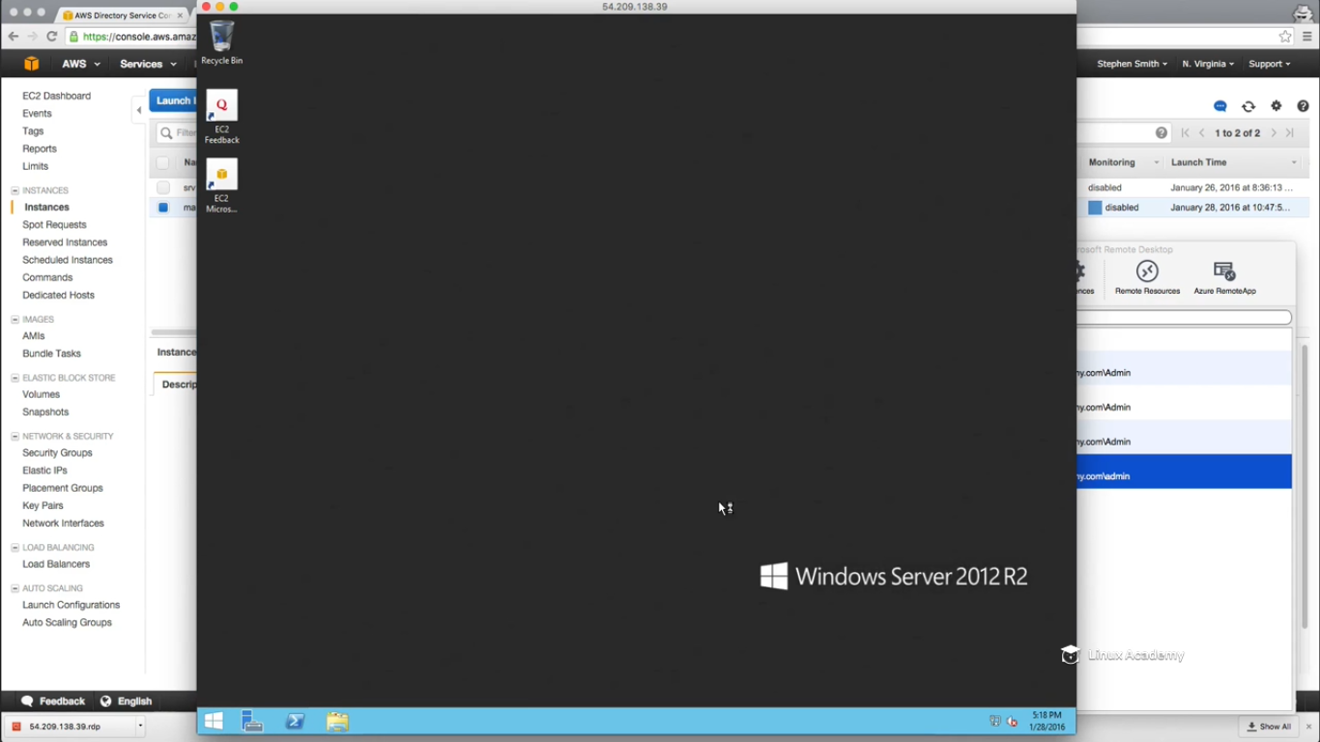

So we are now logged on the windows instance after manually adding it to the active directory domain. This time if we go to the local server manager it will show the domain ad.linuxacademy.com instead of the workgroup.

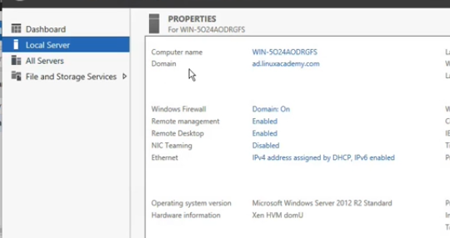

And this was how we add manually a windows machine to the active directory domain.

## Lecture: Add Users and Groups with Simple AD and Microsoft AD

First login into one of the windows instance which is already joined to the AD domain. So After logged in to the server head to the server manager. **This is actually how you add the snap on**. Go to roles and add features.

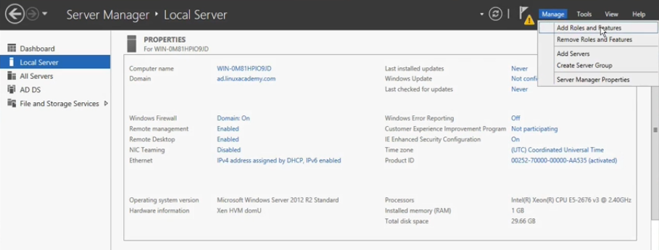

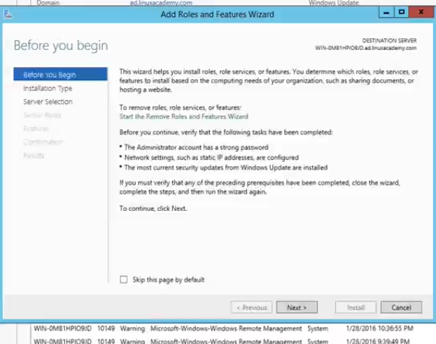

Press next.

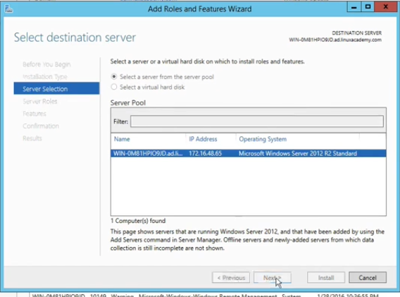

Hit next on the local server.

Make sure the AD domain service is installed as

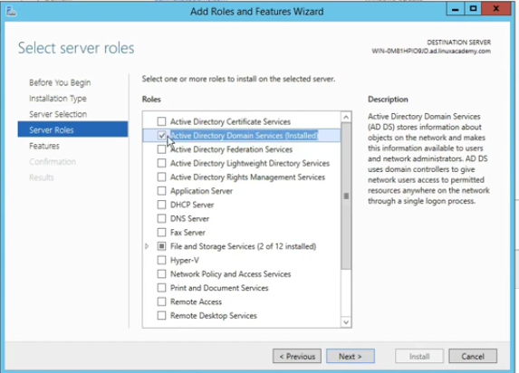

Check and click next

And then drop down and make sure

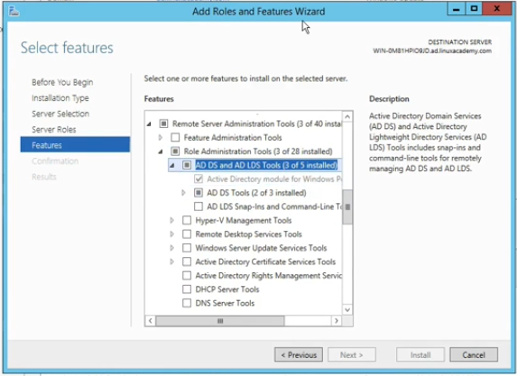

Here then u can press next to get things installed. For me that section is disabled as mine things are already installed. For you press next and make things installed.

So lets now show u how to access the installed once that is installed. At this point if you search for users and groups on the windows instance you are in

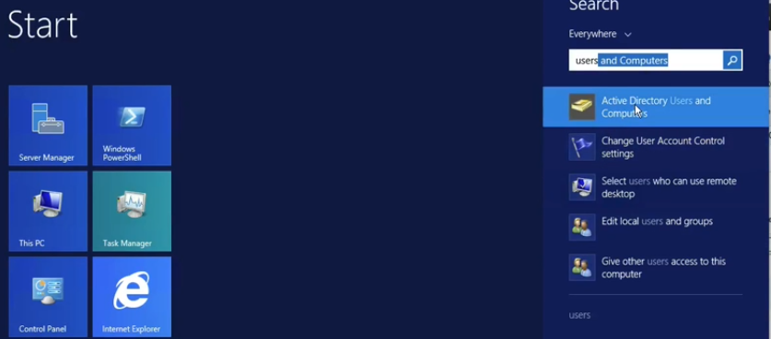

You will see active directory users and computers.



Click on it.

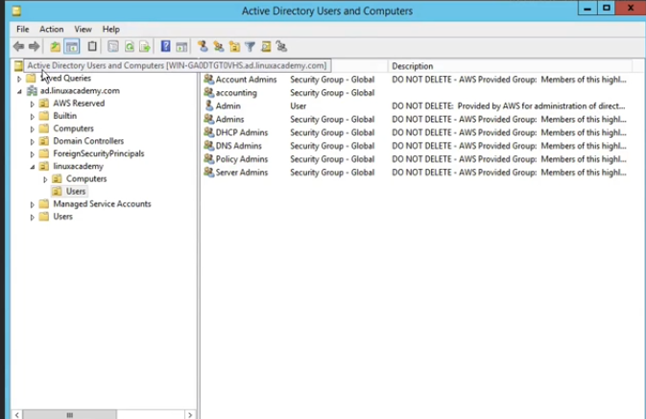

You will notice that we have active directory for the domain of the ad.linuxacademy.com in my example. We have OU’s . The first OU we are concerned with is the linuxacademy OU. This is where the AWS manages the users and computers that we will manage within our domain. IF we go to the computers we see one computer and that is where im now.

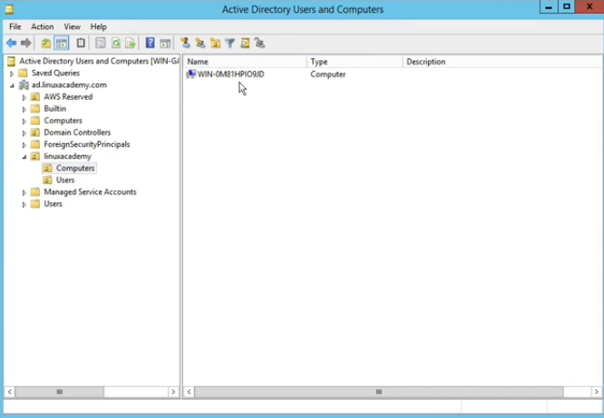

And under users I have the admin account that we have been using so far to administer this domain.

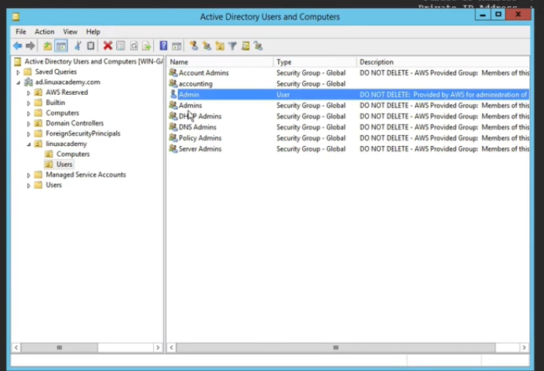

Now we have the ability to add our own users and groups to this particular domain that is being managed by the active directory in AWS. IF we right click

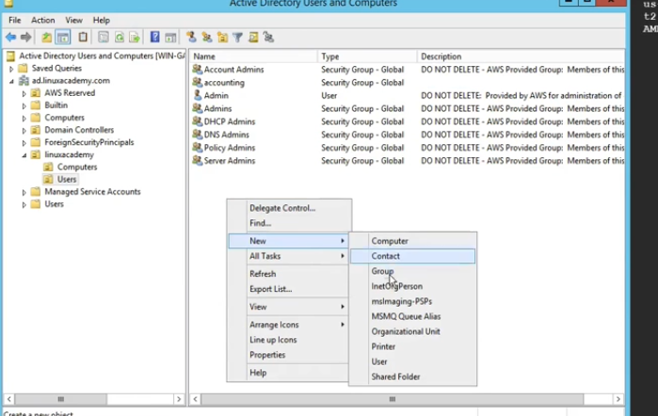

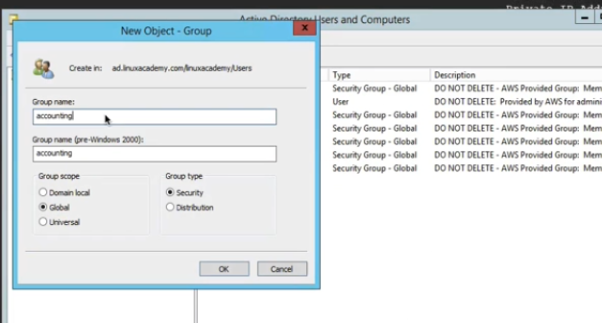

WE can have users to this group now. Right click

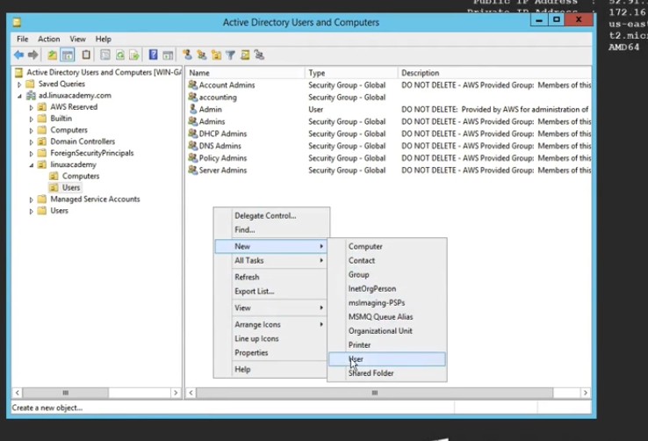

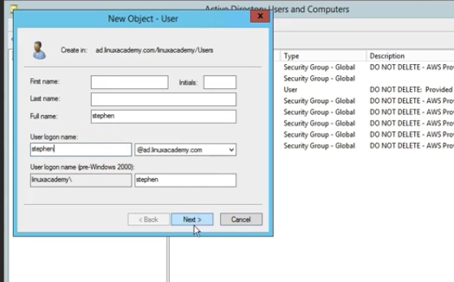

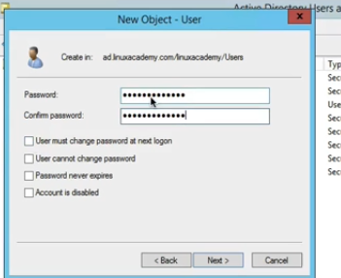

Hit finish.

Now we have a new user Stephen and we want to add him to the account admins

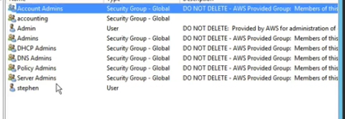

I can do that so for that right click

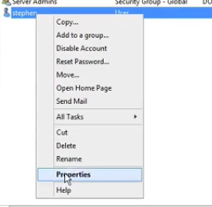

Go to member of and hit add

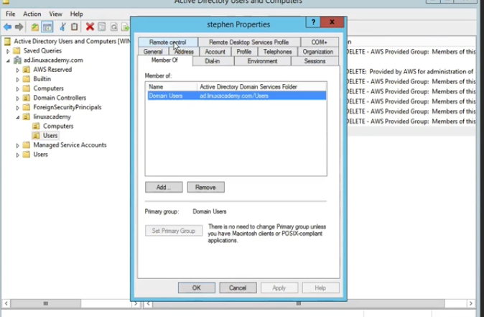

Type account admins

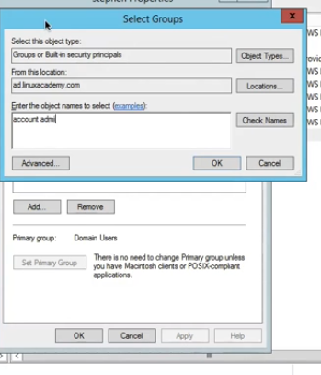

So Stephen user has been added to the account admin group as

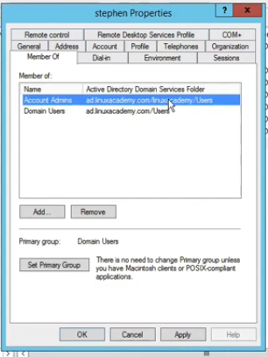

Click apply.

## Lecture: Manually Join EC2 Instance to the Domain (Simple AD & AWS AD) Linux

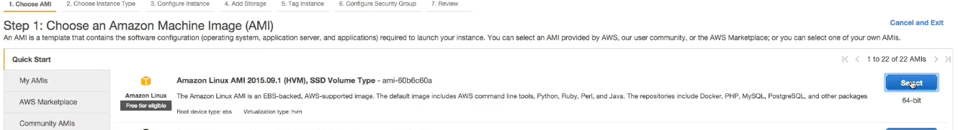

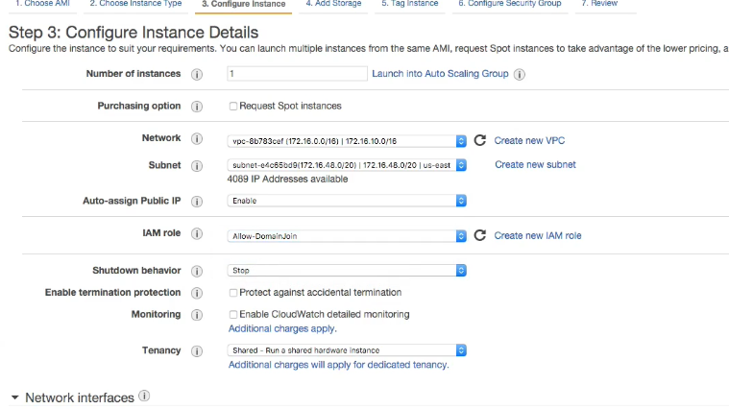

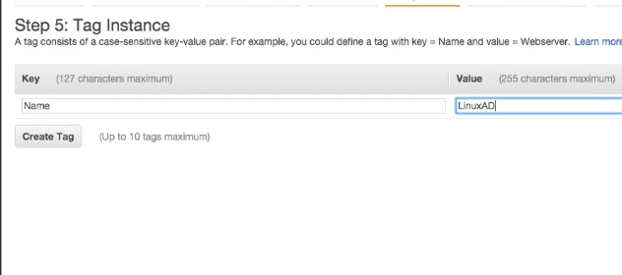

Use the same default SG which we are using in previous lectures but make an addition rule for ssh into the instance as

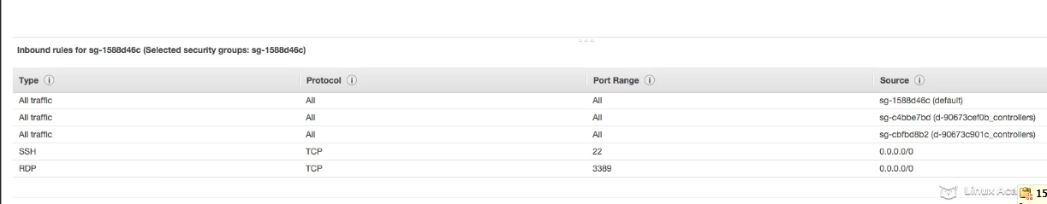

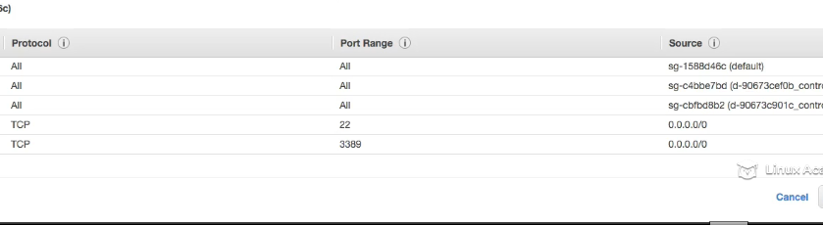

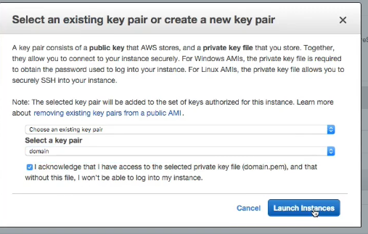

Ssh into the instance once its booted up.

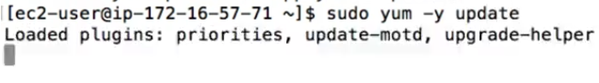

Now we need to install few packages inorder to bind this instance to the AD domain. If you remember in the pre-requisite section for amazon managed domains for dhcp options sets , this instance should already have the default domain controller ip’s for its dns. We can test this by pinging the actual name of our domain.



So you get a response back that means it is set up correctly, you are actually ready to install the packages as needed and we can start up with joining the instance to the domain.





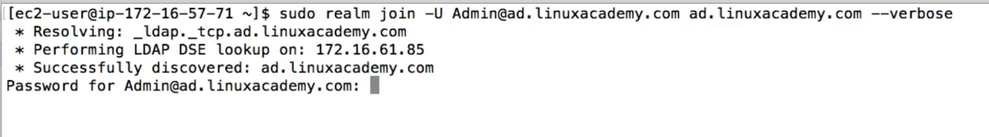

-U -🡪user

Give the password for the admin user

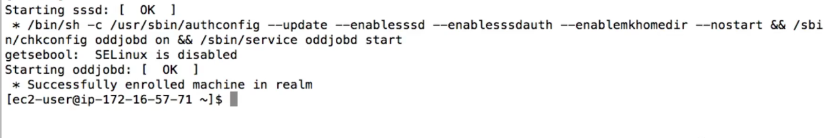

So now we have to enable password authentication to this linux instance so that we can ssh into the instance with the credentials which are the part of the domain.

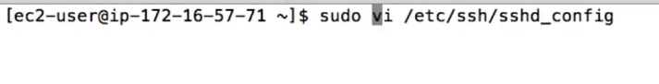Uncomment the password authentication as

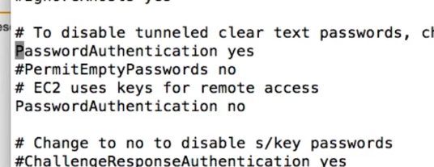

Save the file.

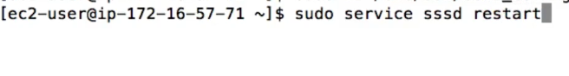

So before using this linux instance we have to reboot it. Once its rebooted we can ssh with the credentials which are a part of AD domain.

So before rebooting lets set a local password for our root account

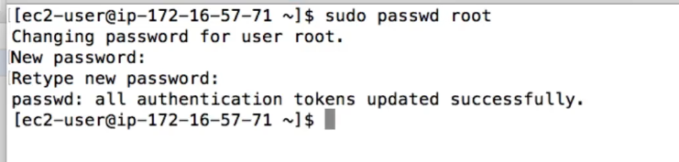

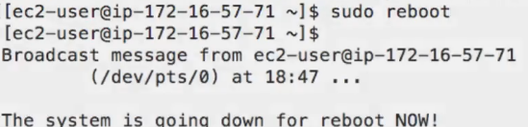

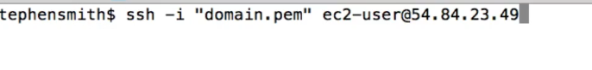

Now what we need to do is to add the domain administrators to the sudoers list by performing the following step.

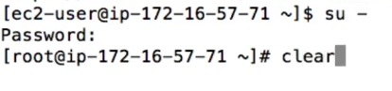

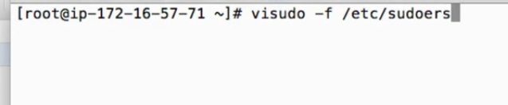

At the bottom add this new line

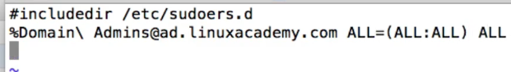

Now by default the account admins not just the domain admins or who have full privileges to our domain. So to do that

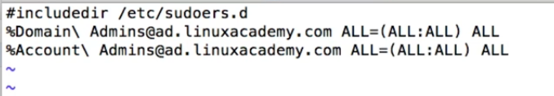

Save the file.

Now since we have the domain and account groups to be able to ssh into the our particular server here. So now by default all the users in the directory can login into this instance. You can allow specific users to login into the instance with what is called a realm permit command. We will do that after we login for the first time. Before we go further though lets try logging into our instance using the admin of our domain

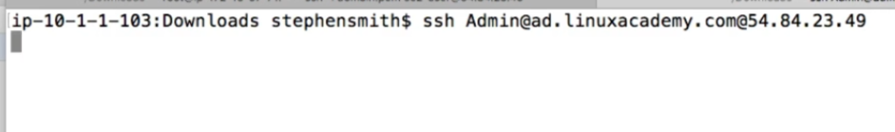

IT will popup for the password of the admin as

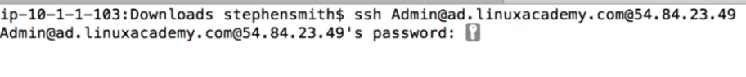

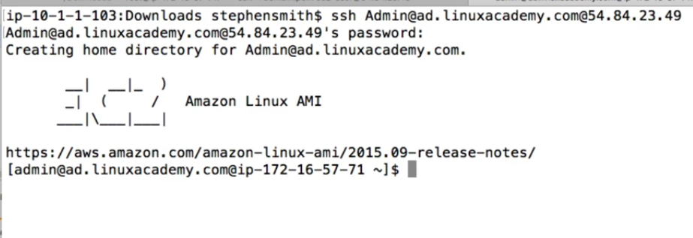

So we are successfully login with the AD domain credentials.

Lets now follow login with a new credentials such as Stephen which we added to the active directory.

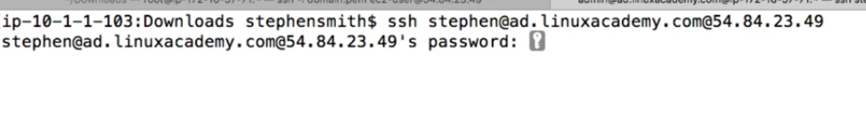

Enter the password for Stephen

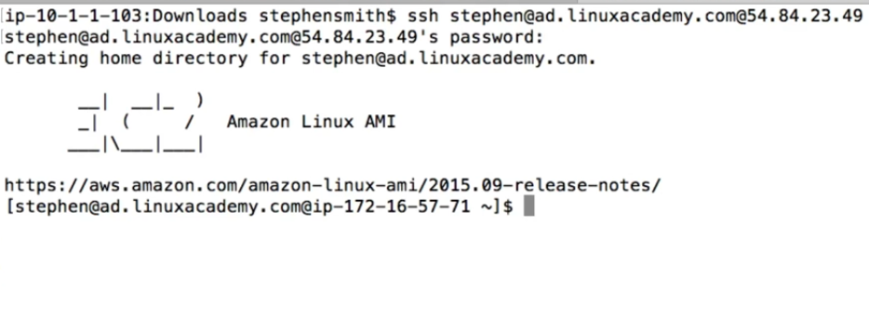

We are logged into the instance with the Stephen credentials.

So I will again go to the server using the root user. By default as we said all the users can log into this instance. However we can allow specific users to login into the instance with the realm permit command.

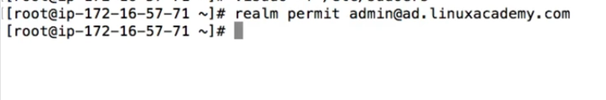

So earlier we were able to access this instance with Stephen credentials lets now try again to login as Stephen.

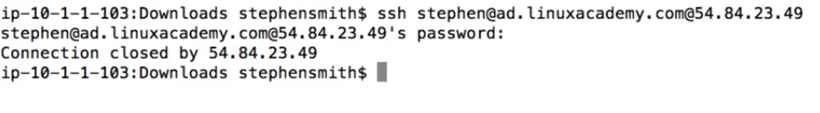

And we see that its not allowing to login with the Stephen credentials. Since we allowed only the admin lets see what happens logging as an admin.

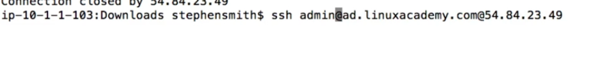

IT will prompt for a password

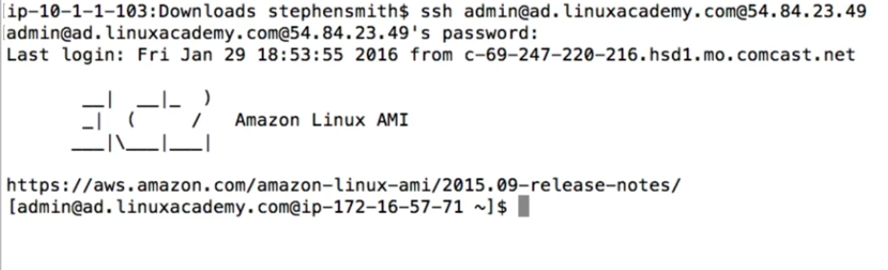

We are able to login as admin

Lets go and add the user Stephen

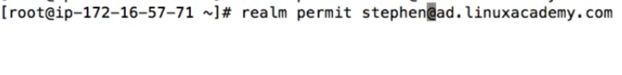

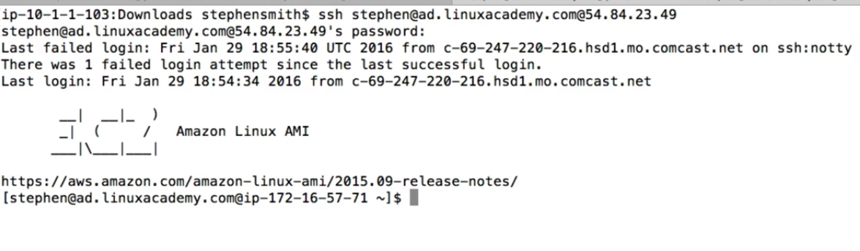

WE are able to login as Stephen also.

Now lets say Stephen just got fired then what needs to be done. So there is a command called withdraw as



Lets try to ssh again as Stephen again.

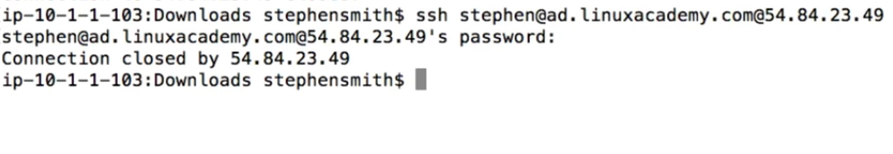

See we aren’t allow to login as Stephen.

So this is how we can add users to permit access with domain credentials and also to withdraw the access. The same way we can do for the groups as well.

So we will add the group so that all the members of that group would be able to connect as

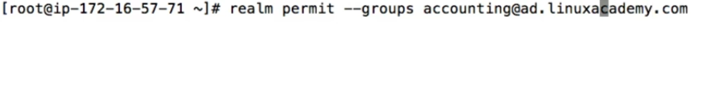

The same way we can remove the access to the users of the accounting group as



This will remove the group access to the instance.

So this was adding manually a linux instance to a domain as well as managing the credential for theusers and groups from that active directory domain to login to that ec2 instance.

### AWS Hybrid Active Directory Environments

## Lecture: Overview Network and Active Directory Hybrid Setups

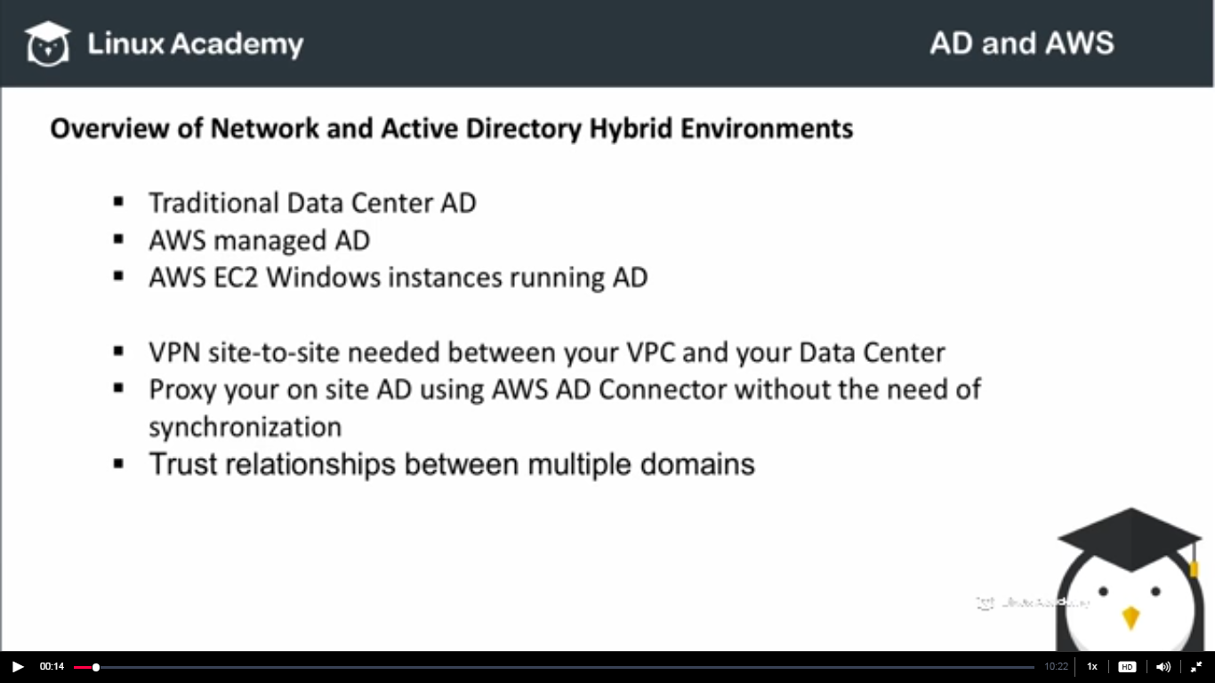

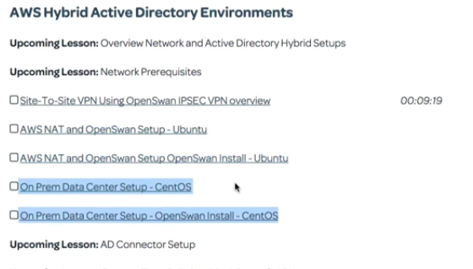

These are basically the option of setting the ipsec VPN tunnels. You can talk to your network administrator for which option to choose.

So here in the example we are going to look, we have 2 aws accounts which on separate VPC’s . So in the below instance we are in North Virginia i.e im in US-east-1 region as



This is one of my ec2 machine which a VPN tunnel setup at one end.

In another AWs account over North California I have another VPN instance as

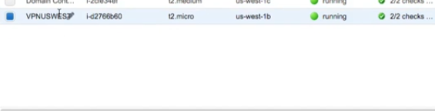

This has openswan setup from one tunnel to another tunnel

Once this is setup I can establish my local subnets let say here in North California my 172.31.9 subnet as

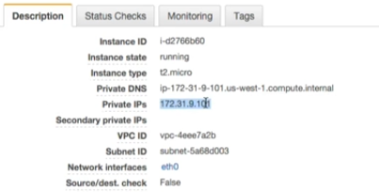

Once this is setup I can establish my local subnets let say here in North California my 172.31.9 subnet can talk with the subnets over in North Virginia on my 172.16.57 subnet. So my VPC subnets are able to communicate between two different VPC’s securely over ipsec tunnel.

Once I have that tunnel created and established I can then based of my SG rules that I have in place enabled to communicate between domain controllers or managed AD instances on one AWs region to a completely different account over on another AWS region so that I can have either synchronization among active directory or perhaps I’m using the AD connector or just I want to have a proxy in one AWS account to use an existing AD account in an another AWS region. This same exact scenario whether its between two AWS accounts or whether its between your on premise data-centre and AWs account works exactly the same. The method of setting this up is obviously going to be different from 2 AWS accounts Vs using an AWS account and a on premise account. So following the lessons i.e

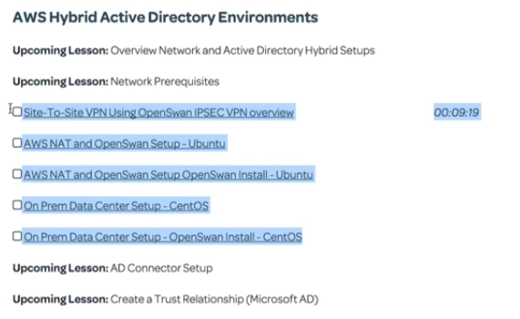

These above lessons would be talking about using an on-premise location on one end say your data centre and AWS on the other end. WE can also do it between 2 aws connections themselves or between two AWS separate VPC’s. so here in this example the communication is between two different AWs accounts. So I hve an AMI of the AWS machine image for linux. Its just an instance on one set up of AWS account in its own VPC and another instance setup in a completely different AWS account set up in its own VPC.

Here I’m in north California’s instance and I should be able to ping subnets and IP’s based of the SG’s that I have in place between the two separate environments . So what I’am going to do is in north California I will go ahead and look into a windows instance that I have in us-east account

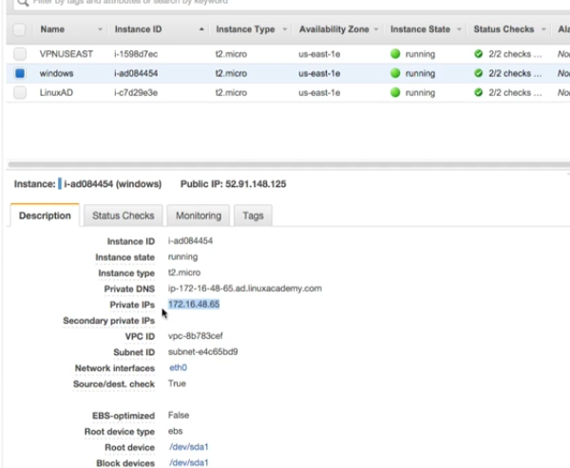

So here is an ip address copy it and remember this IP is of us-east-1 region, because we have VPN connection enabled between two environments I would be able to ping between between them. And I’m pinging from north virginia’s instance

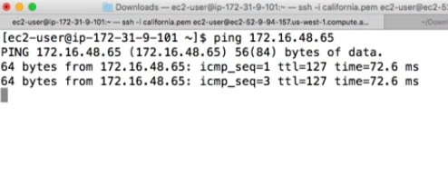

The same can be verified from the instance in north Virginia i.e us-east-1 and we will ping an instance in north California

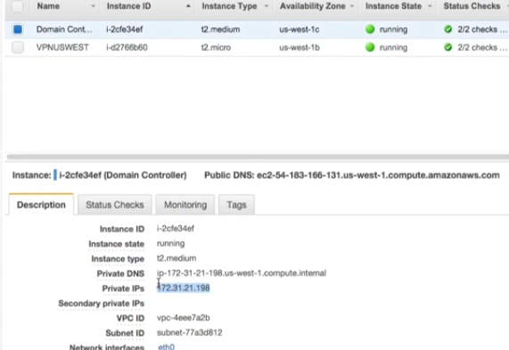

Copied the ip of the instance located in north California and pinging it from north Virginia

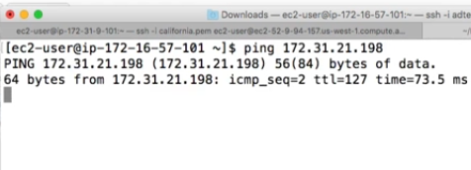

## Lecture: Site-To-Site VPN Using OpenSwan IPSEC VPN overview

Here we are trying to setup a openswan connection between the AWS and the data center where our AD is.

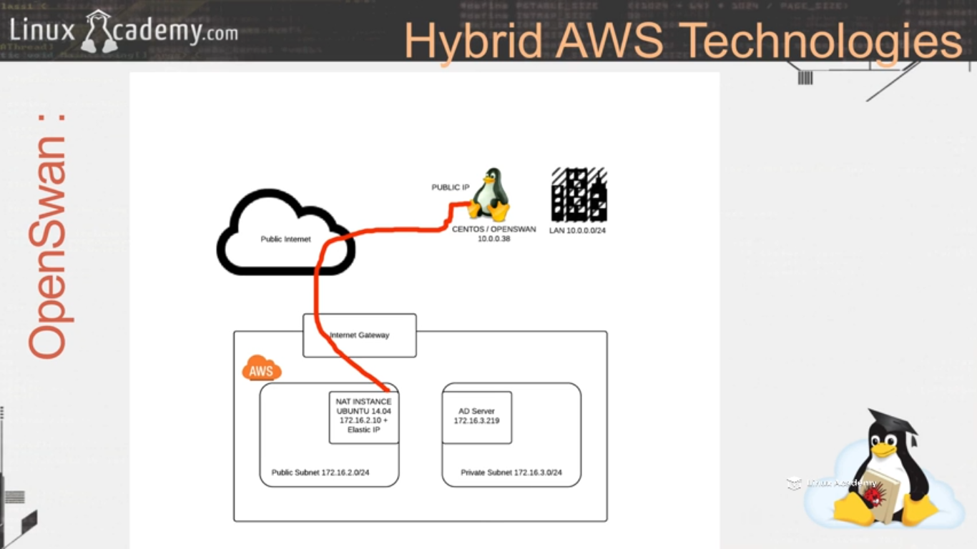

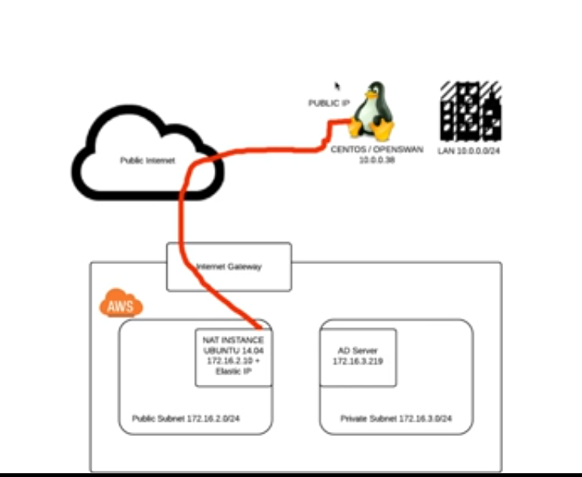

I have already setup the openswan connection and I’m currently on the Ubuntu instance that is basically the NAT instance in the public subnet with a public IP.

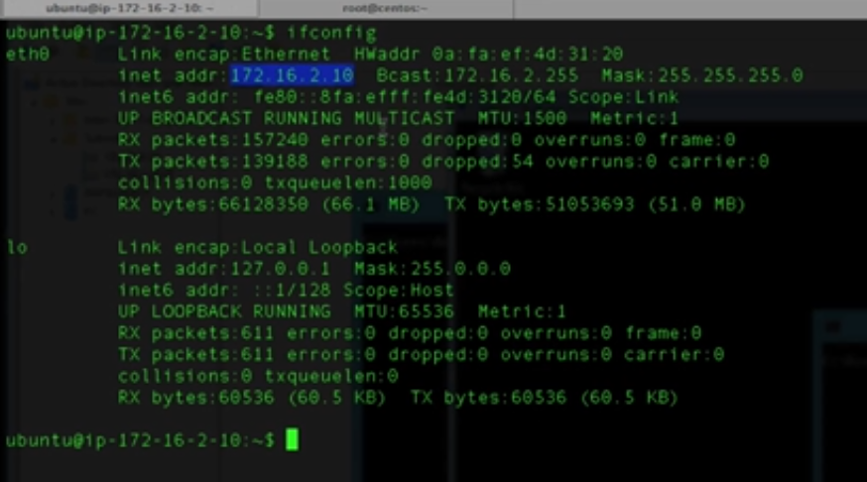

The ip of this instance is 172.16.2.10.

Also lets see the centos instance which is sitting in the private data center as

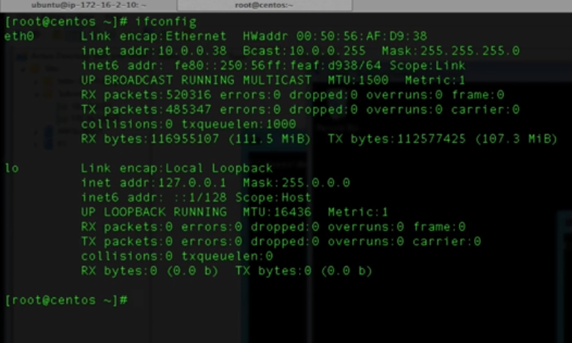

Its private ip is 10.0.0.38

There is already a tunnel between these servers. Iam pinging the server on the data center from the AWS Ubuntu server as there is already a tunnel e in place between these two environments

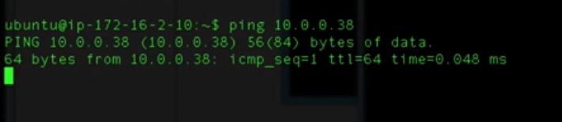

Another test I want to demonstrate is how now I have an AD domain controller. This is AC01, lets look its ip address in the data center as

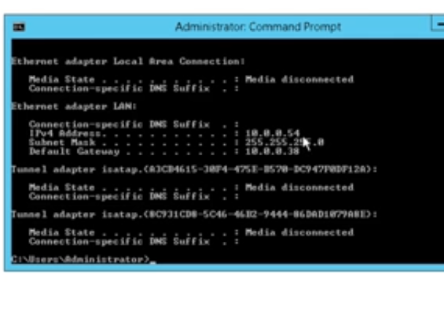

Its 10.0.0.54. I have another domain controller ADC02 that is in our AWS private subnet.

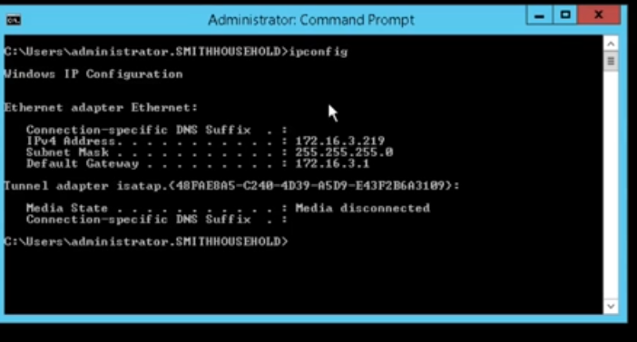

And its ip is 172.16.3.219. We can see the two different instances i.e two different domain controllers and it’s the same AD that is split between two sites. Again ADC01 is in the data center and ADC02 is in AWS.IF I ping by its name

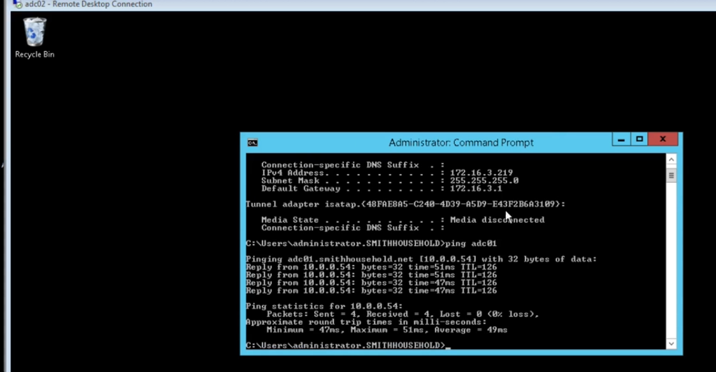

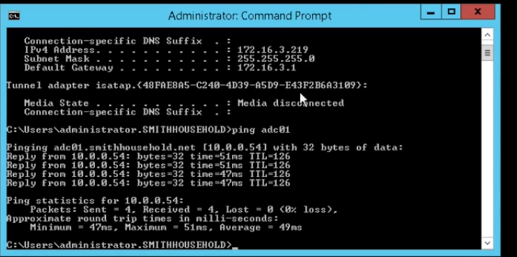

Its successfully pinging to the domain controller which is in the data center. I can ping ADC02 from the instance on the data center as well .

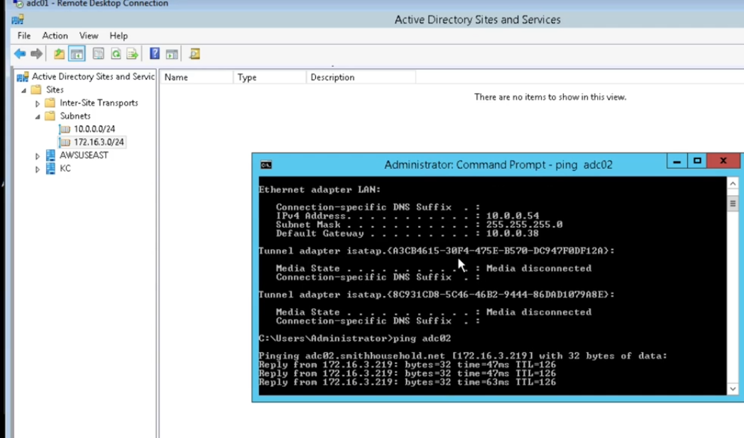

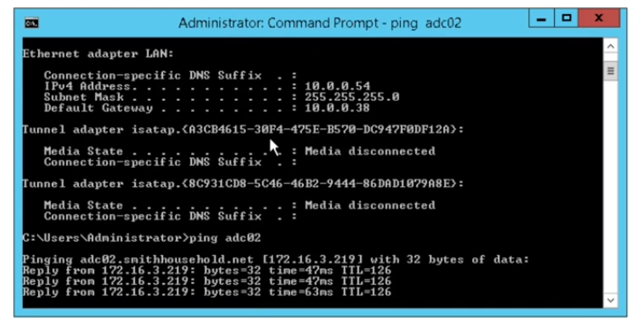

We can see the private ip address which is in our AWS VPC.

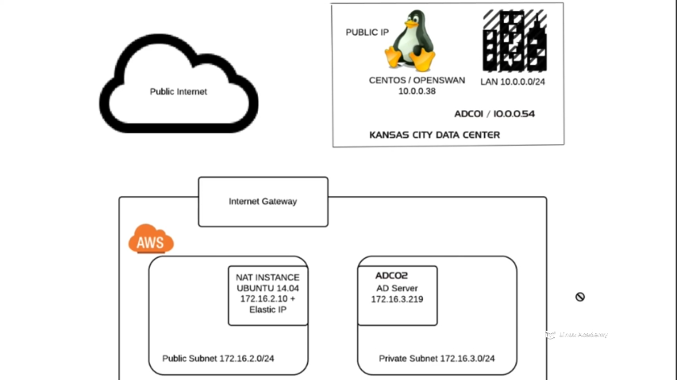

We have one domain controller in the data center and another domain controller in AWS and the resources in these two places are able to communicate to each other via the ipsec tunnel regardless of the geographic location.

## Lecture: AWS NAT and OpenSwan Setup - Ubuntu

WE are now going to setup our VPN ipsec tunnel between our AWS VPC to our private subnet on our on premise data center. We call our data center as Kansa city.

The first we will start with is the AWS side tunnel. Be sure to create a VPC and two subnets one private and one pubic from the other lectures.

We will create a NAT instance which will act as a gateway to our VPC network . this is going to be routing private and public subnet in our VPC out of AWS via the openswan ipsec VPN tunnel to our other openswan tunnel that we are going to later setup at our private data center.

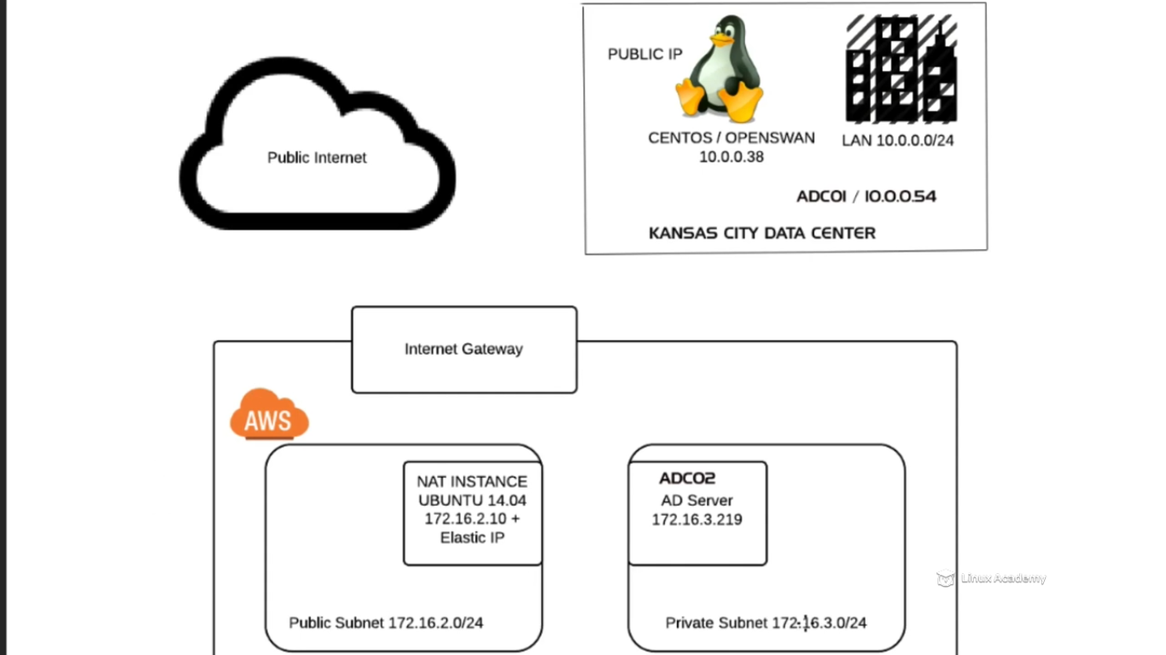

We are going to built the NAT instance in this lecture.

Lets launch a Ubuntu instance now

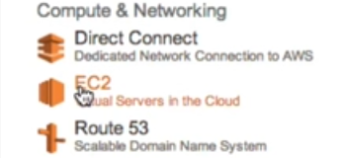

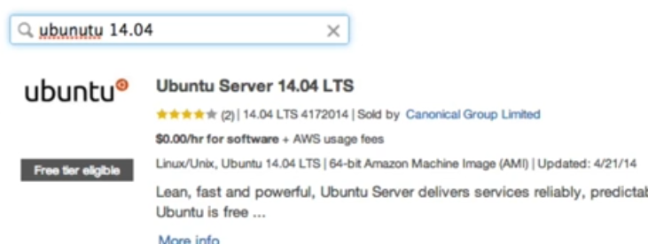

Stick with free-tier only.

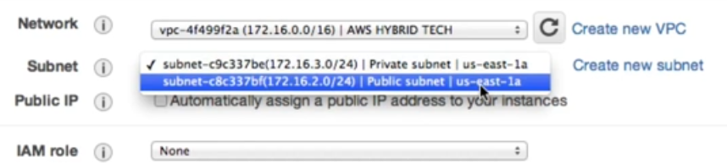

Make sure its launched in the public subnet.

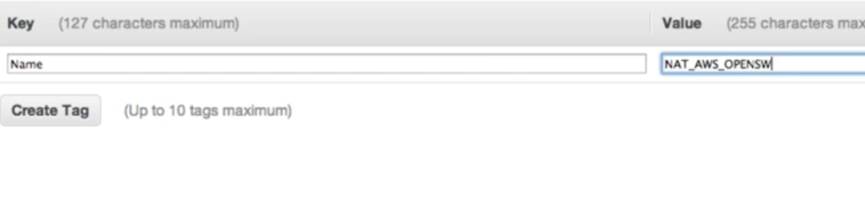

Already have created a SG that have proper inbound and outbound rules associated with this. Launch the instance.

Below is the SG rules for the above mentioned NAT instance

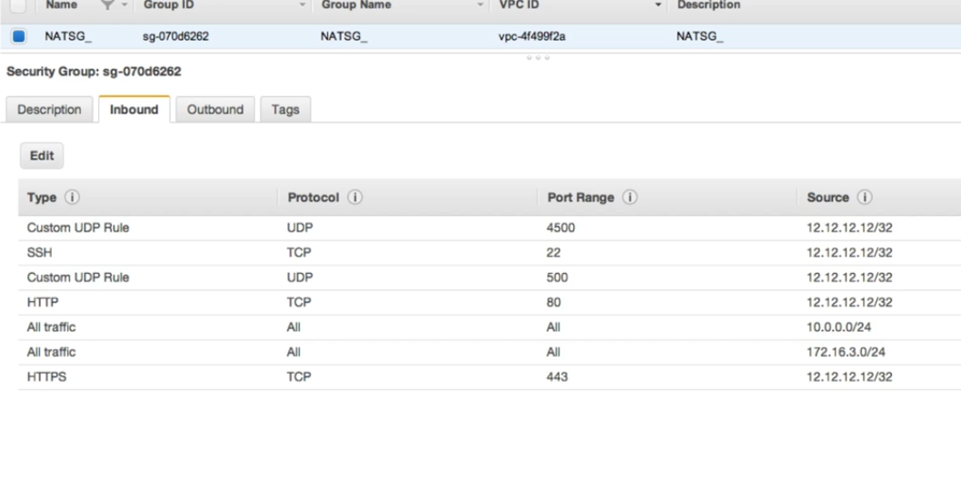

The 12.12.12.12/32 is the public ip of the instance in the data center kansa city.

WE have two more rules i.e all traffic these are for internal communication between the private and public subnets in the AWS. The all traffic with 172.16.3.0/24 is going to allow our private subnet to traverse via our nat instance in the public subnet out to the internet. The rule with 10.0.0/24 is the private subnet in the data center. WE are allowing traffic from that subnet to get traverse through our NAT instance once the tunnel is up.

Now lets see the instance which we have launched is ready or not.



Its running but it doesn’t have any elastic IP attached to it.

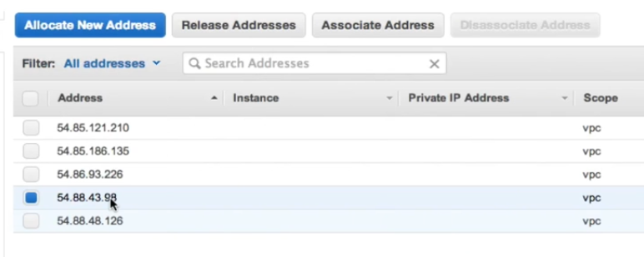

Attach this IP to the NAT instance.

Disable source and destination check inorder to let this Nat instance work properly.

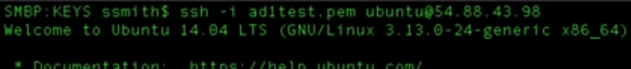

The first thing we have to do now is that we need to do enable ip forwarding.

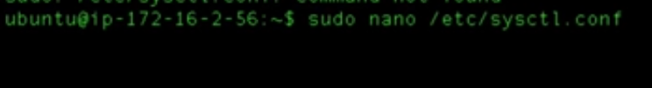

Uncomment the line





Reconnect

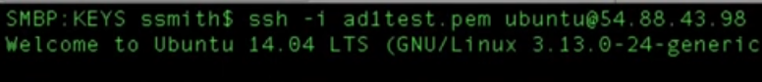

Issue the command to add to the iptables the specific subnet that we want to allow through our NAT instance



So lets now go to the AWS and make sure whether the route tables are in place or not.

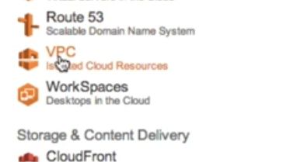

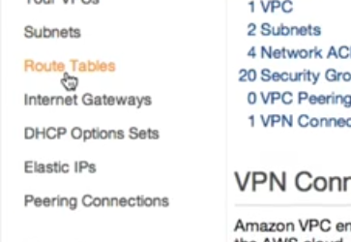

Here I have attached the private subnet to a route table called as the private so that its easy for me to realize which subnet is attached to which route. The advantage of having a NAT instance in AWS VPC is so that the private subnet are able to access the internet to download things and do other things in the internet without being publically available as a public subnet. So what we have to do is to create route tables that are able to route traffic from our private subnet out to the internet.

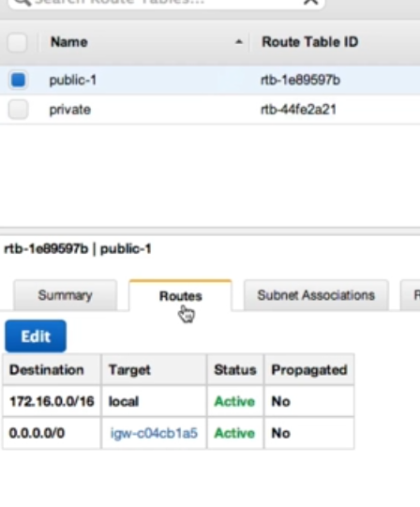

WE see the public route table has a gateway id associated with it and which basically makes anything in the public subnet publically available as long as we give the ip the public ip address.

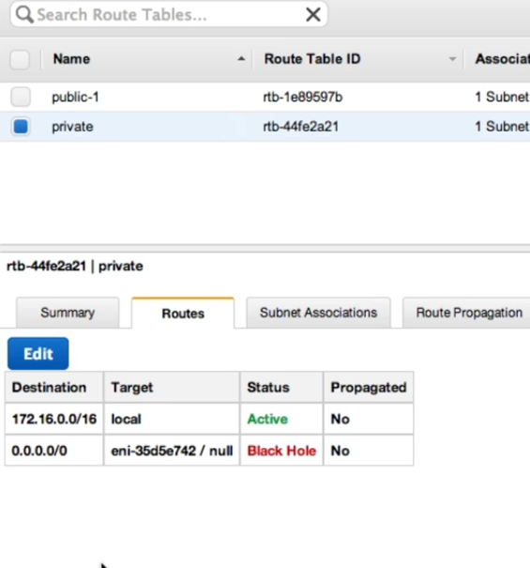

This private subnet is not attached to any gateway and this needs to be attached to NAT which is going to route private subnet traffic out to the internet.

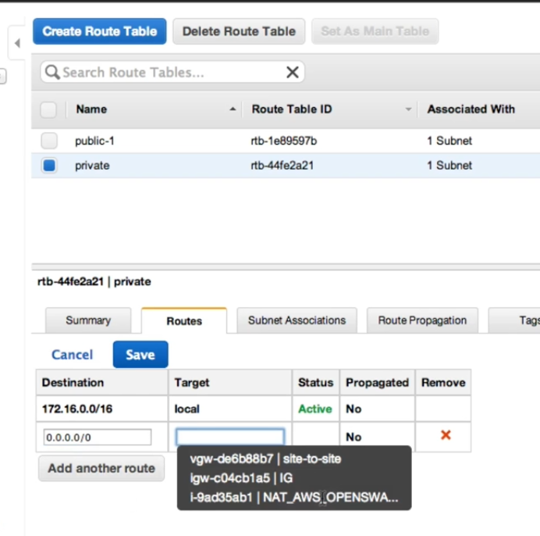

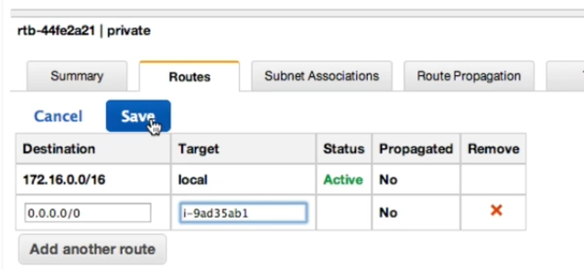

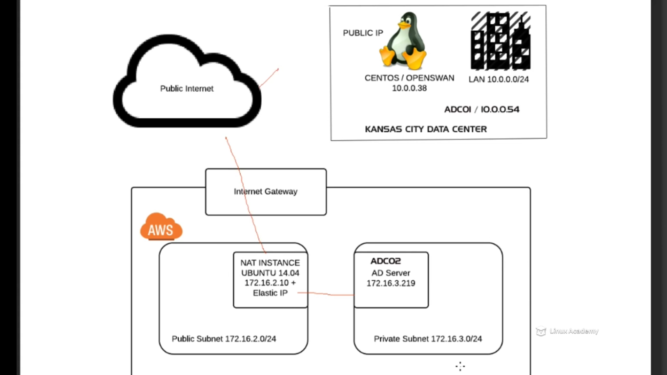

This is done.

Now if we want the changes which we made to the config file on the NAT instance to remain permanent even after reboot what needs to be done is

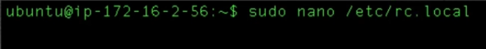\

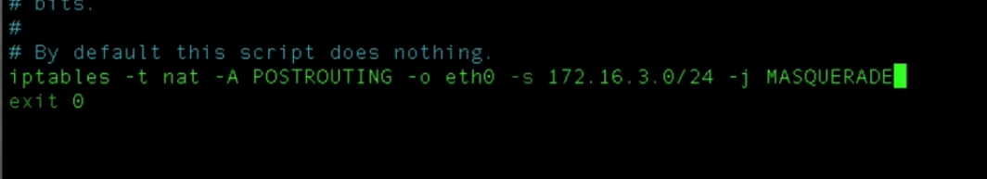

Put the iptable command which we did earlier before the exit and save. Now we have created a NAT instance and now we can configure openswan on this in the next lecture.

## Lecture: AWS NAT and OpenSwan Setup OpenSwan Install - Ubuntu

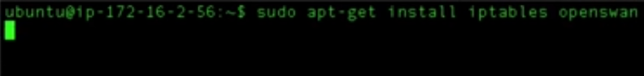

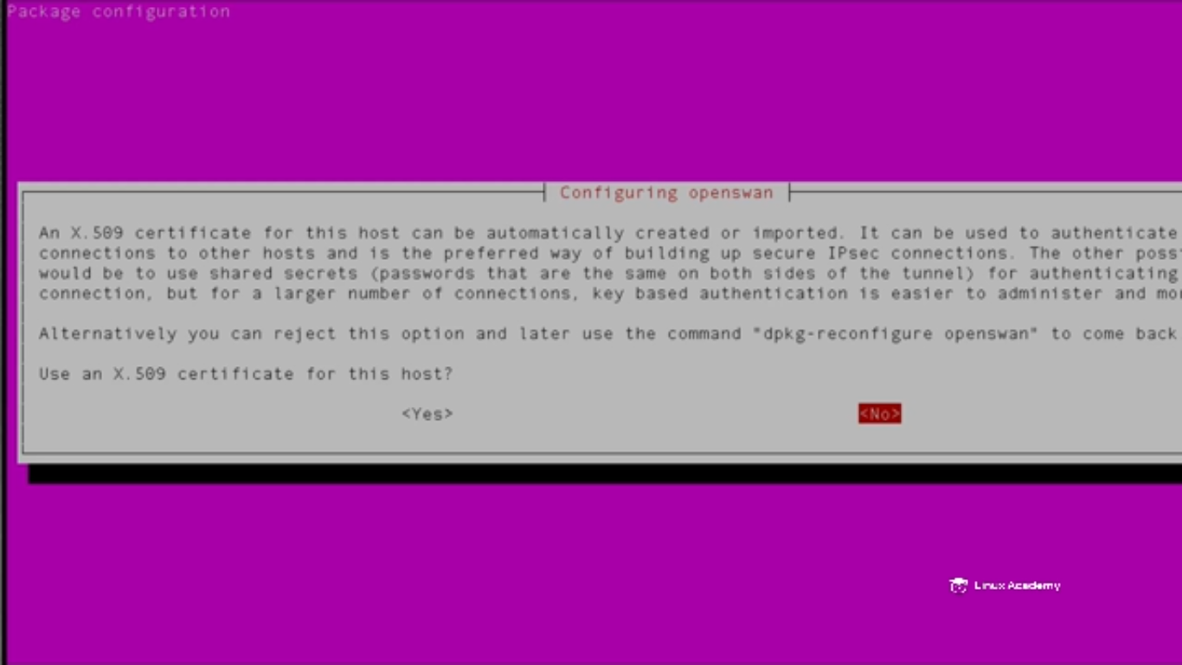

Hit no

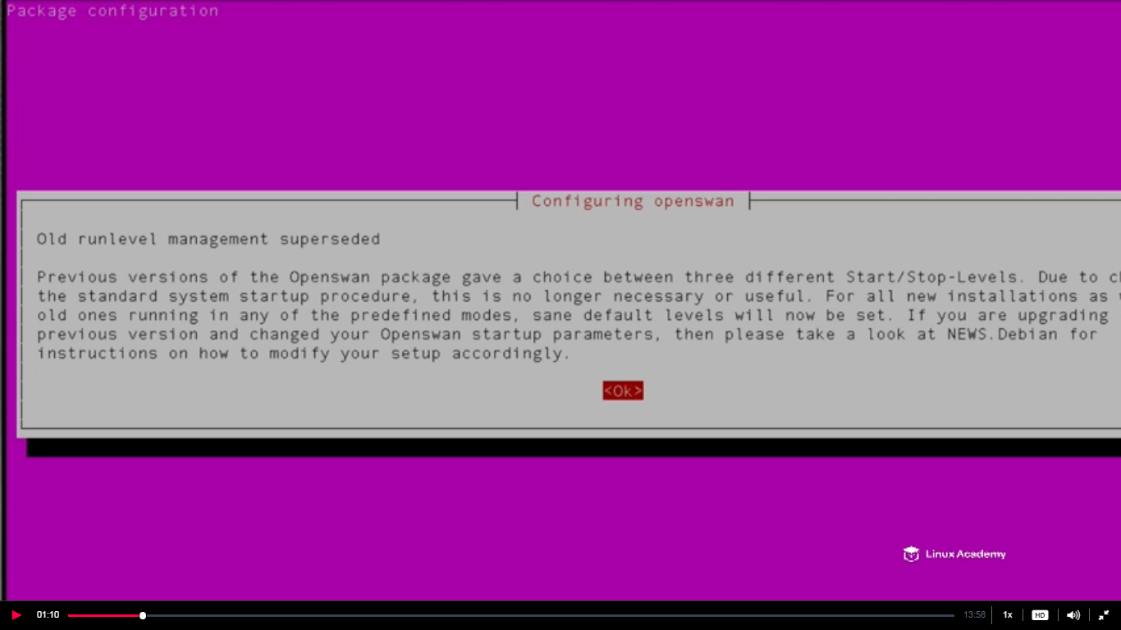

Hit ok



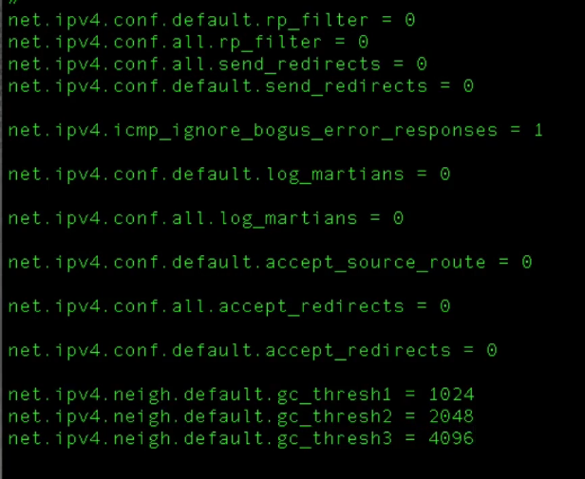

Add above lines at the bottom of the config file.

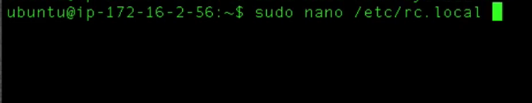

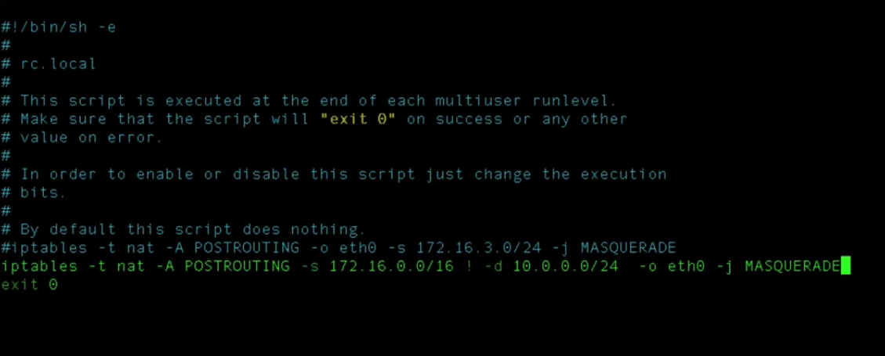

What we are saying here by the line we added is that our complete VPC subnet i.e both our private and public subnet i.e 172 series(on AWS public) and 10 series(on data center private) to be able to communicate to each other via this ipsec tunnel.

Save the above file.

Reboot the server.

After reboot reconnect to the NAT

Now configure the ipsec config

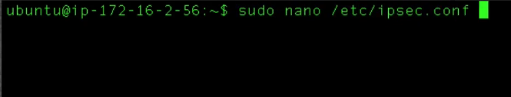

Left subnet on the config file is the subnet where you are configuring the ipsec and the right is where you are going to connect via this tunnel.

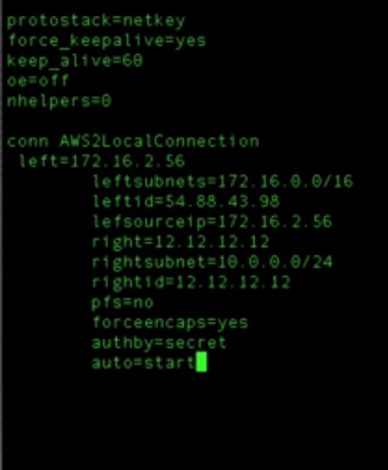

Save this file and add the configuration at the bottom

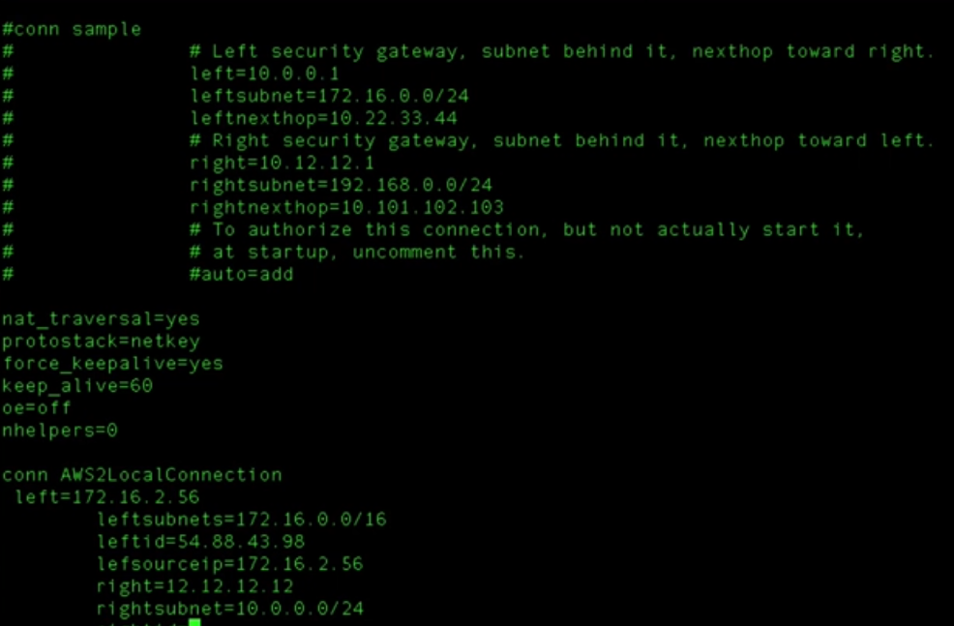

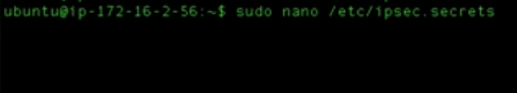

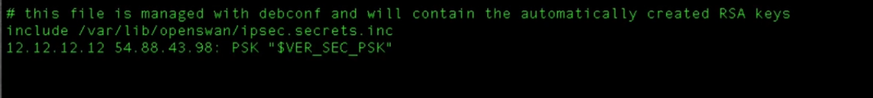

The 12.12.12.12 is the public ip of the instance on the data center and the 54.88….. ip is the elastic ip of the NAT instance we created or on which we are configuring openswan. What we are saying here is by the first ip listed ie 12.12…… which is our ip of the data center is allowed to connect via the tunnel to our public ip which is our elastic ip which we gave to this NAT instance 54.88…..It is using a preshared key which is then followed in quotes for our example here . You can define anything which you want here inside the quotes.

Save the file.

## Lecture: On Prem Data Center Setup - CentOS

Here we are using vcenter and we downloaded the things with the dvd.

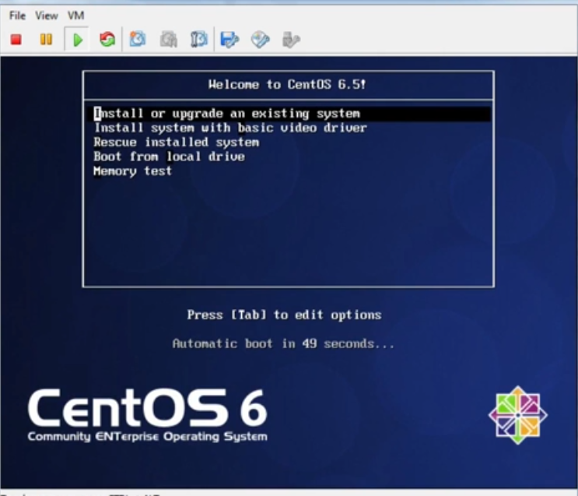

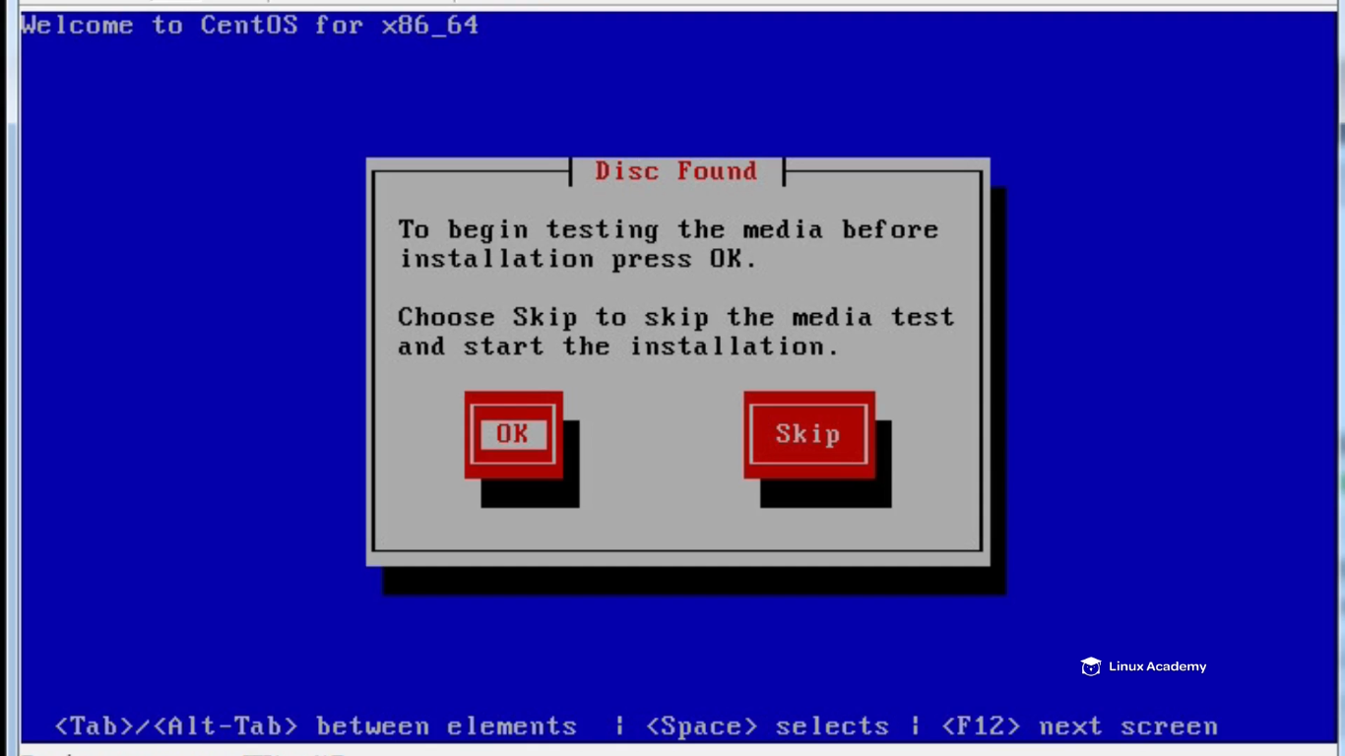

We are downloading centos on the vcenter.

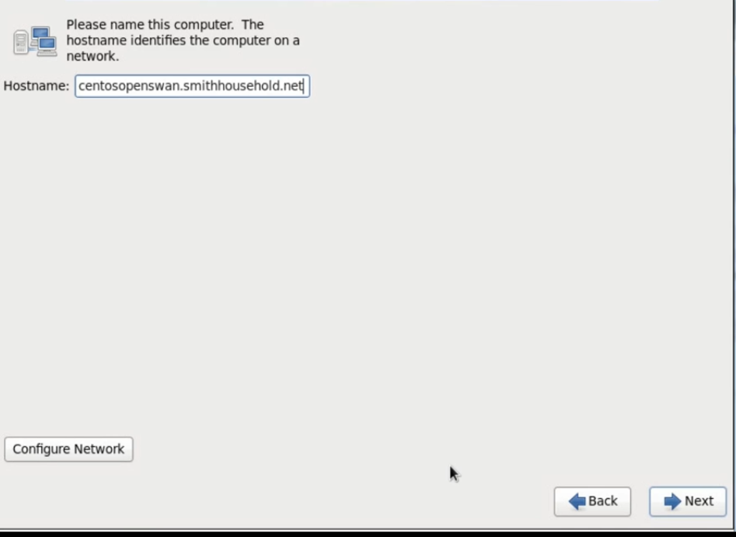

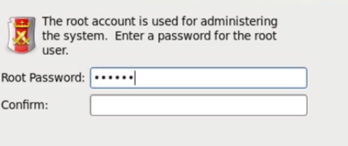

Do next next.

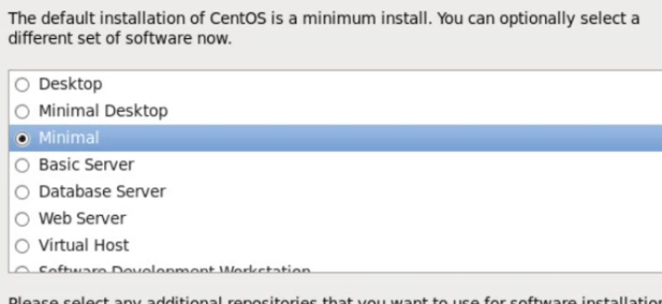



Make the changes on the existing file

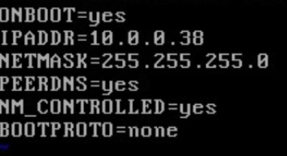

Save it . Now we want to config our network file which is

**Vi /etc/sysconfig/network**

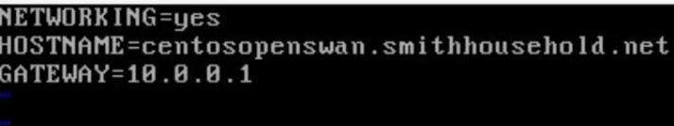

Hit save after adding the gateway.

Now we can define what our name servers are and where our resolve config file is. On centos go to

**Vi /etc/resolv.config**

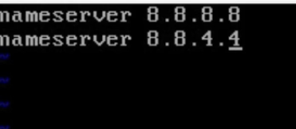

We gave the google nameservers here.

Save the file.

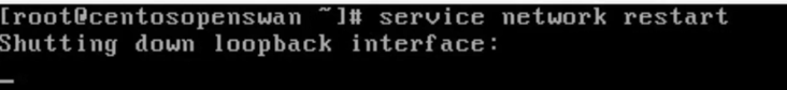

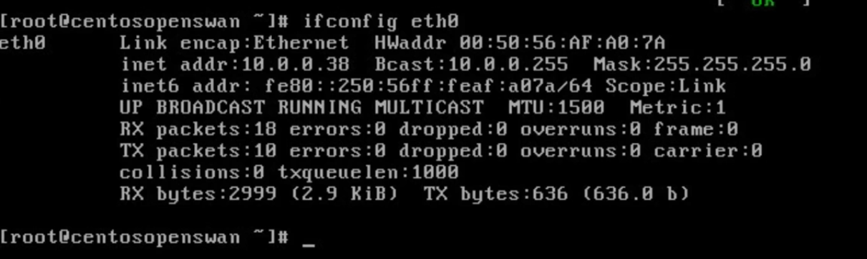

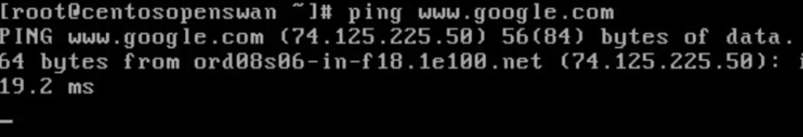

## Lecture: On Prem Data Center Setup - OpenSwan Install - CentOS